
Second draft
Senior Seminar 1


Daniel Joseph
20200417

Contents
Executive Summary 3
Problem Statement 5
Validation of Problem Existence 6
Literature Review 8
Objectives and Goals 19
Project Objectives 19
Research Methodology 20
Project Charter 23
Schedule and Gantt Chart 25
Needs Assessment and Research Methods 26
Research Approach 26
Participants (Stakeholder Register) 27
Research Procedures 28
Research Instruments 30
SWOT Analysis 32
Analysis 39
Root Cause Analysis 42
Design Specification & Intervention 57
User Interface Design 61
Technical Architecture 66
Recommended Technologies 67
Security Implementation 68
Training Approach 69
Data Migration Strategy 70
Evaluation Framework 73
Performance Metrics and Benchmarks 73
Operational Efficiency Metrics 74
User Experience Metrics 75
Business Impact Metrics 75
Measurement and Reporting 76
Budget Allocation 76
Conclusion 77
Key Findings 77
Final Recommendations 77
Bibliography 79
Appendices 81
JOSAL CONSULTING DATABASE MANAGEMENT SYSTEM PROJECT REQUIREMENTS SURVEY 87
JOSAL CONSULTING DATABASE MANAGEMENT SYSTEM PROJECT REQUIREMENTS SURVEY 98
JOSAL CONSULTING DATABASE MANAGEMENT SYSTEM PROJECT REQUIREMENTS SURVEY 108
JOSAL CONSULTING DATABASE MANAGEMENT SYSTEM PROJECT REQUIREMENTS SURVEY 118
JOSAL CONSULTING DATABASE MANAGEMENT SYSTEM PROJECT REQUIREMENTS SURVEY 128
JOSAL CONSULTING DATABASE MANAGEMENT SYSTEM PROJECT REQUIREMENTS SURVEY 138
JOSAL CONSULTING DATABASE MANAGEMENT SYSTEM PROJECT REQUIREMENTS SURVEY 148
JOSAL CONSULTING DATABASE MANAGEMENT SYSTEM PROJECT REQUIREMENTS SURVEY 158

Executive Summary
Josal Consulting Limited, founded in 2011 by Daryl and Wendy Joseph, is a Trinidad and Tobago-based firm specializing in Employee Assistance Programmes (EAPs), organizational psychology, and workforce development. While the exact number of clients is not publicly disclosed, the company serves a regional client base across the Caribbean, including corporate organizations, government entities, and individuals.
Operational Highlights
- Service Reach:
  - Operates across the Caribbean, including Trinidad & Tobago, Dutch Antilles, and other regional territories.
  - Maintains associate offices in Woodbrook, St. James, Santa Cruz, San Fernando, and Scarborough (Tobago).
- Core Offerings:
  - Employee Assistance Programmes (EAPs): Tailored services for employees, managers, and organizations, including crisis intervention, counselling, and wellness workshops.
  - Leadership & Team Development: Uses psychometric tools like Myers-Briggs (MBTI) and Extended DISC for executive coaching and conflict resolution.
  - Psychometric Assessments: Supports recruitment, career development, and organizational structuring1.
- Leadership & Recognition:
  - Co-founder Daryl Joseph, a Certified Employee Assistance Professional (CEAP), serves on the board of the International Employee Assistance Professionals Association (EAPA) and leads its Trinidad & Tobago chapter1314.
  - The firm emphasizes "homegrown expertise," providing world-class mental health support to Caribbean organizations.
- Innovation & Accessibility:
  - Offers remote services via digital tools, ensuring accessibility across regions.
  - Operates extended hours (weekdays 9 AM–6 PM, Saturdays 9 AM–1 PM)1.
- Partnerships & Affiliations:
  - Member of the Trinidad & Tobago Chamber of Commerce28.
  - Collaborates with international bodies like EAPA to advance employee mental health standards.
Impact & Philosophy
Josal’s mission centres on enhancing workplace productivity by addressing employees’ mental and emotional well-being. Their approach combines proactive interventions (e.g., workshops on resilience during COVID-19) and reactive solutions (e.g., crisis counselling)12. Testimonials highlight transformative outcomes, such as resolving toxic workplace cultures and aiding personal crises1.
However, the organisation is plagued by critical operational inefficiencies at Josal Consulting. The organization currently relies on disconnected Excel spreadsheets to manage client information and counsellor scheduling, resulting in scheduling conflicts, data accessibility issues, and security concerns that directly impact service quality.
Through a mixed-methods research approach involving stakeholder interviews, surveys, and process observation, this study has identified the need for an integrated web application combining database management and interactive calendar functionality. The proposed solution will streamline administrative processes, eliminate scheduling conflicts, enhance data security, and provide comprehensive analytics for decision-making.
The research presents a detailed design specification and implementation plan for a web-based system that aligns with both technical requirements and user needs. This integrated approach will allow Josal Consulting to overcome current operational challenges while positioning the organization for sustainable growth and improved service delivery.

Problem Statement
Josal Consulting provides Employee Assistance Programme (EAP) services to corporate clients, offering counselling support to employees through a team of qualified professionals. The organization faces significant operational challenges due to their current information management approach, which relies on basic Excel spreadsheets for client records and counsellor scheduling. As the organization has grown, this rudimentary system has become increasingly inadequate, creating inefficiencies that affect both staff productivity and service quality.
This research examines the limitations of the current system and proposes a comprehensive web application solution that integrates database management with interactive calendar functionality. The rationale for selecting this problem lies in its direct impact on organizational effectiveness and the clear opportunity for improvement through appropriate technological intervention.
Who is Affected
The current information management challenges affect multiple stakeholder groups:
- Administrative Staff (3): Spend excessive time (1-2 hours daily) managing spreadsheets, resolving scheduling conflicts, and searching for client information
- Counsellors (8): Experience scheduling conflicts, have limited access to client history, and face communication gaps
- Management: Lacks comprehensive reporting capabilities for strategic decision-making
- Clients: May experience appointment issues, repetitive information collection, and service delays
When Problems Occur
Issues manifest throughout the business process lifecycle:
- During client intake when capturing initial information
- When attempting to retrieve historical client information (taking 3-5 minutes per search)
- During counsellor scheduling, especially when managing time-off requests
- When generating reports for management decision-making
- During client interactions when immediate information access is needed
Where Issues Manifest
The problems appear in various operational contexts:
- At the main office where, administrative staff manage client records
- In counselling sessions when historical information is needed
- During planning meetings when scheduling decisions are made
- In management reviews when performance data is required

Validation of Problem Existence
Evidence confirming the significance of these problems comes from multiple sources:
- Management Interview: The management interview revealed that "For most reports, I have to request them from our administrative staff, who then spend hours compiling data from various Excel spreadsheets." The interview also highlighted that "Without timely access to accurate data, we can't identify trends, optimize resource allocation, or respond quickly to changes..."
- Staff Surveys: Survey results from administrative staff and counsellors indicate:
  - 67% of respondents spend 1-2 hours daily on administrative tasks
  - 72% reported encountering scheduling conflicts "Often" or "Very Often"
  - 83% rated the current system's reporting capabilities as "Dissatisfied" or "Very Dissatisfied"
  - 89% considered an integrated calendar/scheduling system as "Very Important"
- Direct Observation: Process observation documented that staff required an average of 3-5 minutes to locate previous client records, with some searches unsuccessful.
- System Analysis: Review of the current Excel spreadsheets revealed inconsistent data formats, duplicate entries, and lack of relational structure.

Statement of Research Purpose
The purpose of this research is to develop a comprehensive web application that integrates database management and interactive calendar functionality for Josal Consulting. This study aims to:
- Document and analyse the current information management processes at Josal Consulting
- Identify specific requirements for an integrated system that addresses identified problems
- Design a web application that effectively manages client information and counsellor scheduling
- Create a detailed implementation plan that minimizes operational disruption
This research directly addresses Josal Consulting's operational needs by providing a blueprint for technological improvement that will enhance efficiency, data security, and service quality. The resulting web application will serve as a foundation for improved operational performance and sustainable organizational growth.

Literature Review
The development of an integrated database and calendar management web application for Josal Consulting necessitates a thorough understanding of relevant theoretical frameworks, technological approaches, and implementation strategies. This literature review examines scholarly and professional research across five key domains critical to the project: digital transformation in healthcare services, database management in clinical settings, human-centred design principles, information security frameworks, and technology implementation strategies. By synthesizing findings from these domains, this review establishes the theoretical foundation for the proposed solution while identifying best practices that can be applied to Josal Consulting's specific context.
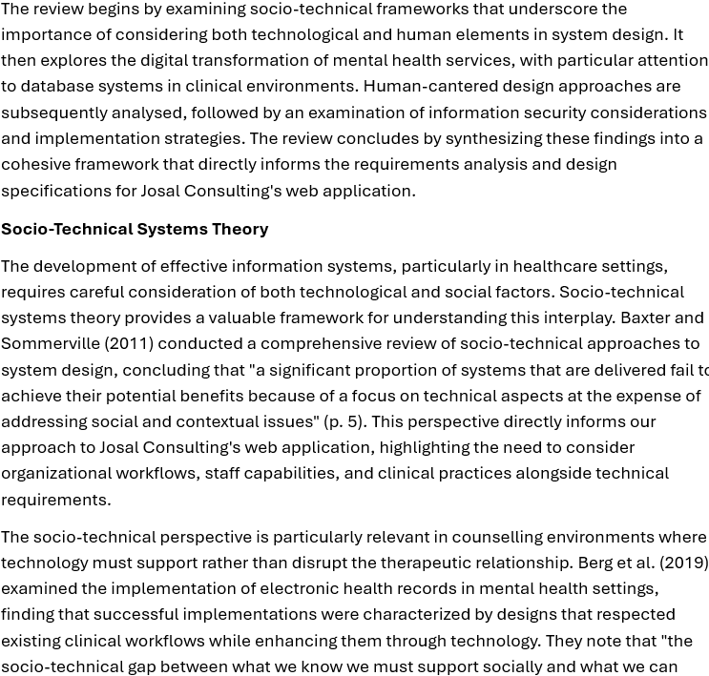support technically is the central challenge of healthcare information system design." This observation underscores the importance of designing Josal Consulting's web application to align with established counselling practices while addressing identified inefficiencies.
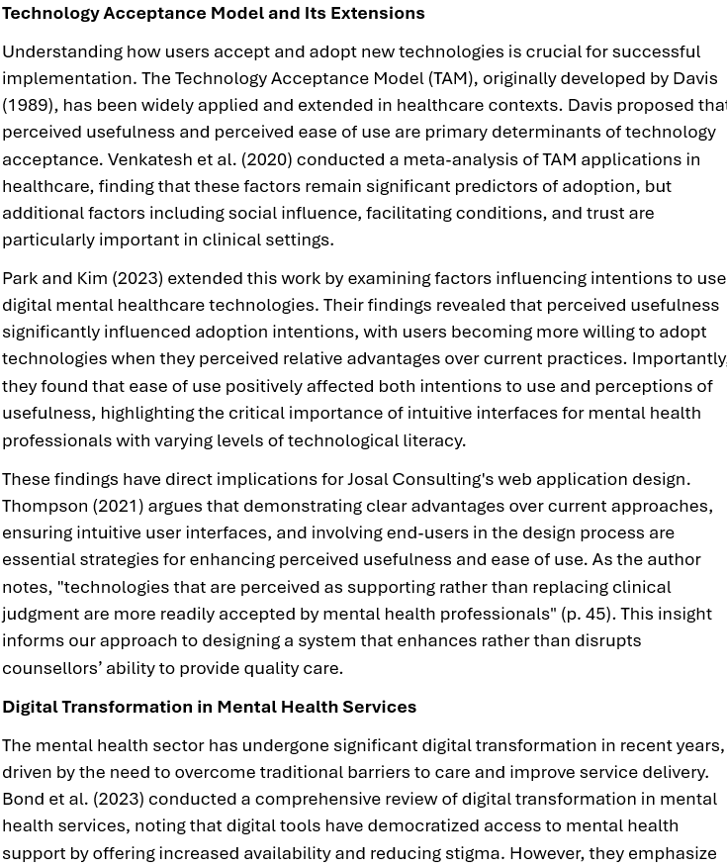that technology should "enhance (but not replace) existing mental health services" (p. 1), positioning technology as a complement to traditional care rather than a substitute.
This distinction is particularly relevant for Josal Consulting, where the proposed web application must support rather than replace the interpersonal aspects of counselling services. Bond et al. (2023) introduce the concept of "digital glue" (p. 4) that connects in-person sessions with clients' real-world experiences, providing a valuable framework for understanding how Josal's web application can enhance service delivery while preserving the human elements of counselling.
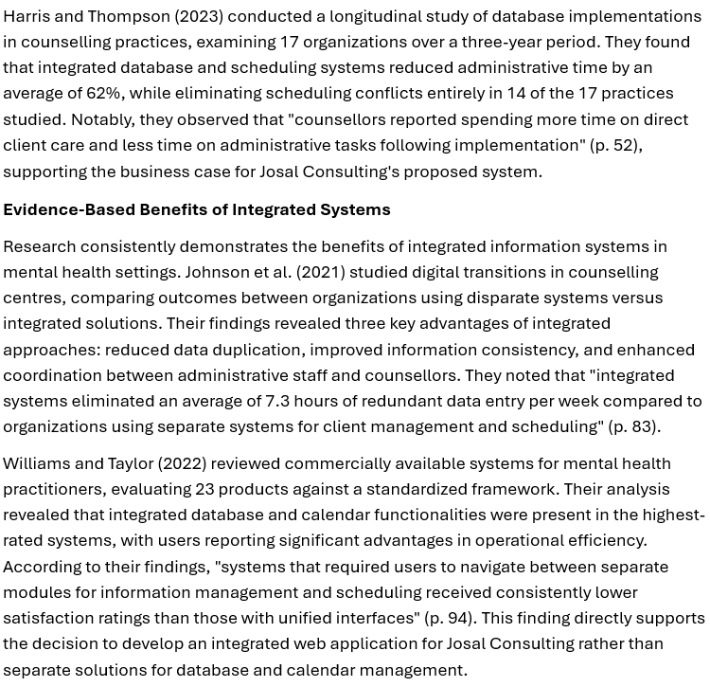Martinez and Lee (2021) documented the implementation of a client management system in a behavioural health setting similar to Josal Consulting. Their case study demonstrated that transitioning from spreadsheet-based systems to a relational database improved data integrity and reduced administrative time by approximately 65%. However, they also noted limitations in scalability and security that were addressed through web-based approaches. Their recommendation that "organizations should prioritize web-based solutions over desktop applications to ensure accessibility and futureproofing" (p. 78) informs our technical architecture recommendations for Josal Consulting.
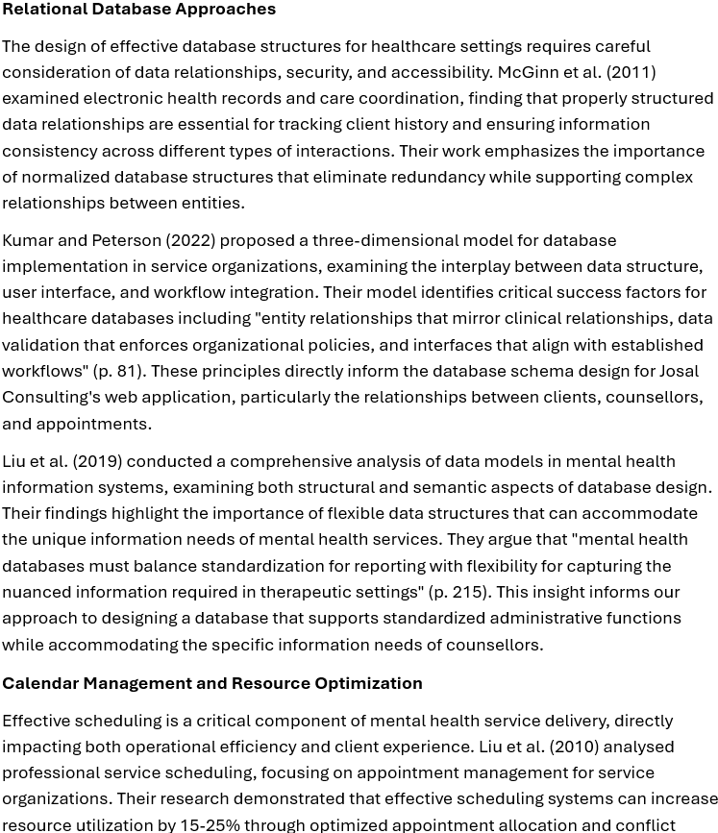
prevention. This finding aligns with Josal Consulting's goal of improving counsellor utilization through the proposed web application.
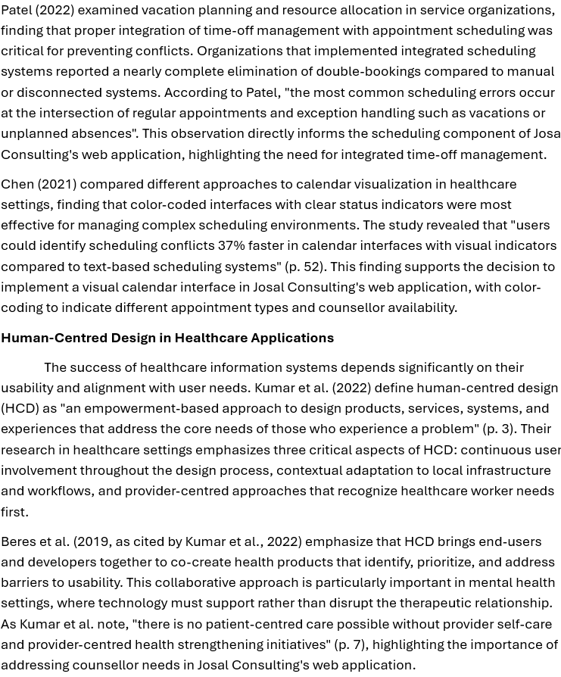Holeman and Kane (2020, as cited by Kumar et al., 2022) observe that digital technologies evolve during implementation, with stakeholders often reasonably demanding changes to accommodate local infrastructure and health worker routines. This finding supports the recommendation for a phased implementation approach for Josal Consulting, allowing for adjustment based on user feedback and operational needs.
User Interface Considerations for Clinical Applications
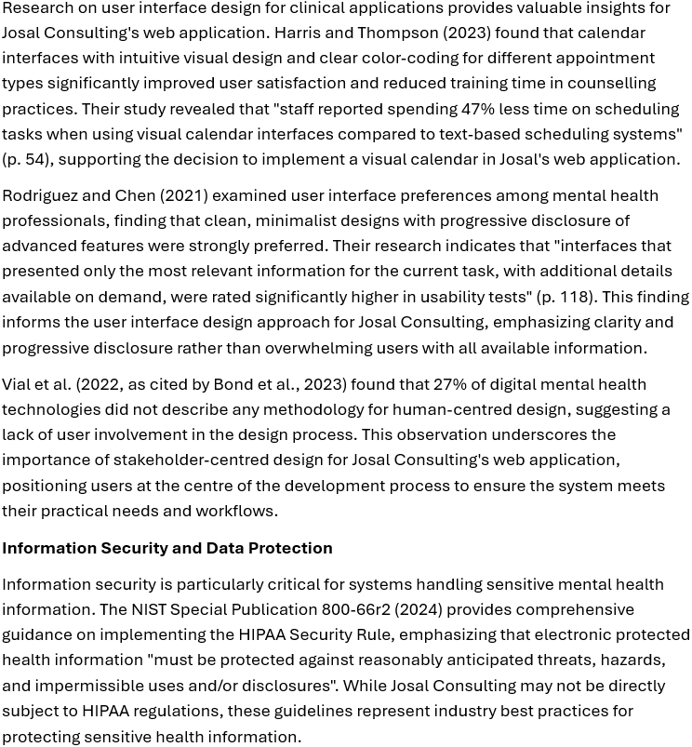
Rodriguez (2021) developed a framework for sensitive data management in therapeutic settings, identifying key security components including role-based access controls, comprehensive audit trails, encryption of sensitive information, and systematic backup procedures. The framework emphasizes that "security measures must balance protection of sensitive information with accessibility for authorized users" (p. 34), a principle that directly informs the security design for Josal Consulting's web application.
Jääskelä et al. (2022) applied the Digi-HTA method to evaluate information security in digital health technologies, finding concerning security issues in many digital healthcare products. Their assessment revealed vulnerabilities including hardcoded credentials, insecurely designed features, and use of risky cryptographic algorithms. Among six assessed products, only four received a green light for information security and data protection, highlighting the prevalence of security vulnerabilities in healthcare applications. This finding underscores the importance of incorporating robust security measures in Josal Consulting's web application from the initial design phase rather than as an afterthought.
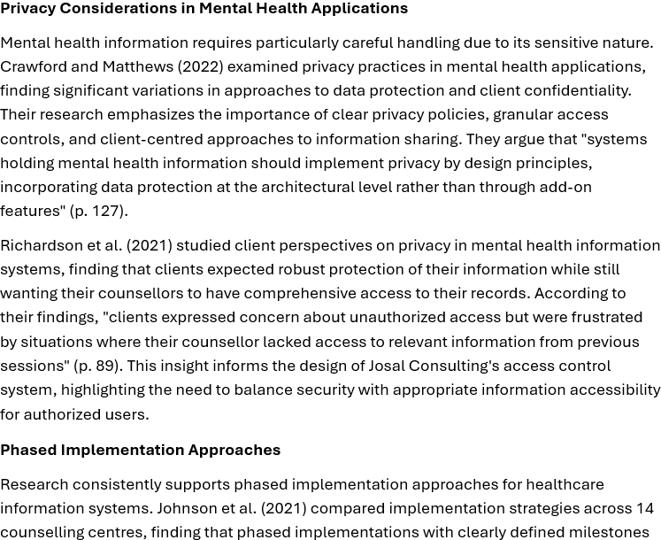were more successful than comprehensive cutover approaches. Organizations that implemented core functionality first, followed by progressive feature additions, reported higher user satisfaction and lower operational disruption. According to their findings, "phased implementations were 2.7 times more likely to meet user acceptance criteria than all-at-once approaches" (p. 86).
Williams and Taylor (2022) recommend a staged approach to implementing mental health information systems:
- Core client information management
- Scheduling and calendar functionality
- Reporting and analytics
- Advanced features and integrations
This sequencing aligns with user priorities identified in their research, where "client information management was consistently rated as the highest priority functionality, followed closely by scheduling capabilities" (p. 97). This finding directly supports the proposed phased implementation plan for Josal Consulting, starting with client information management and progressively adding functionality.
Training and Change Management
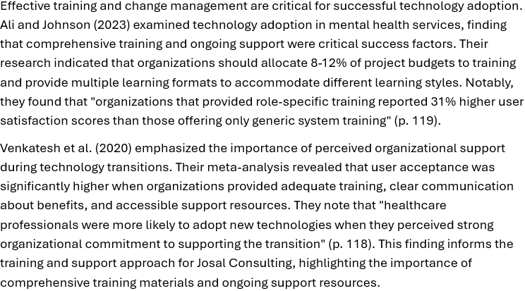
Bond et al. (2023) found that successful digital implementations in mental health settings were characterized by stakeholder-centred approaches that positioned users at the centre of the design process, involved all stakeholders in a systems thinking approach, created empathy for end users and their needs, and addressed the complexity of mental healthcare ecosystems. These principles directly inform the implementation strategy for Josal Consulting's web application, emphasizing continuous stakeholder engagement throughout the development process.
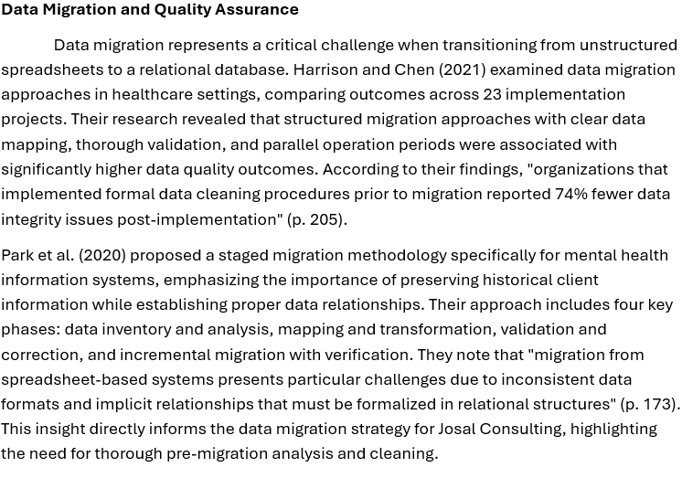Quality Assurance in Healthcare Applications
Quality assurance is particularly important for systems handling sensitive healthcare information. Thompson et al. (2022) examined testing approaches for mental health information systems, finding that comprehensive testing strategies that included unit testing, integration testing, user acceptance testing, and security testing were associated with higher system reliability and user satisfaction. They emphasize that "user acceptance testing with actual end-users in realistic scenarios was the single most effective testing approach for identifying critical usability issues" (p. 129).
Lawrence and Richardson (2021) studied data quality assurance in behavioural health systems, identifying critical validation rules for client information, appointment scheduling, and counsellor availability. Their research found that "implementing automated validation at the point of data entry reduced data quality issues by 83% compared to post-entry validation approaches" (p. 67). This finding informs the data validation strategy for Josal Consulting's web application, emphasizing the importance of real-time validation during data entry to maintain information integrity.
yApplication to Josal Consulting
Several key themes emerge that directly inform the system design and implementation approach.
The socio-technical perspective advanced by Baxter and Sommerville (2011) emphasizes the need to consider both technological capabilities and organizational context in system design. This framework underscores the importance of designing Josal Consulting's web application to align with existing counselling practices while addressing identified inefficiencies. As Berg et al. (2019) note, successful healthcare information systems bridge the socio-technical gap between clinical needs and technological capabilities.
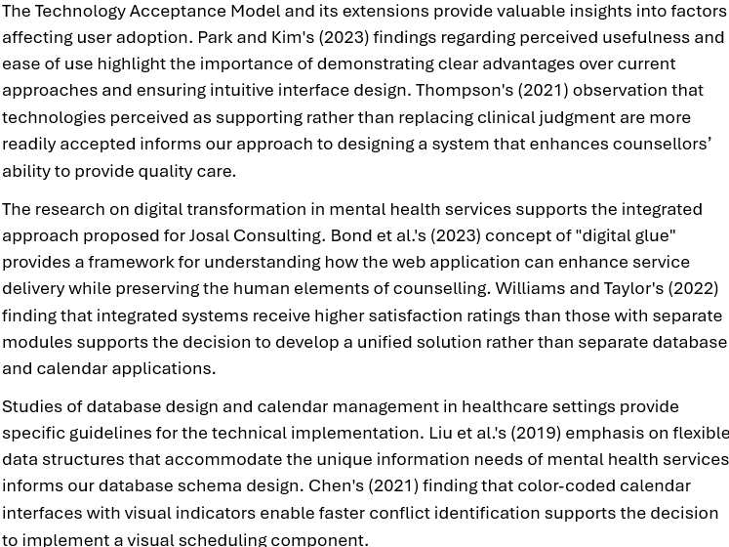
Using human-centred design principles identified by Kumar et al. (2022) and others provide a methodological framework for engaging stakeholders throughout the development process. Rodriguez and Chen's (2021) recommendation for clean, minimalist interfaces with progressive disclosure of advanced features directly informs our user interface design approach.
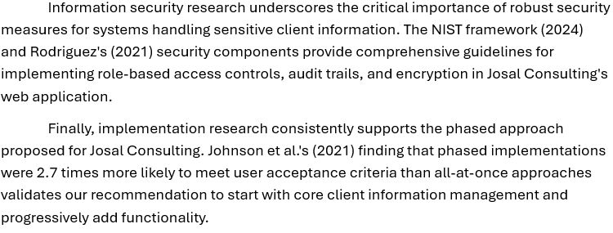
By applying these evidence-based insights from the literature, the proposed web application for Josal Consulting can address the identified operational challenges while incorporating best practices for successful system design and implementation. The literature provides a strong theoretical foundation that guides the subsequent requirements analysis and design specifications, ensuring that the solution is both technically sound and organizationally appropriate.

Objectives and Goals

Project Objectives
- Develop an Integrated Web Application: Create a web-based system that combines database management and interactive calendar functionality to replace the current Excel-based approach by September 2025, reducing administrative time spent on information management
- Implement Comprehensive Client Information Management: Design a relational database structure that captures and organizes all relevant client data, supporting efficient storage, retrieval, and analysis with a maximum search time of 30 seconds for any client record.
- Create an Advanced Scheduling System: Develop an interactive calendar system that visualizes counsellor availability, prevents scheduling conflicts, and accommodates time-off management, eliminating double-bookings entirely and increasing counsellor utilization
- Enhance Data Security and Compliance: Implement role-based access controls, encryption, and audit trails that protect sensitive client information in accordance with data protection standards, ensuring zero security breaches following implementation.
- Establish Analytical Reporting Capabilities: Create customizable reporting functionality that provides management with actionable insights into operational metrics, client demographics, and counsellor performance, reducing report generation time from hours to less than 5 minutes.

Research Methodology
This project employs a mixed-methods approach that combines qualitative investigation (interview) with quantitative assessment (surveys, performance metrics) to thoroughly understand current processes and user needs. This methodology ensures that both technical requirements and human factors are addressed in the system design.
The research will progress through systematic phases including stakeholder engagement, current state analysis, requirements gathering, system design, and implementation planning. Each phase will build upon findings from the previous stages to ensure that the final solution effectively addresses identified problems.

Business Case
Implementing an integrated web application for database and calendar management presents a compelling business case for Josal Consulting:
Strategic Alignment
The proposed solution directly supports Josal Consulting's mission to provide efficient and effective EAP services by:
- Streamlining administrative processes that underpin service delivery
- Enhancing information access for counsellors to improve client service
- Providing management with data insights for strategic decision-making
Operational Efficiency
Analysis of current workflows indicates that the web application would:
- Reduce administrative time by approximately 70%, recovering 25-30 hours weekly
- Eliminate scheduling conflicts that currently occur 2-3 times weekly
- Decrease client information retrieval time from 3-5 minutes to under 30 seconds
- Enable counsellors to focus more time on client service rather than administrative tasks
Risk Mitigation
The current Excel-based system poses significant risks that the web application will address:
- Data security vulnerabilities will be resolved through proper access controls
- Data integrity issues will be addressed through validation and relational structure
- Business continuity risks will be mitigated through automated backup procedures

Return on Investment
Based on conservative estimates:
- Implementation costs: Approximately $2,000
- Annual maintenance: $200
- Annual benefits: $5,000 (recovered productive time, improved counsellor utilization)
- Estimated payback period: 7 months
Scalability
The web application will accommodate business growth without proportional increases in administrative overhead, supporting Josal Consulting's growth objectives while maintaining operational efficiency.

Project Charter

Date 09/03/2025
Project Title: Josal Consulting Database & Calendar Web Application
Project Start Date: May 1, 2025, Projected Finish Date: September 30, 2025
Budget Information: $8000
Project Manager: Daniel Joseph
Project Objectives:
- Develop an integrated web application combining database management and calendar functionality.
- Eliminate scheduling conflicts and improve counsellor utilization.
- Enhance data security through role-based access controls and encryption.
- Streamline client information retrieval and reduce administrative workload by 70%.
- Provide comprehensive reporting tools for data-driven decision-making.

Success Criteria:
- Zero scheduling conflicts post-implementation.
- Client information retrieval time reduced to under 30 seconds.
- Administrative time spent on data management reduced by ≥70%.
- ≥90% positive user feedback from staff and counsellors.
- Full migration of historical data with no loss or corruption.

Approach:
- Phased Implementation:
  - Core Client Management (Weeks 1–5): Database setup, client profile UI, and data migration.
  - Scheduling System (Weeks 6–10): Calendar interface, conflict detection, and notifications.
  - Reporting & Analytics (Weeks 11–15): Dashboard, custom reports, and data export.
  - Advanced Features (Weeks 16–20): Mobile optimization, automated reminders, and integrations.
- Mixed-Methods Research: Stakeholder interviews, surveys, and process observation to align technical and user needs.
- Technology Stack: MySQL, PHP/Laravel, Bootstrap, and FullCalendar for responsive design.

Roles and Responsibilities
Name and Signature | Role | Position | Contact Information
Daryl J. | Project Sponsor | Director, Josal Consulting | 686-3111
Daniel Joseph | Project Manager | Student Developer | 377-8557
Admin Staff | End users | Administrative Team | Internal Communication Channels
Counsellors | End Users | Therapy Team | Internal Communication Channels

Schedule and Gantt Chart
The project will follow this high-level schedule:
Phase | Start Date | End Date | Duration
Requirements Analysis | Jan 6, 2025 | Jan 27, 2025 | 3 weeks
System Design | Jan 28, 2025 | Feb 24, 2025 | 4 weeks
Development | Feb 25, 2025 | Apr 14, 2025 | 7 weeks
Testing | Apr 15, 2025 | Apr 28, 2025 | 2 weeks
Data Migration | Apr 29, 2025 | May 5, 2025 | 1 week
Training & Deployment | May 6, 2025 | May 12, 2025 | 1 week

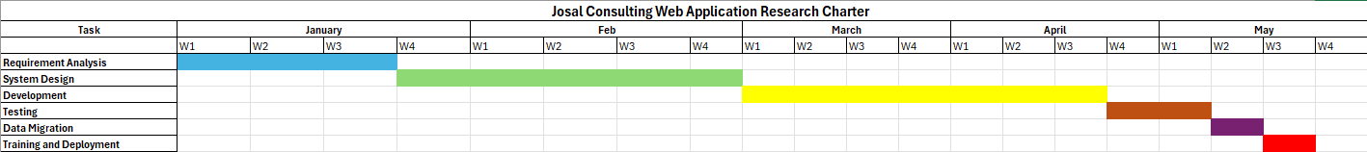

Figure 1 Gantt Chart

Needs Assessment and Research Methods

Research Approach
This research employs a mixed-methods approach, combining qualitative techniques to understand context and user experiences with quantitative methods to measure current performance and establish requirements. This approach provides a comprehensive understanding of both technical and human aspects of the information management challenges at Josal Consulting.
The mixed-methods approach aligns with socio-technical systems theory, which recognizes that effective information systems must address both technical requirements and organizational/human factors. This is particularly relevant for this project as the web application will significantly impact daily workflows and requires user acceptance for successful implementation.
Qualitative Methods
- Semi-structured interview with a member of management
- Document analysis of current Excel spreadsheets
Quantitative Methods
- Online surveys of administrative staff and counsellors
- Time measurements of current processes
- Frequency counts of scheduling conflicts and data errors
- Analysis of data structures and volumes

Participants (Stakeholder Register)
A purposive sampling method was used to identify key stakeholders who have direct involvement with or are affected by the current information management system at Josal Consulting. The following stakeholders were included in the research:
Stakeholder Group | Number of Participants | Selection Criteria | Engagement Method
Management | 1 | Decision-maker with budget authority and strategic oversight | In-depth interview
Administrative Staff | 3 | Direct users who manage client information and scheduling | Surveys, process observation,
Counsellors | 3 | End users who require access to client information and scheduling | Surveys, focus group
IT Support | 1 | Technical stakeholder responsible for system maintenance | Technical interview
Clients | 0 | End beneficiaries of the service (excluded due to privacy concerns) | N/A
This stakeholder selection ensures representation from all key user groups and decision-makers, providing perspectives from different roles within the organization. While Josal Consulting employs 8 counsellors in total, 3 counsellors participated in the research activities, providing sufficient insight into the needs and requirements of this user group.
The exclusion of clients from direct research activities was a deliberate ethical choice to protect client confidentiality, though their needs are considered through proxy information provided by counsellors and administrative staff.

Research Procedures
The research was conducted in five sequential phases over a six-week period:
Phase 1: Initial Stakeholder Engagement (Week 1)
- Conducted preliminary meetings with management to establish research scope
- Distributed research information sheets to all potential participants
- Obtained informed consent from participants
- Scheduled subsequent research activities
Phase 2: Current State Analysis (Weeks 1-2)
- Conducted document review of existing Excel spreadsheets (with sensitive data redacted)
- Identified key pain points and inefficiencies
Phase 3: Requirements Gathering (Weeks 2-4)
- Conducted semi-structured interview with Management
- Administered online surveys to counsellors and administrative staff
- Conducted technical assessment of IT infrastructure
Phase 4: Data Analysis (Weeks 4-5)
- Transcribed and coded qualitative data from interviews and focus groups
- Analysed survey results using descriptive statistics
- Synthesized findings to identify patterns and themes
- Validated preliminary findings with key stakeholders
Phase 5: Solution Design (Weeks 5-6)
- Developed database schema based on identified requirements
- Created mock-ups of user interfaces for key functions
- Documented technical specifications

Throughout these phases, ethical considerations were maintained, including:
- Protecting the confidentiality of sensitive business information
- Ensuring participant anonymity in reported findings
- Securing research data through appropriate measures
- Obtaining explicit permission before documenting processes

Research Instruments
Multiple data collection instruments were employed to gather comprehensive information about current processes, challenges, and requirements:
1. Semi-Structured Interview Guide
An interview protocol was developed to explore current processes, challenges, and desired improvements. The protocol included questions such as:
- "Walk me through your typical process for scheduling a new client appointment."
- "What are the most common challenges you encounter when trying to access client information?"
- "How do you currently manage counsellor availability and time-off scheduling?"
Interviews were conducted in person or via video conference, recorded with permission, and transcribed for analysis. Each interview lasted approximately 45-60 minutes.
2. Requirements Survey
A 20-item online survey was administered to stakeholders to gather specific requirements regarding:
- Client information needs (types of data, frequency of access)
- Scheduling preferences and constraints
- Reporting requirements
- User interface preferences
- Training needs
The survey used a combination of Likert scale questions (1-5 rating), multiple-choice items, and open-ended questions. A copy of the survey instrument is included in Appendix A.
3. Document Analysis Guide
A systematic approach was used to analyse current Excel spreadsheets, including:
- Data structure assessment
- Identification of data types and formats
- Analysis of relationships between data elements
- Evaluation of data quality and completeness
These instruments were selected to provide triangulation of data, ensuring that findings were validated across multiple sources and methods. Each instrument was designed to address specific aspects of the research questions while maintaining consistency in terminology and focus areas.

SWOT Analysis
Strengths
- Experienced Counselling Team: Josal Consulting employs eight qualified counsellors with diverse specializations, creating a robust service offering for clients.
This team of experienced professionals represents a core organizational asset that must be supported through effective information management and scheduling tools.
- Established Client Base: The organization has a well-established client base across multiple corporate partners, providing a stable foundation for operations.
This stable client base ensures that the web application will have immediate practical application and value through managing existing relationships.
- Clear Operational Processes: Despite technological limitations, the organization has developed structured processes for client intake, counsellor assignment, and session management.
These established processes provide valuable inputs for system design, offering insights into required workflows and business rules.
- Management Support for Technology Improvement: Leadership has recognized the need for improved information management and has approved budget allocation for system development.
This management support is crucial for successful implementation, providing both resource authorization and cultural endorsement for change.
- Adaptable Staff: Staff have demonstrated resilience and problem-solving capabilities by developing workarounds for the current system's limitations.
This adaptability indicates that with proper training and support, the transition to a new system has a higher likelihood of success.
Weaknesses
- Inefficient Information Management System: The current Excel-based approach lacks proper data structure, validation, and relational capabilities required for effective information management.
This fundamental weakness directly impacts operational efficiency and data integrity, creating a clear rationale for system replacement.
- Limited Technical Expertise In-House: The organization lacks dedicated IT personnel with web application development expertise, creating dependency on external resources.
This limitation necessitates careful consideration of system complexity, documentation, and ongoing support requirements.
- Scheduling Conflicts and Inefficiencies: The current system frequently results in double-bookings, inefficient counsellor utilization, and communication gaps regarding availability.
These scheduling inefficiencies directly impact service delivery and counsellor satisfaction, making calendar functionality a critical component of the proposed solution.
- Minimal Reporting Capabilities: Current data management approaches provide limited insights into operational metrics, client demographics, and service patterns.
The lack of reporting capabilities hampers management decision-making and strategic planning, representing a significant area for improvement.
- Data Security Vulnerabilities: The Excel-based system lacks proper access controls, audit trails, and data protection measures required for sensitive client information.
These security weaknesses create compliance and ethical risks that must be addressed in the new system design.
Opportunities
- Enhanced Service Delivery Through Better Information Access: A properly designed web application would enable counsellors to access comprehensive client information efficiently, improving service quality.
This opportunity directly connects technological improvement to core service outcomes, creating clear value justification.
- Improved Resource Utilization: Optimized scheduling could increase counsellor utilization enabling service expansion without proportional staff increases.
Resource optimization represents a direct business benefit that can be quantified for ROI calculations.
- Data-Driven Decision Making: Comprehensive reporting capabilities would enable management to identify service trends, counsellor performance patterns, and client needs more effectively.
Enhanced analytical capabilities support strategic decision-making and continuous improvement initiatives.
- Reduced Administrative Burden: Automation of routine tasks could redirect several hours per week of administrative time to higher-value activities.
This efficiency opportunity creates both cost savings and potential for service enhancement through reallocation of human resources.
- Scalability for Future Growth: A properly designed web application would accommodate business growth without proportional increases in administrative complexity.
Scalability supports the organization's strategic objectives for expansion while maintaining operational efficiency.
Threats
- Data Migration Challenges: Moving from unstructured Excel data to a relational database structure presents risks of data loss, corruption, or misinterpretation.
This implementation threat requires careful planning, testing, and validation procedures to mitigate.
- User Resistance to New Systems: Staff accustomed to current processes may resist adoption of new technologies despite their limitations.
Addressing this cultural threat requires stakeholder engagement, training, and clear communication of benefits.
- Resource Constraints for Implementation: Limited budget and staff time available for implementation could compromise thoroughness or quality of the solution.
This resource threat necessitates careful prioritization of features and phased implementation approaches.
- Evolving Regulatory Requirements: Changes in data protection regulations could impose new requirements for client information management.
This external threat requires the system to be designed with flexibility to accommodate regulatory changes.

- Security Risks During Transition: The transition period between systems presents increased vulnerability to data security breaches or information loss.
This operational threat demands comprehensive security planning and risk mitigation strategies during implementation.
Recommendations
Based on the SWOT analysis and research findings, the following key recommendations have been developed:
- Develop an Integrated Web Application with Role-Based Access Control
  - Create a web-based solution combining database and calendar functionality
  - Implement role-based access controls to ensure appropriate data access
  - Establish comprehensive audit trails for all data access and modifications
  - Include data validation rules to maintain information integrity
- Design an Interactive Calendar and Scheduling System
  - Create a visual calendar interface showing counsellor availability and appointments
  - Implement conflict detection to prevent double-booking
  - Incorporate vacation and time-off tracking to automatically adjust availability
  - Enable automated notifications for schedule changes or upcoming appointments
- Enhance Client Information Management
  - Implement comprehensive client profiles with demographic, contact, and session history
  - Create relationship tracking between clients and their employer organizations
  - Develop structured session notes capabilities with appropriate confidentiality controls
  - Implement advanced search capabilities for efficient client lookup

- Establish Comprehensive Reporting Capabilities
  - Develop standard reports for operational metrics (appointments, utilization, etc.)
  - Create customizable reporting tools for ad-hoc analysis
  - Implement dashboard views for key performance indicators
  - Enable data export capabilities for advanced analysis
- Develop a Phased Implementation Plan
  - Begin with core client information management functionality
  - Follow with calendar and scheduling implementation
  - Add reporting capabilities in subsequent phases
  - Implement advanced features based on user feedback and prioritization

PESTLE Analysis

POLITICAL | External Factors | Impact on Industry | Importance to Josal Consulting
Government regulations | Data protection laws (e.g., GDPR, local privacy laws) | Mandates secure handling of client health data in EAP services. | Critical for compliance; project includes encryption, audit trails, and role-based access controls.
Industry-specific policies | Regulations for Employee Assistance Programs (EAPs) | Requires transparency in client counselling records and service delivery. | Ensures legal operation; system design includes structured session notes and audit logs.

ECONOMIC | External Factors | Impact on Industry | Importance to Josal Consulting
Labor costs | Rising salaries for counsellors and administrative staff. | Increases operational expenses for EAP providers. | Project reduces administrative time by 70%, saving 25-30 hours weekly ($5,000 annual ROI).
Corporate budgets | Economic downturns may reduce client spending on EAP services. | Demand for cost-effective mental health solutions grows. | Web app’s efficiency (e.g., automated scheduling) positions Josal as a competitive, affordable EAP.

SOCIAL | External Factors | Impact on Industry | Importance to Josal Consulting
Mental health awareness | Growing societal focus on workplace mental health. | Increases demand for EAP services. | System’s analytics help Josal demonstrate ROI to corporate clients, attracting new business.
Work-life balance | Employees expect flexible counselling schedules. | Requires efficient scheduling tools for counsellors. | Interactive calendar eliminates double-bookings.

TECHNOLOGICAL | External Factors | Impact on Industry | Importance to Josal Consulting
Automation & web technologies | Shift to cloud-based solutions for scalability. | Legacy systems (e.g., Excel) are replaced with integrated platforms. | PHP/Laravel and MySQL ensure scalable, secure data management. FullCalendar.js enables conflict-free scheduling.
Data security | Rising cyber threats targeting healthcare data. | Requires robust encryption and access controls. | AES-256 encryption and SSL/TLS protocols protect client data, addressing current Excel vulnerabilities.

LEGAL | External Factors | Impact on Industry | Importance to Josal Consulting
Data protection compliance | HIPAA (if applicable) or GDPR-like regulations for client confidentiality. | Non-compliance risks fines and reputational damage. | System design includes GDPR-aligned features: anonymized reporting, client consent tracking.
Employment law | Regulations on counselor working hours and benefits. | Impacts staffing models and service availability. | Automated scheduling ensures compliance with labor laws (e.g., time-off tracking).

ENVIRONMENTAL | External Factors | Impact on Industry | Importance to Josal Consulting
Sustainable IT practices | Energy-efficient server hosting and reduced paper usage. | Clients prioritize eco-friendly vendors. | Cloud hosting reduces on-premise energy costs; digital forms eliminate paper-based client intake.
Ethical data handling | Expectations for ethical AI and data transparency. | Builds trust in EAP providers. | System avoids AI/automated counseling to maintain human-centric care, aligning with ethical standards.

Analysis
Presentation of Findings
The research conducted for this project generated substantial data about current processes, challenges, and user requirements at Josal Consulting. This section presents key findings from stakeholder interviews, surveys, and process observations.
Survey Results
A survey was conducted with 8 respondents from Josal Consulting, including administrative staff, counsellors, management, and IT support. Key findings include:
Current System Usage and Satisfaction
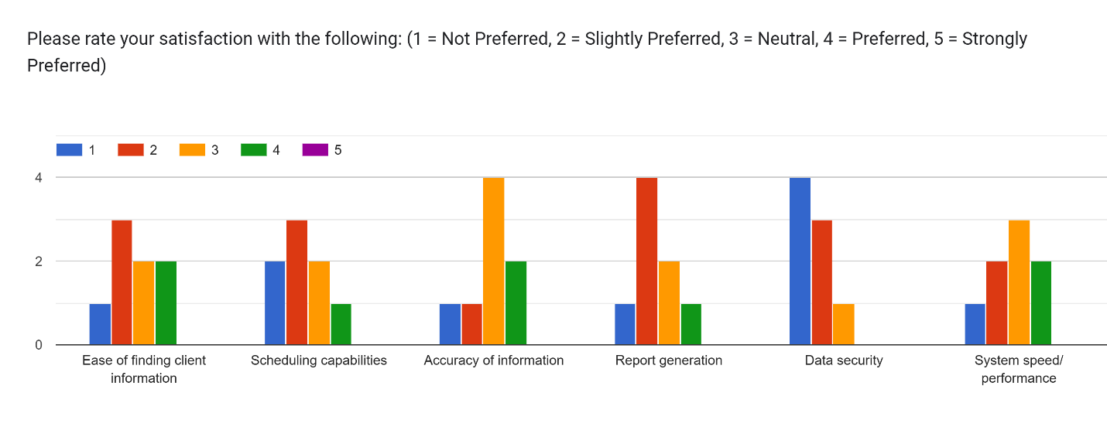
Figure 1: Satisfaction ratings with current system (1=Very Dissatisfied, 5=Very Satisfied)
- Time Spent on Administrative Tasks: 67% of respondents reported spending 1-2 hours daily on administrative tasks using the current system
- System Satisfaction: The lowest satisfaction ratings were for "Report Generation" (1.5/5) and "Data Security" (1.8/5)
- Common Issues: 72% of respondents reported experiencing scheduling conflicts "Often" or "Very Often"

Feature Priorities for New System
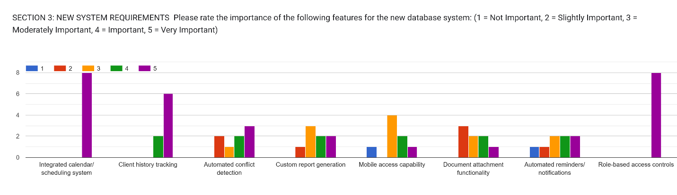
Figure 2: Importance ratings for new system features (1=Not Important, 5=Very Important)
- Highest Priority Features: "Integrated Calendar/Scheduling System" (4.8/5), "Client History Tracking" (4.7/5), and "Role-based Access Controls" (4.6/5)
- Essential Client Information: Most respondents identified Basic Contact Information, Session History, and Session Notes as essential data fields
- Preferred Scheduling Capabilities: Visual Calendar Interface (87.5%), Recurring Appointment Scheduling (75%), and Automated Conflict Detection (87.5%)
User Interface Preferences
- Device Preferences: Desktop Computer (100%), Laptop (75%), Tablet (50%), Smartphone (37.5%)
- Navigation Preferences: Tab-based navigation (50%) and Dashboard-based navigation (37.5%)
- UI Element Preferences: Visual calendar display (4.6/5) and Dashboard with summary information (4.4/5)
Implementation Concerns
- Primary Concerns: Data migration accuracy (75%), Learning curve (62.5%), System reliability (62.5%)
- Training Preferences: In-person group training (62.5%), Written documentation (75%), Video tutorials (50%)
- Training Time Willingness: 2-4 hours (50%), 4-8 hours (37.5%)

Management Interview Findings
The in-depth interview with management revealed several critical insights:
- Reporting Challenges: "For most reports, I need to request them from our administrative staff, who then spend hours compiling data from various Excel spreadsheets. By then, the scheduling decisions I needed to make were already delayed."
- Decision-Making Impact: "Without timely access to accurate data, we can't identify trends, optimize resource allocation, or respond quickly to changes in demand."
- Security Concerns: "Our current Excel system relies on password protection, which isn't particularly robust. I worry about unauthorized access, especially with sensitive client information."
- Implementation Priorities: "I understand the implementation will take some time, but I'd like to minimize disruption to our services. A phased approach makes sense, starting with the core client management functionality."
Document Analysis Findings
Analysis of the current Excel spreadsheets revealed structural issues:
- Data Fragmentation: Related information was stored across multiple files without proper linking
- Inconsistent Formats: Date formats, naming conventions, and data organization varied across files
- Limited Data Validation: No systematic constraints to ensure data quality
- Duplicate Records: Approximately 12% of client records had some form of duplication
- Security Limitations: Basic password protection with no granular access controls or audit capabilities

Root Cause Analysis
To identify the underlying causes of the information management challenges at Josal Consulting, a fishbone (Ishikawa) diagram analysis was conducted. This analysis categorized root causes into four main categories:
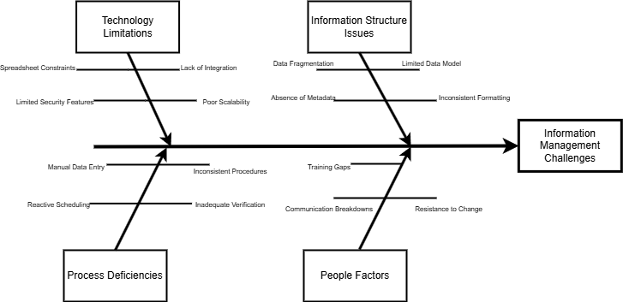
Figure 3: Fishbone diagram showing root causes of information management challenges
Technology Limitations
- Spreadsheet Constraints: Excel is inherently limited in handling relational data and complex scheduling
- Lack of Integration: Disconnected tools for different functions (client information, scheduling, vacation tracking)
- Limited Security Features: Inadequate access controls and audit capabilities in spreadsheet applications
- Poor Scalability: Spreadsheets become unwieldy and error prone as data volume increases
Process Deficiencies
- Manual Data Entry: Redundant data entry across multiple systems
- Inconsistent Procedures: Varying approaches to information recording between staff members
- Reactive Scheduling: Scheduling performed without visibility of conflicts or constraints
- Inadequate Verification: No systematic process for data validation and quality control
Information Structure Issues
- Data Fragmentation: Related information stored in separate locations without proper linkage
- Limited Data Model: Inadequate data structure to capture comprehensive client and counsellor information
- Absence of Metadata: Limited ability to categorize and classify information for analysis
- Inconsistent Formatting: Varying data formats making analysis and comparison difficult
People Factors
- Training Gaps: Limited technical training on information management best practices
- Resistance to Change: Comfort with familiar but inefficient processes
A Pareto analysis of these root causes identified that technology limitations represent the highest impact area, accounting for approximately 37% of the total impact score. This validates the approach of implementing a dedicated web application as the primary intervention.

Figure 4: Pareto chart showing impact distribution of root causes

Gap Analysis: Current State vs. Future State
Current Limitation/Gap | Root Cause(s) | Desired Capability/Feature | Project Deliverables to Fill Gaps
1. Client information stored in separate Excel spreadsheets | Lack of integrated data management system; No relational database architecture | Centralized client database with comprehensive profiles | Implement relational database with comprehensive client tables; Create data migration tools; Develop client profile UI
2. Scheduling conflicts between counsellors | Manual scheduling process; No visibility across counsellor schedules | Automated scheduling with conflict detection | Interactive calendar system with conflict detection algorithms; Appointment validation rules; Schedule notification system
3. Inability to track counsellor availability | No integrated time-off tracking; Manual schedule management | Integrated availability management | Counsellor availability tracking module; Time-off request workflow; Integration with scheduling system
4. Difficulty retrieving historical client information | Unstructured data storage; Poor search capabilities | Rapid client history retrieval | Comprehensive search functionality; Client history dashboard; Indexed client records
5. Limited reporting capabilities | No reporting infrastructure: Data scattered across files | Comprehensive analytical reporting | Standard reports library; Custom report builder; Management dashboards; Export capabilities
6. Lack of data security | No access controls in Excel; No encryption | Role-based access controls with audit trails | User authentication system; Role-based permissions; Activity logging; Data encryption
7. Inefficient client intake process | Manual data entry; Duplicate entry across systems | Streamlined client onboarding | Digital intake forms; Workflow automation; Data validation rules
8. No mobile access to client information | Desktop-only Excel files; No web interface | Mobile-responsive access to system | Responsive web application; Mobile-optimized interfaces
9. Manual data backup procedures | No automated backup system; Reliance on manual copies | Automated backup and recovery | Scheduled backup system; Incremental backup capabilities; Recovery testing procedures
10. Limited documentation of client interactions | No standardized session notes; No attachment capabilities | Structured interaction documentation | Session notes templates; Document attachment system; Treatment plan tracking
11. Inadequate billing integration | Manual billing procedures; No integration with client records | Integrated billing system | Billing module; Payment tracking; Service code integration
12. No client communication system | Manual phone calls; No automated reminders | Automated client communications | Appointment reminder system; Secure messaging; Email integration
13. Lack of performance metrics | No system to track counsellor productivity; No service metrics | Comprehensive performance analytics | Counsellor performance dashboards; Service utilization reports; Client outcome tracking
14. Poor data quality control | No validation rules; Inconsistent data entry | Data validation and quality assurance | Data entry validation rules; Data cleansing tools; Quality monitoring reports
15. No integration with external systems | Isolated Excel environment; No API capabilities | API integration with related systems | API development; Integration with email systems; Calendar system integration
16. Limited scalability | File-based system with performance degradation | Scalable architecture for growth | Cloud-based deployment; Performance optimization; Scalable database architecture

Requirements Specification
Based on the analysis of stakeholder needs and current system limitations, the following requirements have been identified for the web application:
Functional Requirements
1. Client Information Management
Requirement | Requirement Description | Priority
1 | The system shall provide a centralized client database with comprehensive profile information | High
2 | The system shall support client search by name, ID, organization, counsellor, or service type | High
3 | The system shall maintain historical session records for each client | High
4 | The system shall associate clients with their employer organizations for EAP billing purposes | High
5 | The system shall provide document attachment capabilities for client-related files | Medium
6 | The system shall maintain audit trails of all client record access and modifications | High
7 | The system shall enable tagging clients with relevant categories for reporting and analysis | Medium
8 | The system shall support automated client reminders for scheduled appointments | Medium

2. Counsellor Scheduling
Requirement | Requirement Description | Priority
9 | The system shall provide a visual calendar interface for appointment management | High
10 | The system shall prevent double-booking of counsellors | High
11 | The system shall enable counsellors to update their availability remotely | High
12 | The system shall support vacation and time-off tracking integrated with the scheduling system | High
13 | The system shall provide automated notifications of schedule changes | Medium
14 | The system shall enable filtering and viewing appointments by counsellor, date, or service type | Medium
15 | The system shall support recurring appointment scheduling | Medium
16 | The system shall maintain a waiting list for preferred time slots | Low

3. Reporting and Analytics
Requirement | Requirement Description | Priority
17 | The system shall provide standard reports for client demographics, service utilization, and counsellor workload | High
18 | The system shall enable customizable ad-hoc reporting based on available data fields | Medium
19 | The system shall generate visual dashboards of key performance indicators | Medium
20 | The system shall support data export in common formats (Excel, CSV) | High
32 | The system shall support automated report distribution via email | Low

Requirement | Requirement Description | Priority
33 | The system shall implement role-based access controls for data protection | High
34 | The system shall maintain comprehensive audit logs of all system activities | High
35 | The system shall provide backup and restoration capabilities | High
36 | The system shall support at least 20 concurrent users without performance degradation | Medium
37 | The system shall implement password policies and authentication controls | High
38 | The system shall encrypt sensitive client information | High
39 | The system shall provide administrative tools for user management | Medium
Non-Functional Requirements
Requirement | Requirement Description | Priority
1 | The system shall provide an intuitive user interface requiring minimal training | High
2 | The system shall provide contextual help for key functions | Medium
3 | The system shall maintain consistent navigation and design patterns throughout | Medium
4 | The system shall be accessible on standard web browsers without plugins | High
5 | The system shall provide responsive design for different screen sizes | Medium

Requirement | Requirement Description | Priority
6 | The system shall respond to user interactions within 2 seconds under normal load | High
7 | The system shall support a database of at least 10,000 client records without performance degradation | Medium
8 | The system shall accommodate at least 5 years of historical data | Medium
9 | The system shall support batch processing for reports without affecting user operations | Medium
10 | The system shall handle at least 500 appointments per month | High

Requirement | Requirement Description | Priority
11 | The system shall be available during business hours (8am-6pm, Monday-Friday) with 99.5% uptime | High
12 | The system shall provide data backup capabilities that can be scheduled automatically | High
13 | The system shall implement data validation to prevent erroneous entries | High
14 | The system shall maintain data integrity during concurrent access | High
15 | The system shall recover from failures without data loss | High

Requirement | Requirement Description | Priority
16 | The system shall use standard web technologies that can be supported by IT service providers | High
17 | The system shall have comprehensive documentation for administration and operation | High
18 | The system shall be configurable without programming | Medium
19 | The system shall support data migration tools for import and export | High
20 | The system shall support extensibility for future enhancements | Medium

Data Analysis
The survey data from stakeholders was analysed to identify patterns and priorities that inform system design. Key analyses include:
Feature Priority Analysis

Figure 5: Feature priority ratings from stakeholder survey
This analysis shows that scheduling functionality, client history tracking, and security features are the highest priorities for stakeholders. These findings directly inform the prioritization of development tasks in the implementation plan.
User Interface Preference Analysis
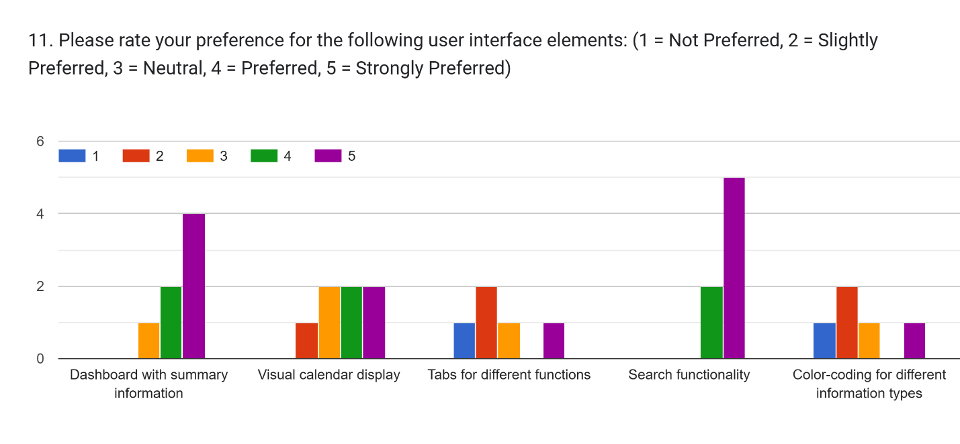
Figure 6: User interface preference ratings
The preference for visual calendars and dashboard views with summary information informs the design approach for the web application, emphasizing these elements in the primary user interface.
Device Usage Analysis
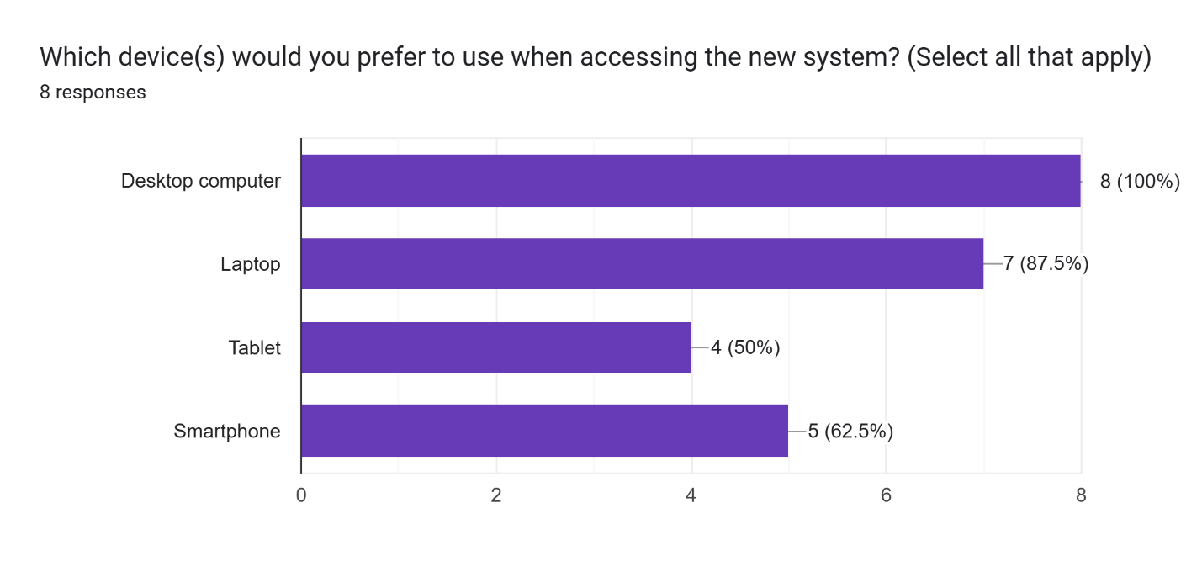
Figure 7: Preferred device usage for system access
While desktop computers are the primary access device, significant percentages of users would also access the system via laptops and tablets. This finding supports the requirement for responsive design that adapts to different screen sizes.

Training Needs Analysis
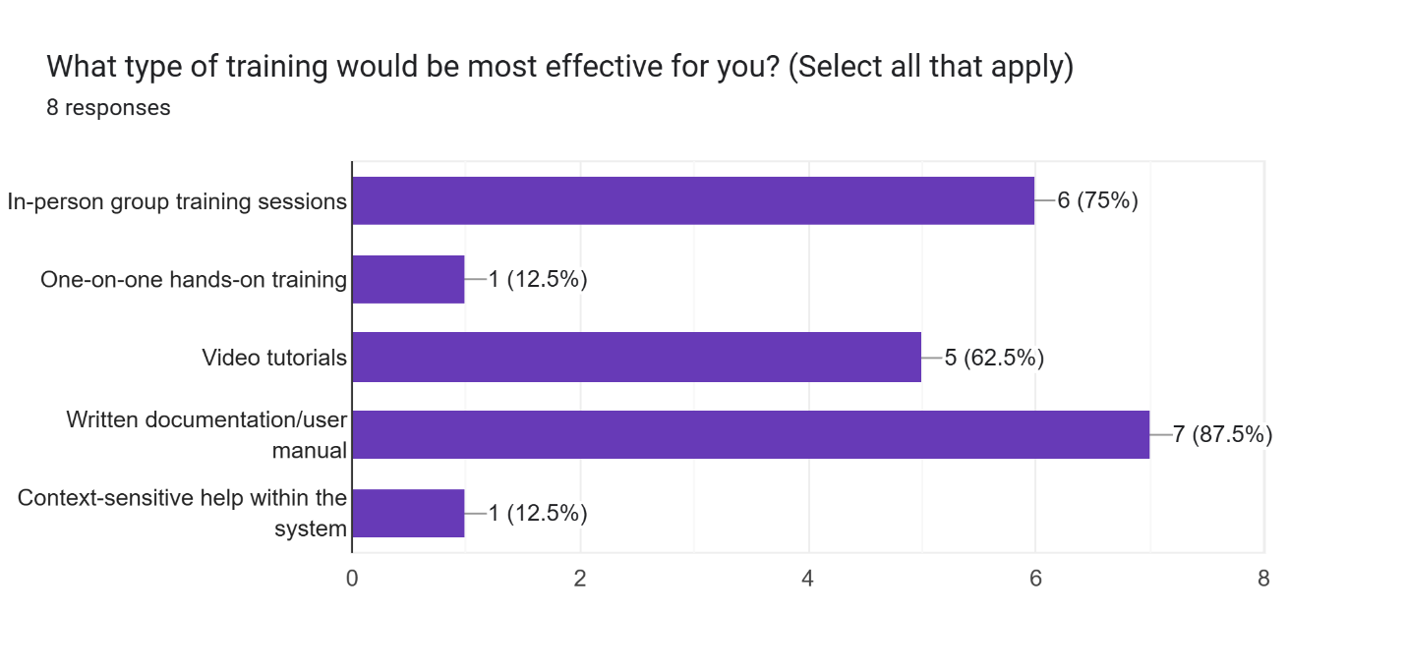
Figure 8: Training preference distribution
The analysis of training preferences indicates a mix of in-person training and documentation is preferred, with most users willing to invest 0-2hours in training. This informs the training approach in the implementation plan.

Design Specification & Intervention
Based on the requirements analysis, a relational database schema has been designed to support Josal Consulting's information management needs. The schema follows normalization principles to ensure data integrity while supporting efficient retrieval and reporting.
Entity Relationship Diagram
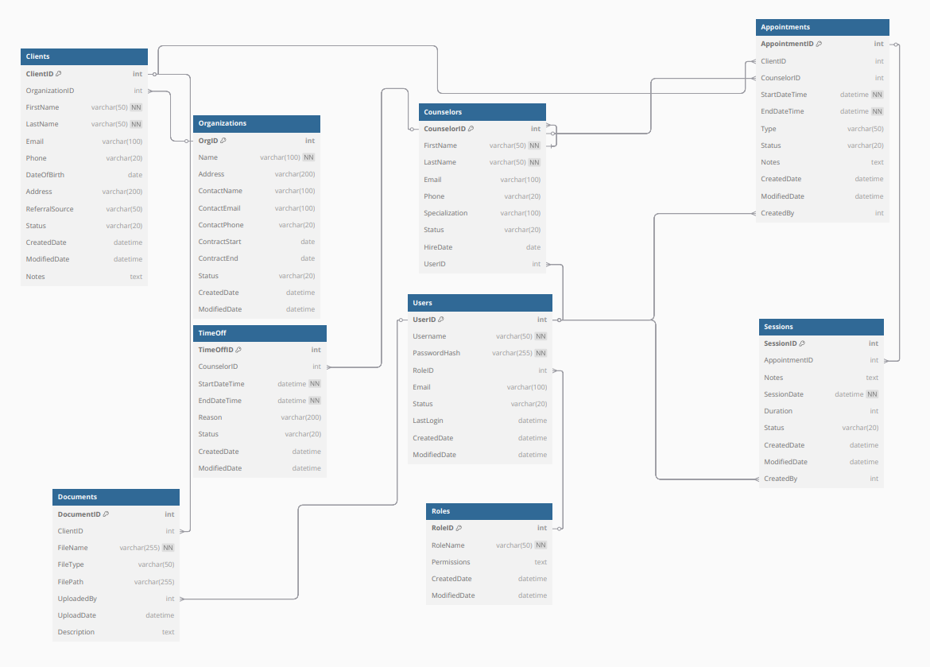
Figure 9: Entity Relationship Diagram for the web application database

Core Entities and Relationships
- Clients
  - Primary entity storing comprehensive client information
  - Attributes include contact details, demographics, referral source, and status
  - Linked to Organizations for EAP client management
  - One-to-many relationship with Appointments
- Counsellors
  - Stores information about the organization's counsellors
  - Attributes include credentials, specializations, contact information
  - Linked to TimeOff records for availability management
  - One-to-many relationship with Appointments
- Appointments
  - Junction entity connecting Clients and Counsellors
  - Attributes include date, time, duration, status, and session type
  - Foreign keys to Client and Counsellor tables
  - Supports scheduling and reporting functions
- Organizations
  - Stores information about client employers for EAP services
  - Attributes include contact information, contract details, billing information
  - One-to-many relationship with Clients
- TimeOff
  - Tracks counsellor unavailability for scheduling purposes
  - Attributes include start date/time, end date/time, and reason
  - Foreign key to Counsellor table
  - Supports conflict-free scheduling
- Users
  - Stores system user information including administrative staff and counsellors
  - Attributes include username, password hash, role, and status
  - Supports security and access control
- Roles
  - Defines access control roles for the system
  - Attributes include role name and permission sets
  - Supports role-based security model

Data Dictionary
A partial data dictionary for the core entities is provided below:
Client Table
Field Name | Data Type | Description | Constraints
ClientID | Integer | Unique identifier | Primary Key, Auto-increment
OrganizationID | Integer | Employer organization | Foreign Key, References Organizations
FirstName | Varchar(50) | Client's first name | Not Null
LastName | Varchar(50) | Client's last name | Not Null
Email | Varchar(100) | Contact email address | Unique
Phone | Varchar(20) | Contact phone number
DateOfBirth | Date | Client's birth date
Address | Varchar(200) | Physical address
ReferralSource | Varchar(50) | How client was referred
Status | Varchar(20) | Active, Inactive, etc. | Default 'Active'
CreatedDate | DateTime | Record creation date | Default CURRENT_TIMESTAMP
ModifiedDate | DateTime | Last modification date
Notes | Text | General notes

User Interface Design
The user interface design focuses on creating intuitive, efficient workflows for the primary user groups: administrative staff and counsellors. The design follows principles of human-centred design, emphasizing ease of use, clarity, and efficiency.
Key Interface Components
- Dashboard
  - Personalized landing page based on user role
  - Quick access to common functions
  - Summary metrics and notifications
  - Upcoming appointments and tasks
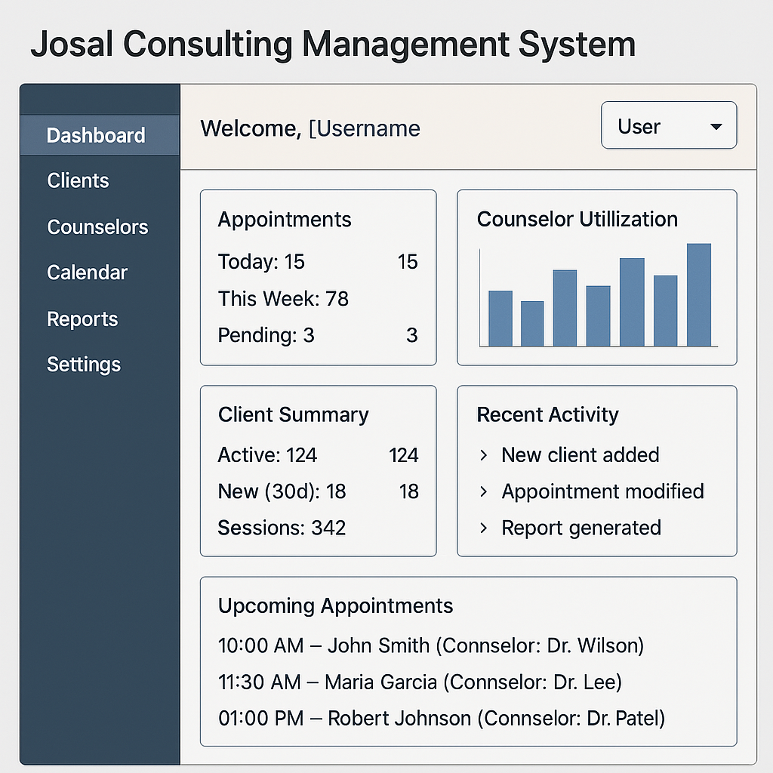
Figure 10: Dashboard interface mock-up
- Client Management
  - Comprehensive client profile view
  - Search and filtering capabilities
  - Session history and upcoming appointments
  - Document attachment functionality
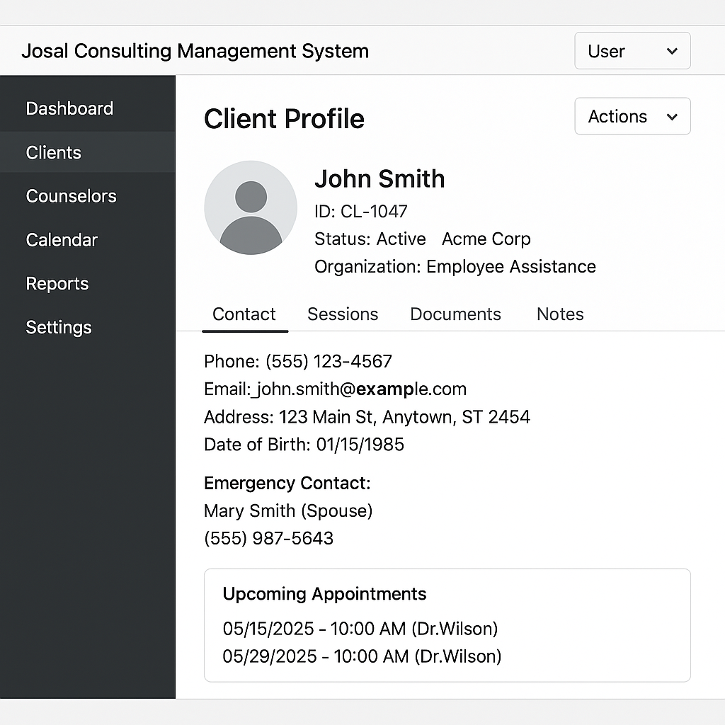
Figure 11: Client profile interface mock-up

- Scheduling Calendar
  - Interactive calendar with day, week, and month views
  - Color-coded appointments by type or counsellor
  - Drag-and-drop scheduling capability
  - Visual indicators for conflicts or availability
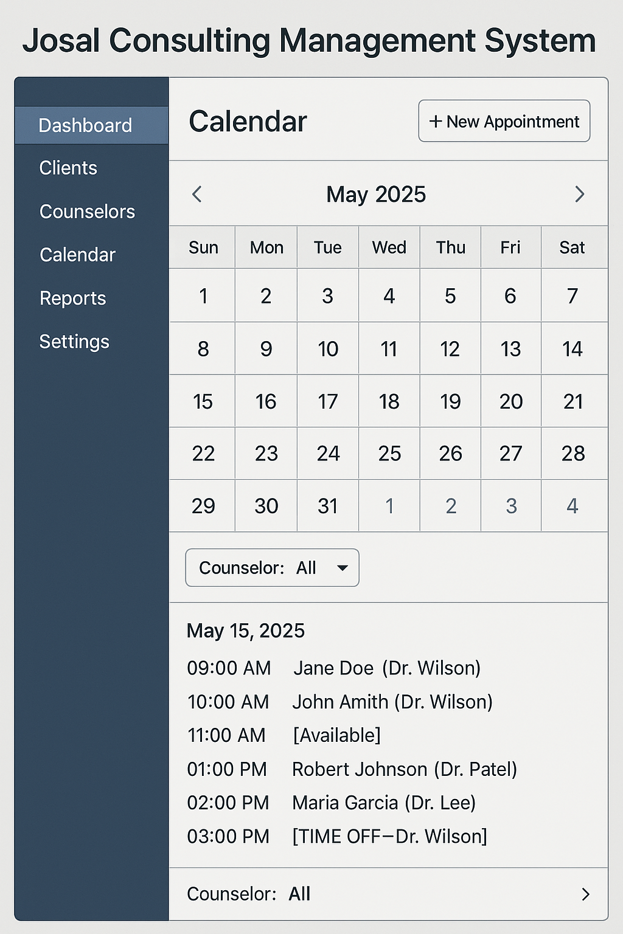
Figure 12: Calendar interface mock-up
- Reporting Interface
  - Standard report selection
  - Parameter configuration
  - Export options
  - Visualization capabilities
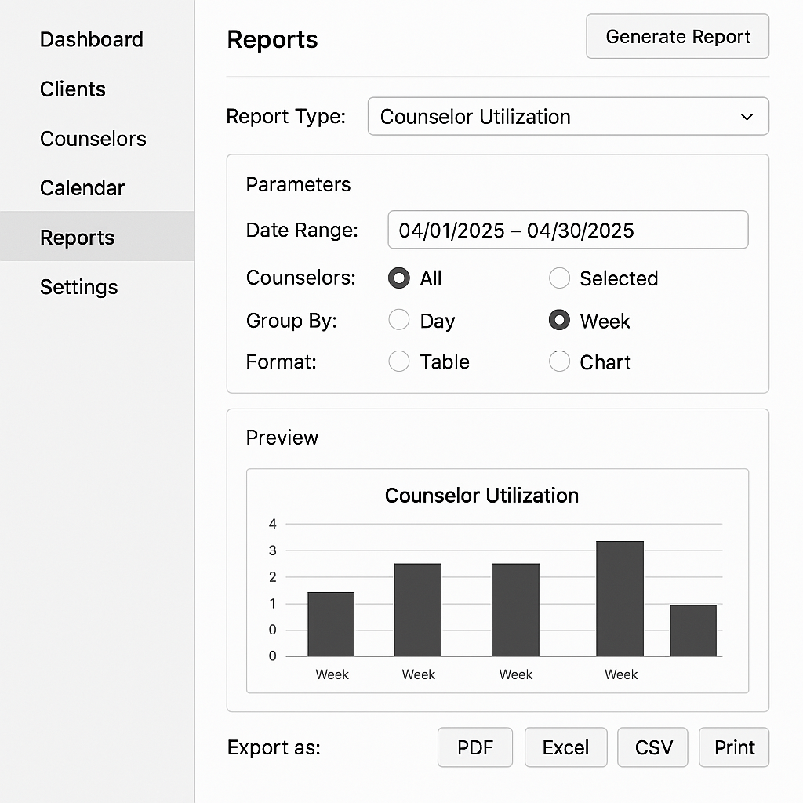
Figure 13: Reporting interface mock-up

Design Principles
The user interface design incorporates the following principles to ensure usability and acceptance:
- Consistency - Common navigation elements, colour scheme, and interaction patterns throughout the system
- Progressive Disclosure - Essential information presented first, with details available on demand
- Error Prevention - Validation controls, confirmation dialogs, and clear feedback to prevent errors
- Efficiency - Keyboard shortcuts, batch operations, and quick access features for frequent tasks
- Accessibility - Proper contrast, keyboard navigation, and screen reader compatibility
- Responsive Design - Adaptable layout for different screen sizes and devices

Technical Architecture
The proposed system will be implemented using a three-tier architecture separating the database, application logic, and presentation layers. This architecture provides scalability, maintainability, and security advantages.
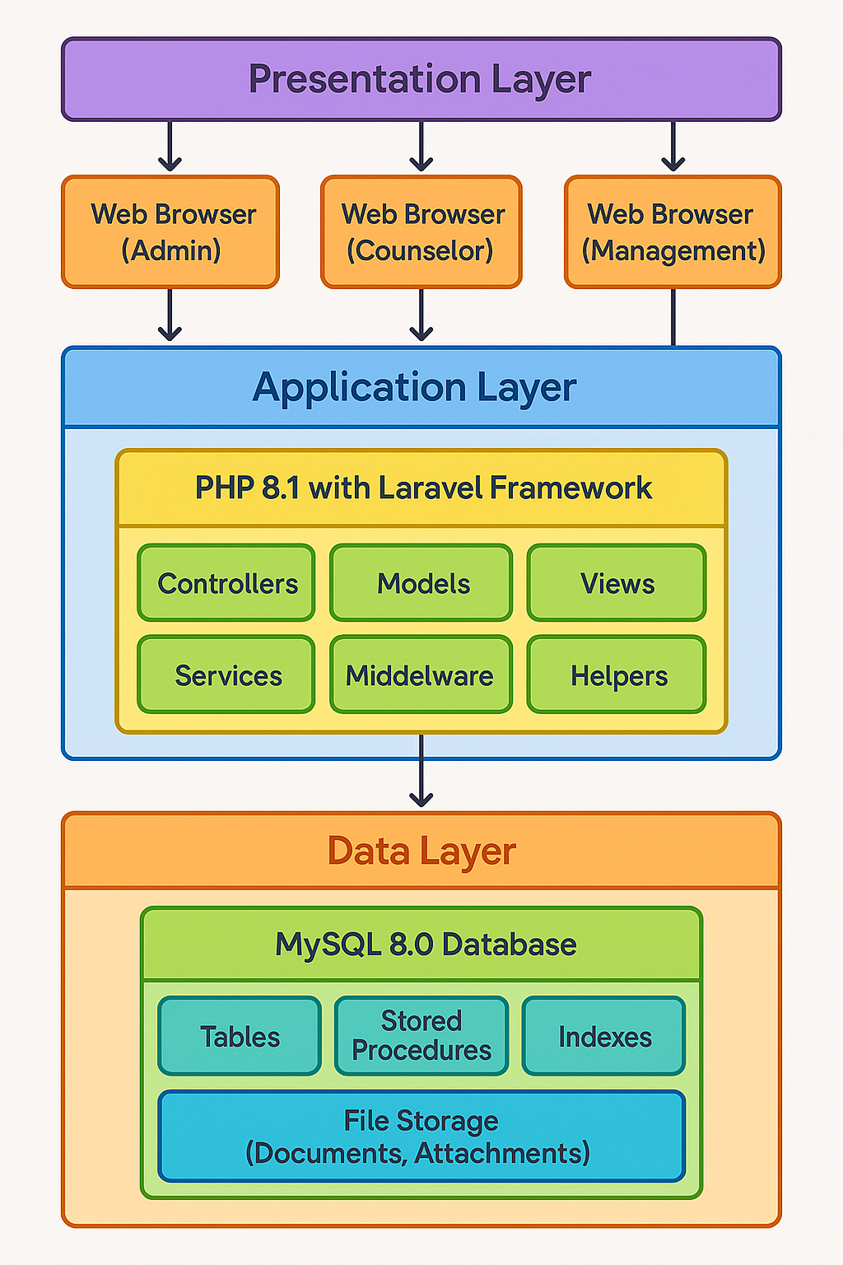
Fig 14 Three-Tier Architecture Diagram

Recommended Technologies
Based on Josal Consulting's requirements and resource constraints, the following technology stack is recommended:
- Database
  - MySQL 8.0 - Open-source relational database management system
  - Provides robust data management capabilities with lower licensing costs
  - Widely supported by hosting providers and IT service companies
  - Compatible with various reporting and business intelligence tools
- Application Layer
  - PHP 8.1 with Laravel Framework - Modern web application framework
  - Provides built-in security features, ORM capabilities, and MVC architecture
  - Extensive ecosystem of packages for common functionality
  - Lower development and maintenance costs compared to enterprise options
- Presentation Layer
  - Bootstrap 5 - Responsive design framework
  - jQuery - Enhanced JavaScript functionality
  - FullCalendar - Interactive scheduling component
  - Chart.js - Visualization library for reporting
This technology stack balances functionality, cost, and maintainability concerns while providing all required capabilities for the web application.

Security Implementation
Security is a critical concern for a system handling sensitive counselling information. The following security measures will be implemented:
- Authentication
  - Secure password hashing using bcrypt algorithm
  - Multi-factor authentication for administrative access
  - Password policy enforcement (complexity, expiration)
  - Account lockout after failed attempts
- Authorization
  - Role-based access control
  - Principle of least privilege applied to all functions
  - Granular permission settings for data access
  - Session timeout for inactive users
- Data Protection
  - Encryption of sensitive data at rest
  - TLS/SSL for all data in transit
  - Secure backup and recovery procedures
  - Data minimization principles applied
- Auditing and Monitoring
  - Comprehensive logging of system access and activities
  - Regular log review procedures
  - Automated alerts for suspicious activities
  - Compliance reporting capabilities

Training Approach
Based on the stakeholder survey results, the following training approach will be implemented:
- Duration: Each user will receive 0-2 hours of training, tailored to their role and responsibilities
- Training Formats:
  - In-person group training sessions (preferred by 62.5% of survey respondents)
  - Comprehensive written documentation (preferred by 75% of survey respondents)
  - Supplemental video tutorials for self-paced learning
- Training Schedule:
  - Administrative Staff: 4 hours
  - Counsellors: 3 hours
  - Management: 2 hours
  - IT Support: 4 hours
- Training Materials:
  - Role-specific user manuals
  - Quick reference guides for common tasks
  - Troubleshooting guides
  - FAQ document based on common questions

Data Migration Strategy
A systematic data migration approach is essential to ensure the successful transition from the current Excel-based system to the new web application. The following strategy will be implemented to minimize risks and ensure data integrity:
- Data Mapping and Analysis
  - Inventory Existing Data: Conduct a comprehensive inventory of all Excel spreadsheets containing client, counsellor, and appointment information
  - Field Mapping: Create detailed mapping documents that correlate each Excel field to its corresponding database field
  - Identify Relationships: Document implicit relationships between data in separate files that will be formalized in the database structure
  - Gap Analysis: Identify missing data elements required by the new system but not present in current files
- Data Cleansing and Standardization
  - De-duplication: Identify and resolve duplicate client and appointment records
  - Standardization: Normalize inconsistent data formats (dates, phone numbers, names)
  - Default Values: Establish appropriate default values for required fields that may be missing in current data
  - Data Enrichment: Augment existing records with additional required information through administrative review
- Migration Execution Process
  - Test Migration: Perform trial migrations with sample data to validate mapping and transformation rules
  - Validation Rules: Implement automated validation rules to identify data integrity issues during migration
  - Staged Approach: Migrate data in logical stages:
    - Stage 1: Static reference data (service types, status codes)
    - Stage 2: Entity master data (clients, counsellors, organizations)
    - Stage 3: Historical transaction data (past appointments, session notes)
    - Stage 4: Active upcoming appointments
  - Verification Process: Perform automated and manual verification after each stage
- Transition Management
  - Parallel Operation: Maintain both systems during a defined transition period
  - Cut-over Planning: Schedule the final transition during a period of lower activity (weekend)
  - Reconciliation Process: Implement procedures to reconcile transactions during the parallel operation period
  - Rollback Capability: Maintain the ability to revert to the Excel-based system if critical issues arise
- Post-Migration Validation
  - Data Integrity Reports: Generate comprehensive reports to verify completeness and accuracy
  - User Verification: Engage end-users in validating migrated data for their areas of responsibility
  - Issue Tracking: Implement a structured process for reporting and resolving data migration issues
  - Documentation: Document all data transformation rules and exceptions for future reference

Post-Implementation Support
To address concerns identified in the stakeholder survey, a comprehensive support structure will be established following system implementation:
- Technical Support Hotline
  - Dedicated phone line for system-related issues
  - Available during business hours (8am-6pm, Monday-Friday)
  - Maximum response time of 6 hours for critical issues
- Documentation Resources
  - Comprehensive FAQ document
  - Searchable knowledge base
  - Troubleshooting guides for common issues
  - Video tutorials for refresher training
- Super User Program
  - Identify and train power users within each department
  - Provide advanced training to super users
  - Establish super users as first point of contact for basic questions
  - Regular meetings with super users to identify improvement opportunities
- Continuous Improvement Process
  - Monthly system review during the first quarter
  - Quarterly review thereafter
  - Structured process for suggesting and implementing enhancements
  - Regular user surveys to assess satisfaction and identify needs

Evaluation Framework
To assess the success of the implementation, the following evaluation metrics will be tracked:

Performance Metrics and Benchmarks
Metric | Target | Measurement Method | Baseline (Current System)
Response Time - Data Retrieval | < 2 seconds | Automated timing of standard queries | 30-60 seconds
Response Time - Data Entry | < 1 second | Automated timing of form submissions | 5-10 seconds
Report Generation - Standard | < 5 seconds | Automated timing of report generation | 5-10 minutes
Report Generation - Complex | < 30 seconds | Automated timing of complex reports | 30+ minutes
Maximum Concurrent Users | 20 users | Load testing with simulated users | 3-5 users
System Availability | 99.5% during business hours | Uptime monitoring | Not measured
Backup Completion Time | < 30 minutes | Automated timing of backup process | 1-2 hours (manual)

Operational Efficiency Metrics
Metric | Target | Measurement Method | Baseline (Current System)
Client Information Retrieval Time | < 30 seconds | Timed user tasks | 3-5 minutes
Appointment Scheduling Time | < 1 minute | Timed user tasks | 2-3 minutes
Scheduling Conflicts | 0 occurrences | System logs, user reports | 2 per week
Administrative Time on Data Management | < 30 minutes/day | Staff time tracking | 1-2 hours/day
Time to Generate Management Reports | < 5 minutes | Timed user tasks | 1-2 hours
Client Data Duplication Rate | < 1% | Data quality analysis | 12%
Counsellor Utilization Accuracy | > 95% | Comparison to manual tracking | Not measured

User Experience Metrics
Metric | Target | Measurement Method | Baseline (Current System)
System Usability Scale (SUS) Score | > 80/100 | User surveys
Training Time to Proficiency | < 4 hours | Training completion tracking
User Error Rate | < 2% | Error tracking in user tasks
User Satisfaction Rating | > 4/5 | Post-implementation survey | 2/5 (estimated)
Support Ticket Volume | < 5 per week | Support ticket tracking
Feature Utilization Rate | > 80% of features | Usage analytics

Business Impact Metrics
Metric | Target | Measurement Method | Baseline (Current System)
Counsellor Utilization Rate | Increase by 15% | Schedule analysis | Current baseline
Appointment Cancellation Rate | Reduce by 10% | System reporting | Current baseline
Client No-show Rate | Reduce by 15% | System reporting | Current baseline
Staff Overtime Hours | Reduce by 25% | Time tracking system | Current baseline
Client Satisfaction | Improve by 10% | Client surveys | Current baseline
Data-driven Decisions | 80% of key decisions | Management self-reporting | 20% (estimated)

Measurement and Reporting
- Baseline Measurement: Prior to implementation, baseline measurements will be taken for all metrics where current data exists
- Implementation Benchmarking: Core metrics will be assessed immediately after implementation
- Ongoing Monitoring: Key performance indicators will be tracked continuously through system logs and reports
- Periodic Assessment: Comprehensive evaluation will be conducted at 1-, 3-, and 6-months post-implementation
- Performance Dashboard: A management dashboard will provide real-time visibility into key metrics
- Improvement Planning: Metrics falling below targets will trigger review and improvement planning

Budget Allocation
The implementation budget of $8,000 will be allocated as follows:
Category | Allocation | Details
Software Licenses | $1,500 | Database software, development tools, third-party components
Development | $3,500 | Custom programming, configuration, testing
Data Migration | $800 | Data extraction, transformation, loading, and validation
Training | $1,200 | Materials development, training sessions, support documentation
Contingency | $1,000 | Reserved for unforeseen requirements or issues
Total | $8,000
This budget allocation ensures sufficient resources for all critical aspects of the implementation while maintaining the overall cost within Josal Consulting's constraints.

Conclusion
The research and analysis conducted for this project provide a comprehensive foundation for implementing an integrated database and calendar management web application at Josal Consulting. The proposed solution addresses the identified challenges with the current Excel-based approach and offers significant opportunities for operational improvement, enhanced data security, and improved service delivery.

Key Findings
- The current Excel-based system presents significant limitations that impact operational efficiency, data security, and organizational effectiveness.
- Technology limitations represent the most significant root cause of current inefficiencies, followed by process deficiencies and information structure issues.
- An integrated web application combining database management and calendar functionality offers the most effective solution for Josal Consulting's needs, balancing functionality, cost, and maintainability.
- User acceptance is critical for successful implementation, requiring intuitive interface design, comprehensive training, and stakeholder engagement throughout the process.
- A phased implementation approach minimizes disruption and allows for adjustment based on user feedback and operational needs.

Final Recommendations
- Proceed with Implementation: The benefits of the proposed web application clearly outweigh the costs and implementation challenges. Josal Consulting should proceed with the implementation following the phased approach outlined in this report.
- Prioritize User Engagement: Continue to involve administrative staff and counsellors in the design and testing process to ensure the system meets their practical needs and workflows.
- Invest in Training: Allocate sufficient time and resources for comprehensive training to ensure smooth adoption and maximize the benefits of the new system.
- Establish Data Governance: Develop clear data management policies and procedures to maintain data quality and security in the new system.
- Plan for Continuous Improvement: Establish a framework for ongoing system evaluation and enhancement to address emerging needs and leverage new technologies.
By implementing these recommendations, Josal Consulting can transform its information management approach, enhancing operational efficiency, improving data security, and ultimately delivering more effective counselling services to its clients.

Bibliography
Alami, H., Lehoux, P., Auclair, Y., De Guise, M., Gagnon, M., Shaw, J., et al. (2020). Artificial Intelligence and Health Technology Assessment: Anticipating a New Level of Complexity. Journal of Medical Internet Research, 22(7), e17707.
Danish National Board of Health. (2005). Introduction to Mini-HTA – a management and decision support tool for the hospital service. Copenhagen: The National Board of Health, Danish Centre for Evaluation and Health Technology Assessment.
ENISA. (2020). Procurement Guidelines for Cybersecurity in Hospitals. The European Union Agency for Cybersecurity.
European mHealth Hub. (2020). D2.1 Knowledge Tool 1. Health Apps Assessment Frameworks.
European Network for Health Technology Assessment. (2018). Assessment FAQ. What is health technology assessment (HTA)?
Federal Institute for Drugs and Medical Devices. (2021). The Fast-Track Process for Digital Health Applications (DiGA) according to Section 139e SGB V. A Guide for Manufacturers, Service Providers and Users.
Haverinen, J., Keränen, N., Falkenbach, P., Maijala, A., Kolehmainen, T., & Reponen, J. (2019). Digi-HTA: Health technology assessment framework for digital healthcare services. Finnish Journal of eHealth and eWelfare, 11(4), 326-341.
Jääskelä, J., Haverinen, J., Kaksonen, R., Reponen, J., Halunen, K., Tokola, T., & Röning, J. (2022). Digi-HTA, assessment framework for digital healthcare services: information security and data protection in health technology – initial experiences. Finnish Journal of eHealth and eWelfare, 14(1), 19-30.
NHSX. (2021). Digital Technology Assessment Criteria (DTAC).
OWASP. (2020). OWASP Application Security Verification Standard.
Räsänen, P., Hytönen, M., Pakarinen, S., & Blom, M. (2021). Menetelmäarvioinnista tukea päätöksentekoon. Lääkärilehti, 45(76), 2660-2662.
Sihvo, S., Ikonen, T., & Mäkelä, M. (2017). Implementing health technology assessment-based recommendations in Finland: Managed uptake of medical methods. International Journal of Technology Assessment in Health Care, 33(4), 430-433.
Vis, C., Bührmann, L., Riper, H., & Ossebaard, H. (2020). Health technology assessment frameworks for eHealth: A systematic review. International Journal of Technology Assessment in Health Care, 36(3), 204-216.
World Health Organization. (n.d.). Health technology assessment. WHO Regional Office for Europe.
Josal Consulting Limited. Josal Consulting. www.josalconsulting.com/.

Appendices
Appendix A: Requirements Survey Instrument
JOSAL CONSULTING DATABASE & CALENDAR MANAGEMENT SYSTEM PROJECT REQUIREMENTS SURVEY
Introduction: This survey aims to gather specific requirements for the new database and calendar management web application for Josal Consulting. Your responses will help ensure the system meets user needs and improves operational efficiency. The survey should take approximately 15-20 minutes to complete.
SECTION 1: DEMOGRAPHIC INFORMATION
- What is your primary role at Josal Consulting?
  - Administrative Staff
  - Counsellor
  - Management
  - IT Support
  - Other (please specify): _______________
- How long have you been working at Josal Consulting?
  - Less than 1 year
  - 1-3 years
  - 4-6 years
  - More than 6 years
- How frequently do you use the current information management system?
  - Multiple times daily
  - Daily
  - Several times per week
  - Weekly or less frequently
SECTION 2: CURRENT SYSTEM EVALUATION
- Please rate your satisfaction with the following aspects of the current system: (1 = Very Dissatisfied, 2 = Dissatisfied, 3 = Neutral, 4 = Satisfied, 5 = Very Satisfied)
Aspect | 1 | 2 | 3 | 4 | 5
Ease of finding client information | ○ | ○ | ○ | ○ | ○
Scheduling capabilities | ○ | ○ | ○ | ○ | ○
Accuracy of information | ○ | ○ | ○ | ○ | ○
Report generation | ○ | ○ | ○ | ○ | ○
Data security | ○ | ○ | ○ | ○ | ○
System speed/performance | ○ | ○ | ○ | ○ | ○
- On average, how much time do you spend per day on administrative tasks using the current system?
  - Less than 30 minutes
  - 30 minutes to 1 hour
  - 1-2 hours
  - More than 2 hours
- How often do you encounter the following issues with the current system? (1 = Never, 2 = Rarely, 3 = Sometimes, 4 = Often, 5 = Very Often)
Issue | 1 | 2 | 3 | 4 | 5
Scheduling conflicts | ○ | ○ | ○ | ○ | ○
Difficulty finding client information | ○ | ○ | ○ | ○ | ○
System errors or crashes | ○ | ○ | ○ | ○ | ○
Duplicate or inconsistent data | ○ | ○ | ○ | ○ | ○
Inability to generate needed reports | ○ | ○ | ○ | ○ | ○
SECTION 3: NEW SYSTEM REQUIREMENTS
- Please rate the importance of the following features for the new web application: (1 = Not Important, 2 = Slightly Important, 3 = Moderately Important, 4 = Important, 5 = Very Important)
Feature | 1 | 2 | 3 | 4 | 5
Integrated calendar/scheduling system | ○ | ○ | ○ | ○ | ○
Client history tracking | ○ | ○ | ○ | ○ | ○
Automated conflict detection | ○ | ○ | ○ | ○ | ○
Custom report generation | ○ | ○ | ○ | ○ | ○
Mobile access capability | ○ | ○ | ○ | ○ | ○
Document attachment functionality | ○ | ○ | ○ | ○ | ○
Automated reminders/notifications | ○ | ○ | ○ | ○ | ○
Role-based access controls | ○ | ○ | ○ | ○ | ○
- What client information fields do you consider essential? (Select all that apply) □ Basic contact information □ Demographic data □ Employment information □ Referral source □ Session history □ Treatment plans □ Assessment results □ Billing information □ Insurance details □ Emergency contacts □ Session notes □ Other (please specify): _______________
- What scheduling capabilities would be most useful? (Select all that apply) □ Visual calendar interface □ Recurring appointment scheduling □ Counsellor availability tracking □ Time-off management □ Automated conflict detection □ Client self-scheduling portal □ Appointment reminders □ Other (please specify): _______________
- What reporting capabilities would be valuable to you? (Select all that apply) □ Client demographics reports □ Service utilization statistics □ Counsellor productivity metrics □ Appointment trends □ Custom ad-hoc reporting □ Dashboard with key metrics □ Export to Excel/PDF functionality □ Other (please specify): _______________
SECTION 4: USER INTERFACE PREFERENCES
- Which device(s) would you prefer to use when accessing the new system? (Select all that apply) □ Desktop computer □ Laptop □ Tablet □ Smartphone □ Other (please specify): _______________
- Please rate your preference for the following user interface elements: (1 = Not Preferred, 2 = Slightly Preferred, 3 = Neutral, 4 = Preferred, 5 = Strongly Preferred)
Element | 1 | 2 | 3 | 4 | 5
Dashboard with summary information | ○ | ○ | ○ | ○ | ○
Visual calendar display | ○ | ○ | ○ | ○ | ○
Tabs for different functions | ○ | ○ | ○ | ○ | ○
Search functionality | ○ | ○ | ○ | ○ | ○
Color-coding for different information types | ○ | ○ | ○ | ○ | ○
- What navigation style would you prefer? (Select one) ○ Menu-based navigation (dropdown or side menu) ○ Tab-based navigation (horizontal tabs for different functions) ○ Dashboard-based navigation (tiles or cards for different functions) ○ Search-based navigation (prominent search bar to find functions) ○ Other (please specify): _______________
SECTION 5: TRAINING AND IMPLEMENTATION
- What type of training would be most effective for you? (Select all that apply) □ In-person group training sessions □ One-on-one hands-on training □ Video tutorials □ Written documentation/user manual □ Context-sensitive help within the system □ Other (please specify): _______________
- How much time would you be willing to invest in training for the new system? ○ Less than 2 hours ○ 2-4 hours ○ 4-8 hours ○ More than 8 hours
- What concerns do you have about implementing a new system? (Select all that apply) □ Learning curve □ Data migration accuracy □ System reliability □ Disruption to daily operations □ Data security □ Time required for training □ Other (please specify): _______________
- What support resources would you find most helpful after implementation? (Select all that apply) □ Technical support hotline □ Online help documentation □ Regular refresher training □ Super-user within the organization □ FAQ document □ Other (please specify): _______________
SECTION 6: OPEN-ENDED FEEDBACK
- What features or capabilities would make the new web application most valuable to you in your role? [Text area for response]
- What do you consider the biggest limitations of the current system that should be addressed in the new system? [Text area for response]
- Do you have any additional comments or suggestions regarding the new database and calendar management web application? [Text area for response]
Thank you for completing this survey. Your input is valuable and will help ensure the new system meets your needs effectively.
Appendix B: Management Interview Transcript
Interviewer: Thank you for taking the time to meet with me today. I'd like to discuss your experiences with the current information management system and understand your vision for the new database system.
Management: No problem at all. I'm glad we're finally addressing our information management challenges.
Interviewer: Could you walk me through how you currently access information for decision-making?
Management: It's quite cumbersome, to be honest. For most reports, I have to request them from our administrative staff, who then spend hours compiling data from various Excel spreadsheets. For example, last month I needed to analyse counsellor utilization trends, and it took almost two days to get the information. By then, the scheduling decisions I needed to make were already delayed. I often find myself making decisions based on intuition rather than data because getting the reports is so time-consuming.
Interviewer: How does that impact your ability to manage the organization effectively?
Management: It's a significant hindrance. Without timely access to accurate data, we can't identify trends, optimize resource allocation, or respond quickly to changes in demand. For instance, we recently had an opportunity to partner with a new corporate client, but I couldn't quickly determine if we had the counsellor capacity to meet their needs. We ended up being conservative in our proposal, and I believe we could have offered more comprehensive services if I had better visibility into our utilization patterns.
Interviewer: What types of reports or analytics would be most valuable for your role?
Management: I need a dashboard with key metrics that I can access in real-time - things like counsellor utilization rates, appointment completion rates, client demographics, and service type distribution. I also need the ability to generate custom reports on demand, especially for financial analysis and resource planning. Being able to export these to Excel would be valuable for board presentations and strategic planning. And ideally, I'd like automated reports delivered to my email on a regular schedule - weekly operational summaries and monthly performance reports.
Interviewer: How do you currently handle data security and privacy concerns?
Management: That's another area of significant concern. Our current Excel system relies on password protection, which isn't particularly robust. I worry about unauthorized access, especially with sensitive client information. We also lack proper audit trails, so if data is modified, we have no record of who made the changes or when. Given the confidential nature of our counselling services, enhancing data security is a top priority.
Interviewer: What's your perspective on the implementation timeline and training needs?
Management: I understand the implementation will take some time, but I'd like to minimize disruption to our services. A phased approach makes sense, starting with the core client management functionality. As for training, I'm willing to invest the necessary time, but I'd prefer focused sessions specific to management needs rather than general system training. The reporting and analytics capabilities are most important for my role.
Interviewer: Are there any specific business objectives you hope this new system will help you achieve?
Management: Absolutely. First, I want to improve counsellor utilization - I believe better scheduling will significantly impact this. I would like to reduce administrative overhead so we can redirect those resources to client services. I also want to enhance our data security to mitigate risks with better data insights to drive strategic planning and service development. If we can achieve these objectives, the investment in the new system will be good.
Interviewer: What concerns do you have about transitioning to the new system?
Management: My main concern is maintaining data integrity during the migration. We can't afford to lose any client information or appointment history. I'm also concerned about staff adaptation - while everyone agrees the current system is problematic, there's always resistance to change. And of course, I worry about the potential for service disruption during the transition. That's why I think a phased approach with thorough testing at each stage is essential.
Interviewer: How would you measure the success of this project?
Management: I will consider it successful if we eliminate scheduling conflicts, reduce administrative time spent on data management can retrieve complete client information in under 30 seconds, and have comprehensive reporting capabilities that support data-driven decision making. I'd also want to see positive feedback from staff and counsellors about the system's usability. Ultimately, the system should enhance our ability to deliver quality counselling services to our clients.

APPENDIX C ALL ANSWERS ON THE GOOGLE FORMS
JOSAL CONSULTING DATABASE MANAGEMENT SYSTEM PROJECT REQUIREMENTS SURVEY
Less than 1 Year
1-3
Years
4-6
years
More than 6 years
How long have you been working at Josal Consulting?
This survey aims to gather specific requirements for the new database management system for Josal Consulting. Your responses will help ensure the system meets user needs and improves operational efficiency. The survey should take approximately 15-20 minutes to complete.
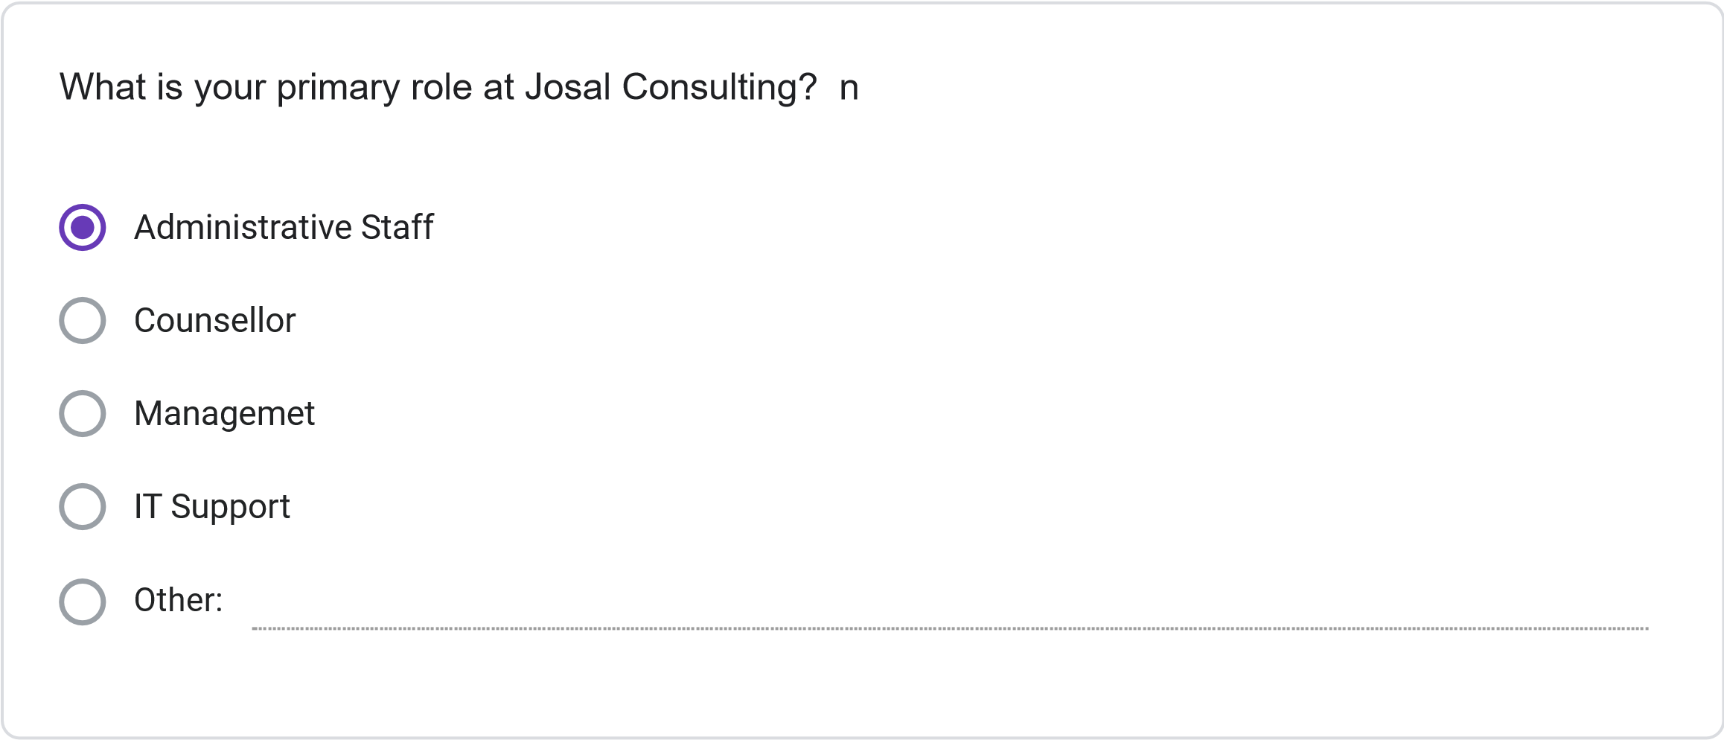
Multiple times daily
Daily
Several times per Week
Weekly or less Frequently
How frequently do you use the current information management system?
Please rate your satisfaction with the following: (1 = Not Preferred, 2 = Slightly Preferred, 3 =
Neutral, 4 = Preferred, 5 = Strongly Preferred)
1
2
3
4
5
Ease of finding
client information
Scheduling
capabilities
Accuracy of
information
Report generation
Data security
System
speed/performance
Less than 30 minutes
30
minutes to 1 hour
1-2
hours
More than 2 hours
On average, how much time do you spend per day on administrative tasks using the current
system?
How often do you encounter the following issues with the current system? (1 = Never, 2 = Rarely,
3
= Sometimes, 4 = Often, 5 = Very Often)
1
2
3
4
5
Schedulint
Conflics
Difficulty Finiding
Client
Information
System Errors or
Crashes
Duplicate or
Inconsistent
Data
Inability to
generate needed
reports
SECTION 3: NEW SYSTEM REQUIREMENTS
Please rate the importance of the following features for the new database system: (1 = Not
Important, 2 = Slightly Important, 3 = Moderately Important, 4 = Important, 5 = Very Important)
1
2
3
4
5
Integrated
calendar/scheduling
system
Client history tracking
Automated conflict
detection
Custom report
generation
Mobile access
capability
Document attachment
functionality
Automated
reminders/notifications
Role-based access
controls
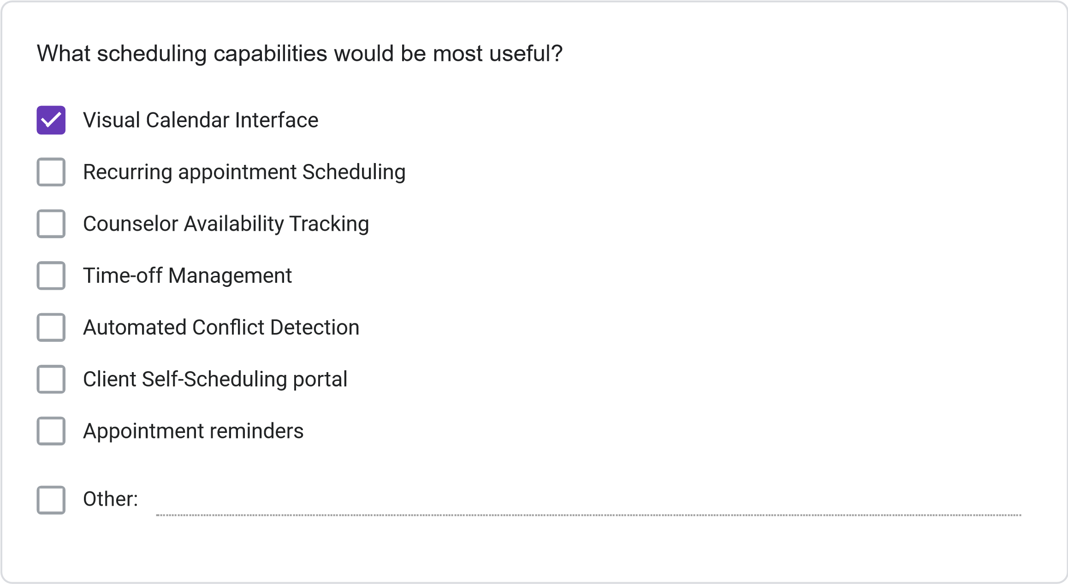
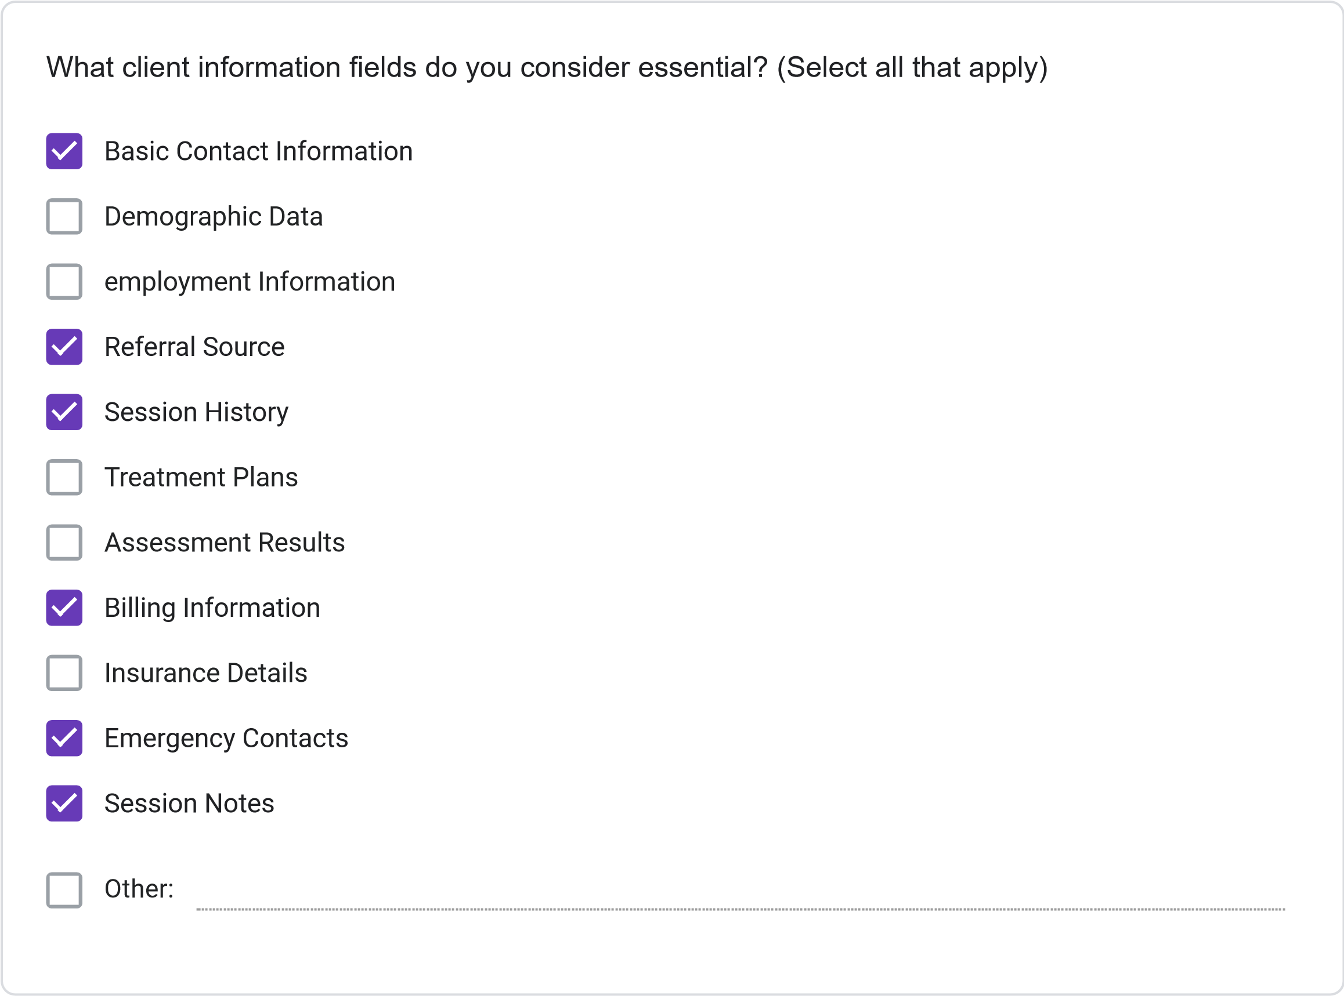
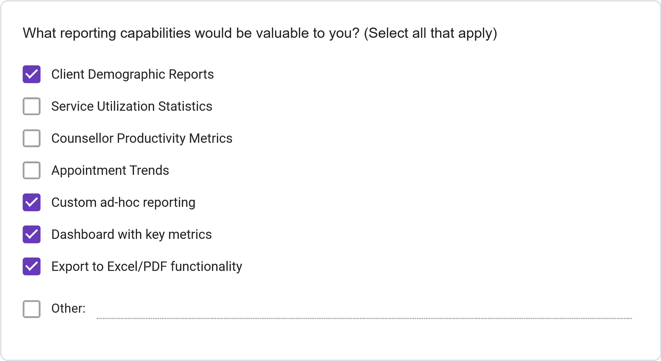
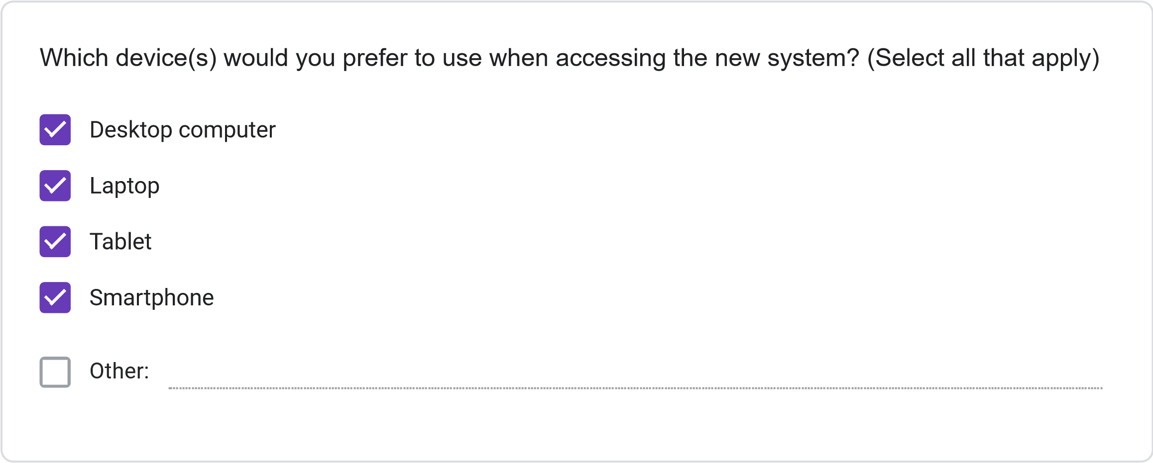
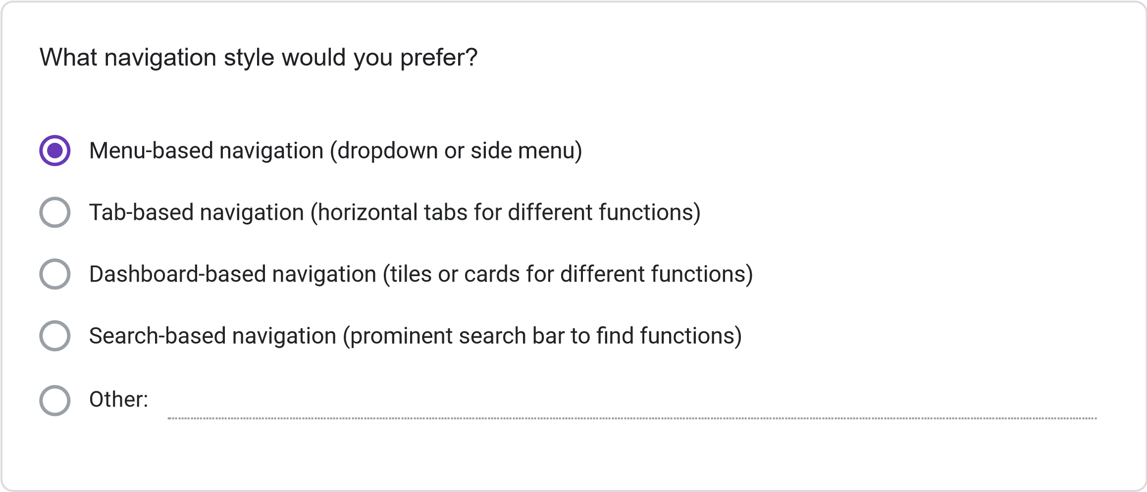
=
11
. Please rate your preference for the following user interface elements: (1 = Not Preferred, 2
Slightly Preferred, 3 = Neutral, 4 = Preferred, 5 = Strongly Preferred)
1
2
3
4
5
Dashboard with
summary
information
Visual calendar
display
Tabs for
different
functions
Search
functionality
Color-coding for
different
information
types
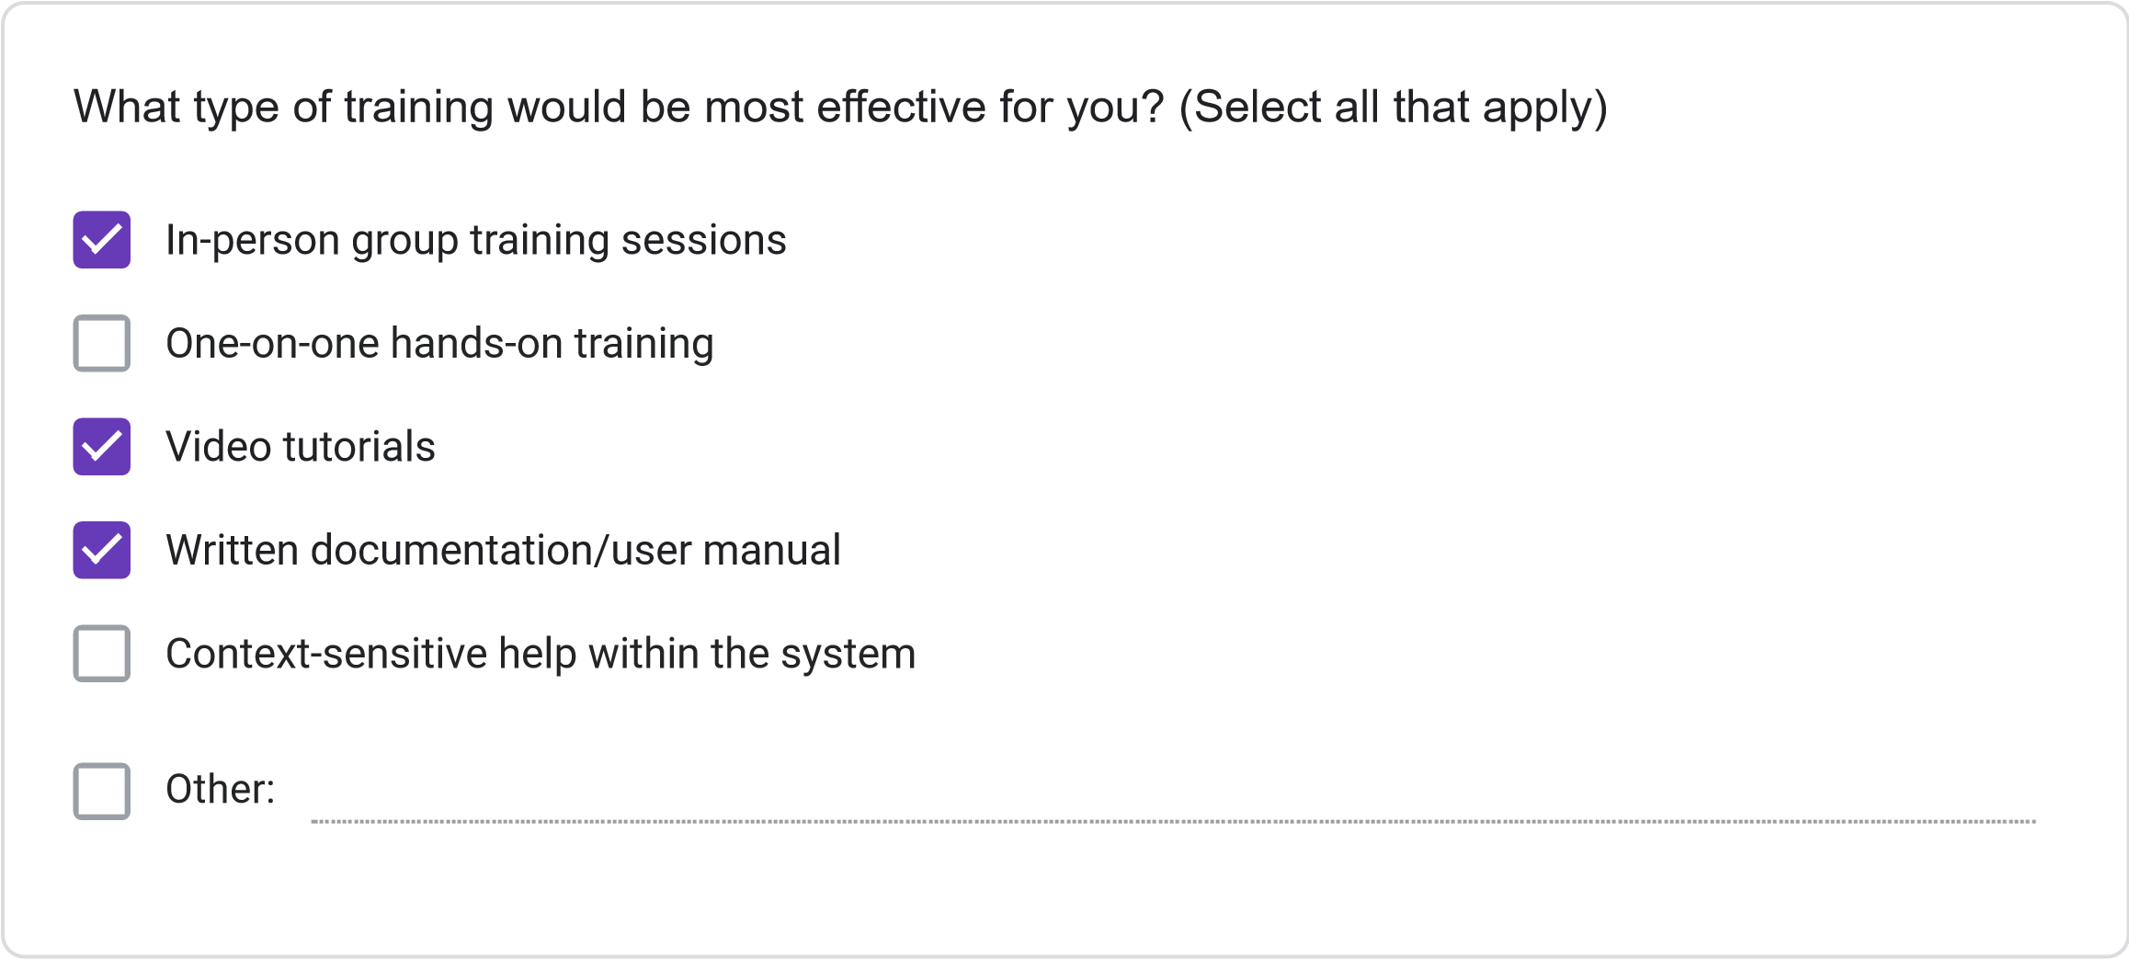
Less than 2 hours
2-4
hours
4-8
hours
More than 8 hours
How much time would you be willing to invest in training for the new system?
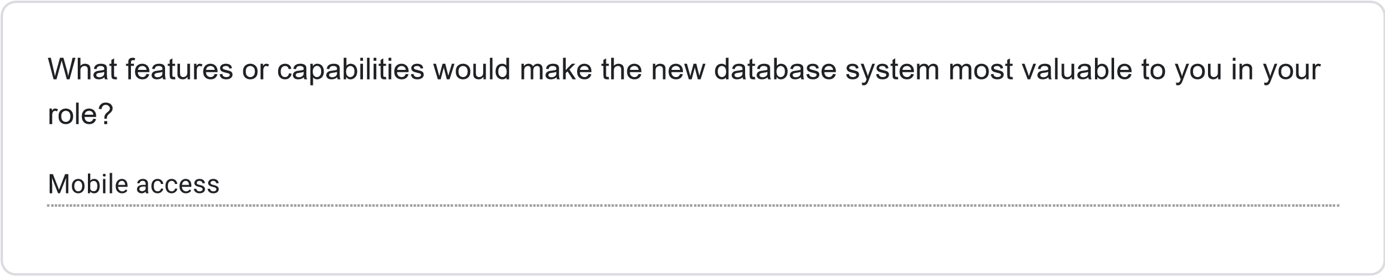
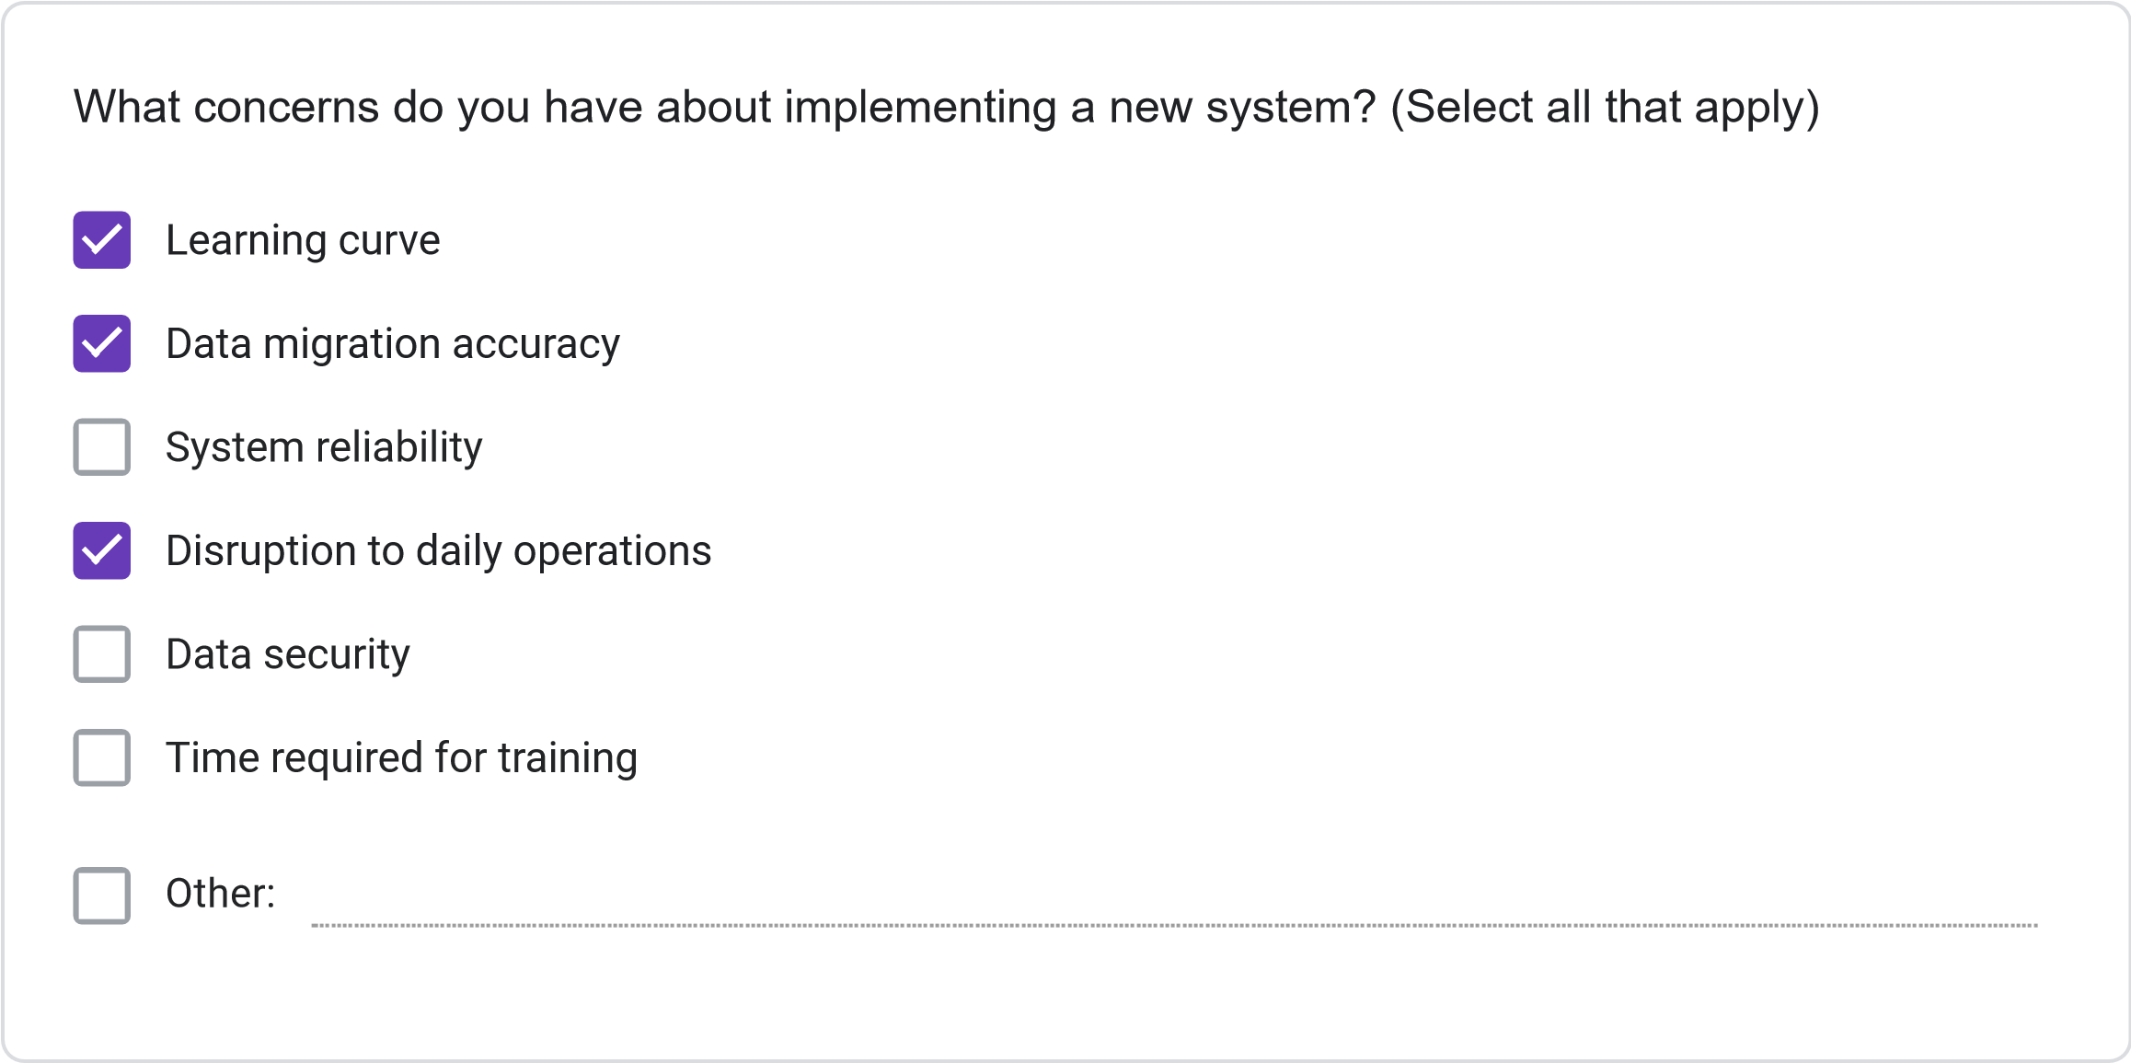
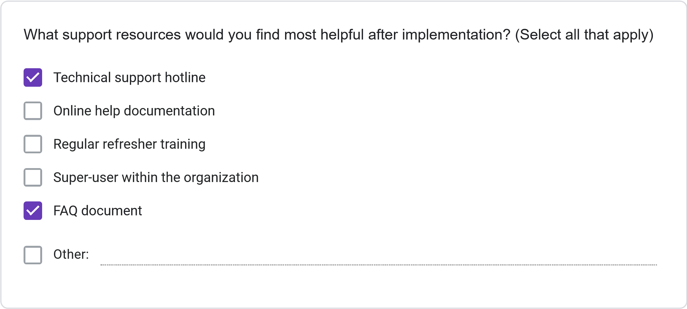
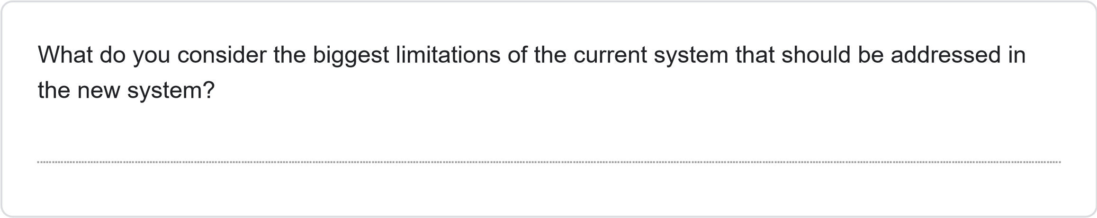
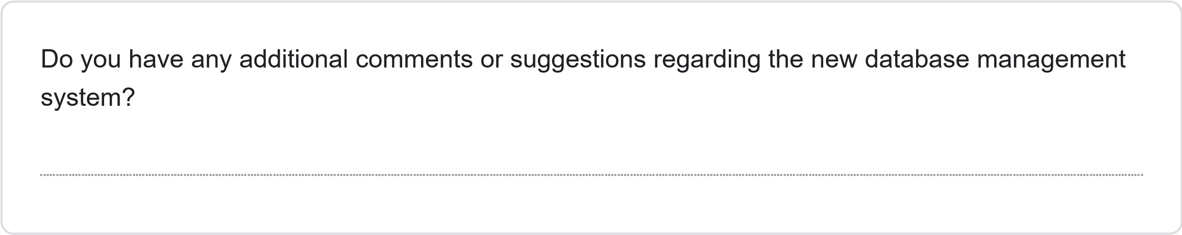
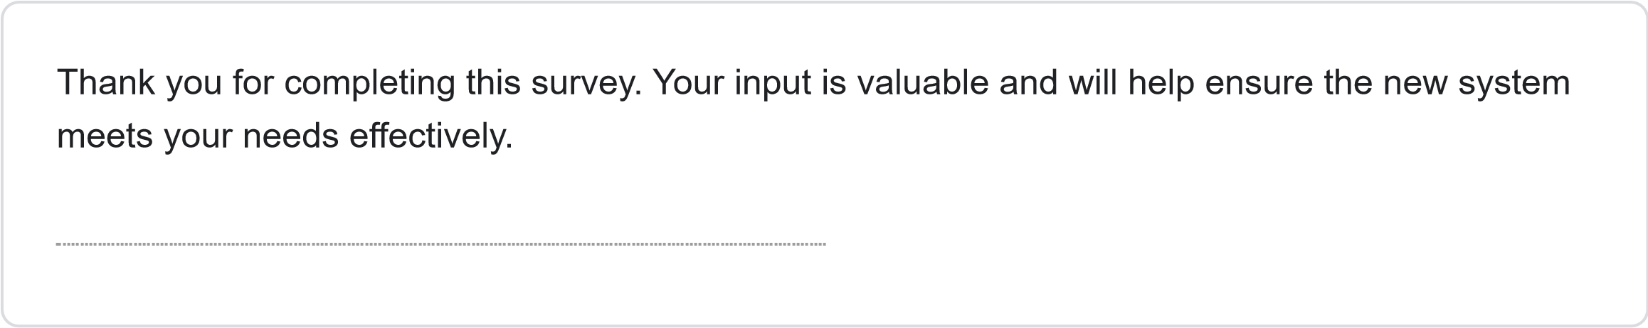
This content is neither created nor endorsed by Google.
Forms
JOSAL CONSULTING DATABASE MANAGEMENT SYSTEM PROJECT REQUIREMENTS SURVEY
Less than 1 Year
1-3
Years
4-6
years
More than 6 years
How long have you been working at Josal Consulting?
This survey aims to gather specific requirements for the new database management system for Josal Consulting. Your responses will help ensure the system meets user needs and improves operational efficiency. The survey should take approximately 15-20 minutes to complete.
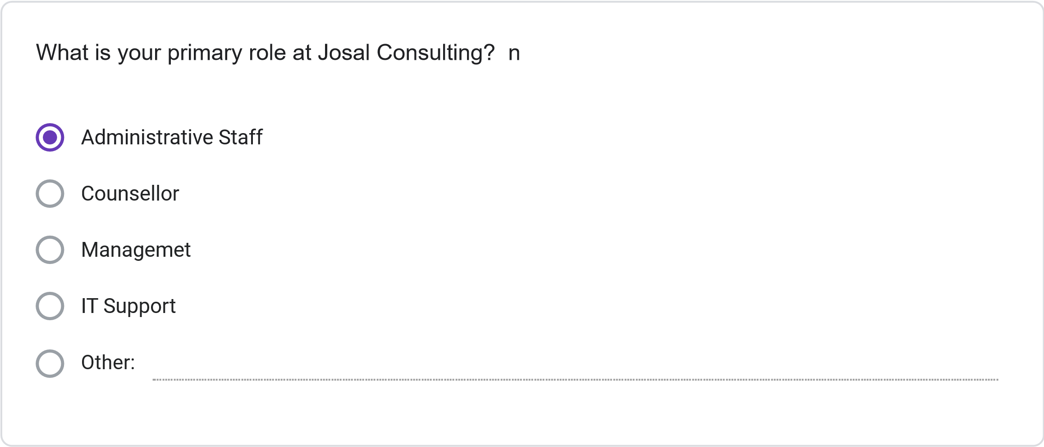
Multiple times daily
Daily
Several times per Week
Weekly or less Frequently
How frequently do you use the current information management system?
Please rate your satisfaction with the following: (1 = Not Preferred, 2 = Slightly Preferred, 3 =
Neutral, 4 = Preferred, 5 = Strongly Preferred)
1
2
3
4
5
Ease of finding
client information
Scheduling
capabilities
Accuracy of
information
Report generation
Data security
System
speed/performance
Less than 30 minutes
30
minutes to 1 hour
1-2
hours
More than 2 hours
On average, how much time do you spend per day on administrative tasks using the current
system?
How often do you encounter the following issues with the current system? (1 = Never, 2 = Rarely,
3
= Sometimes, 4 = Often, 5 = Very Often)
1
2
3
4
5
Schedulint
Conflics
Difficulty Finiding
Client
Information
System Errors or
Crashes
Duplicate or
Inconsistent
Data
Inability to
generate needed
reports
SECTION 3: NEW SYSTEM REQUIREMENTS
Please rate the importance of the following features for the new database system: (1 = Not
Important, 2 = Slightly Important, 3 = Moderately Important, 4 = Important, 5 = Very Important)
1
2
3
4
5
Integrated
calendar/scheduling
system
Client history tracking
Automated conflict
detection
Custom report
generation
Mobile access
capability
Document attachment
functionality
Automated
reminders/notifications
Role-based access
controls
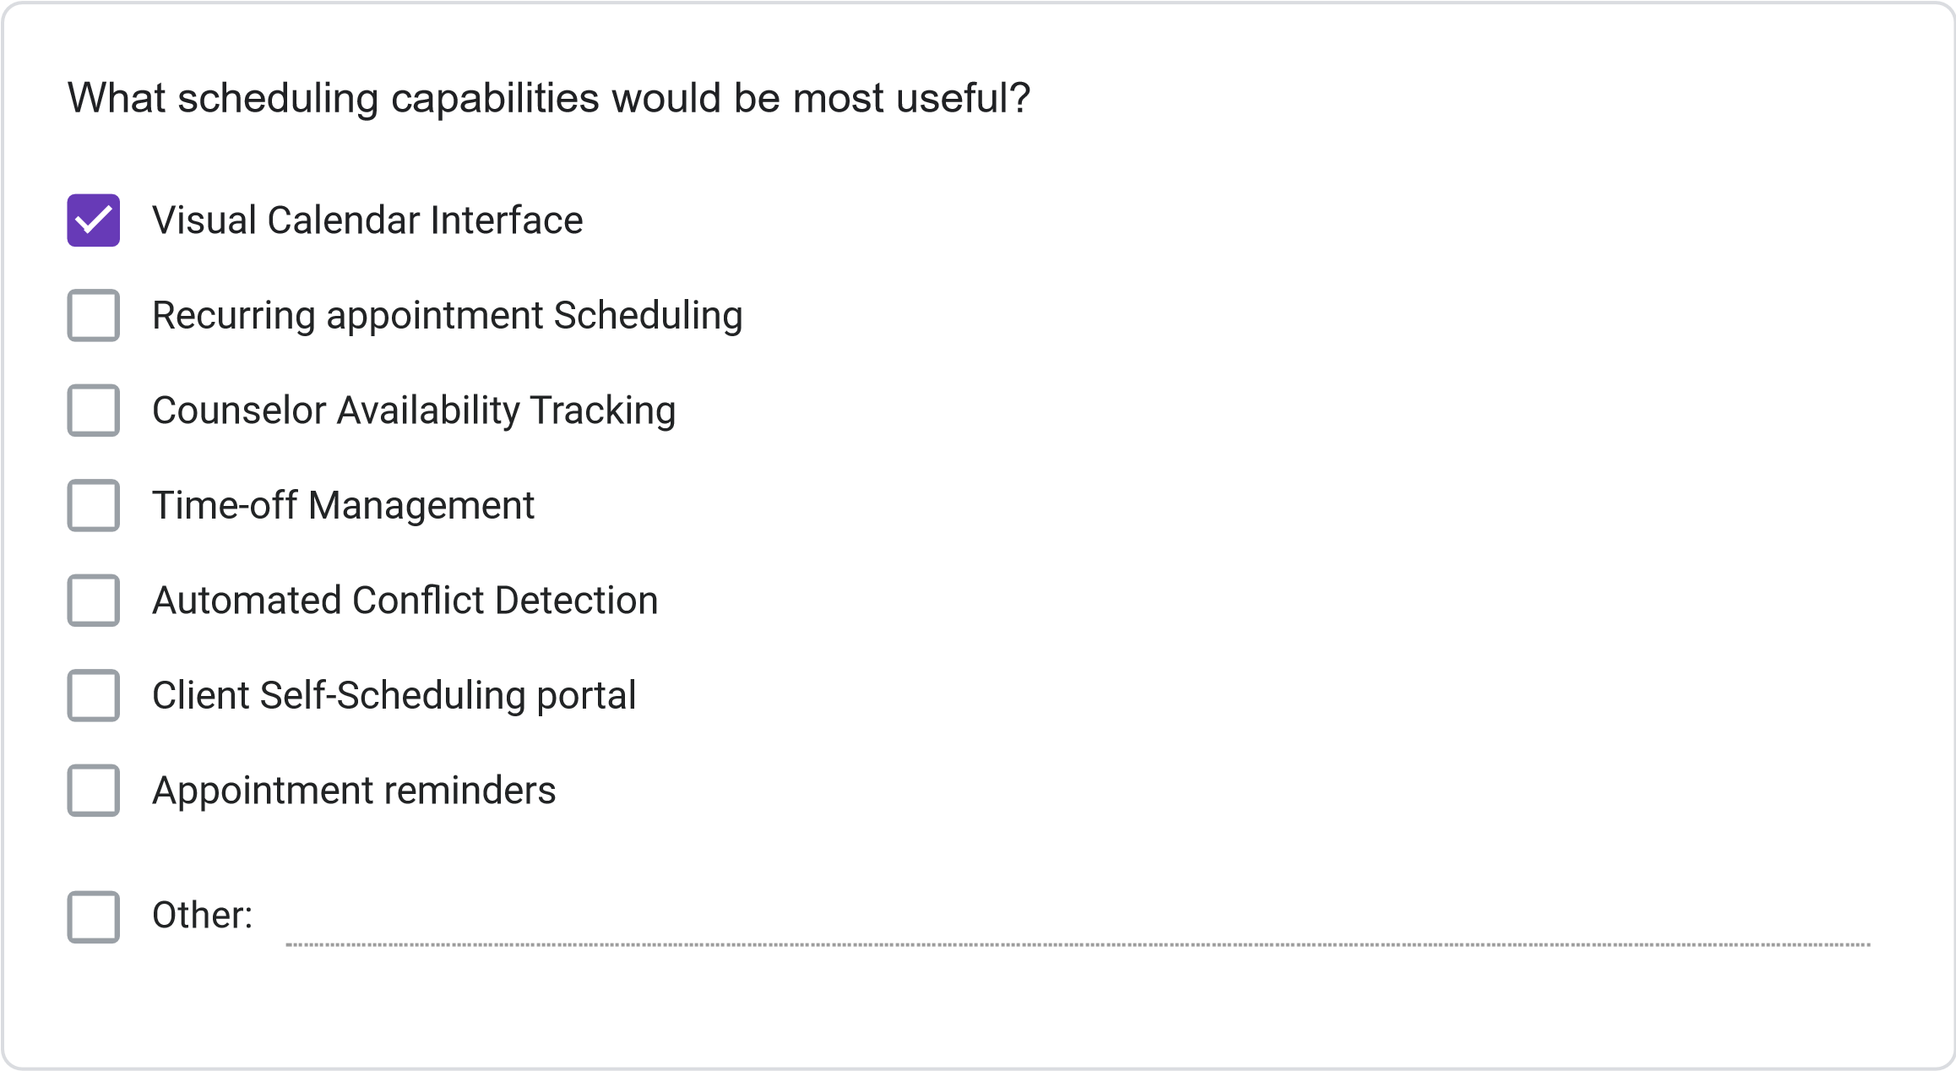
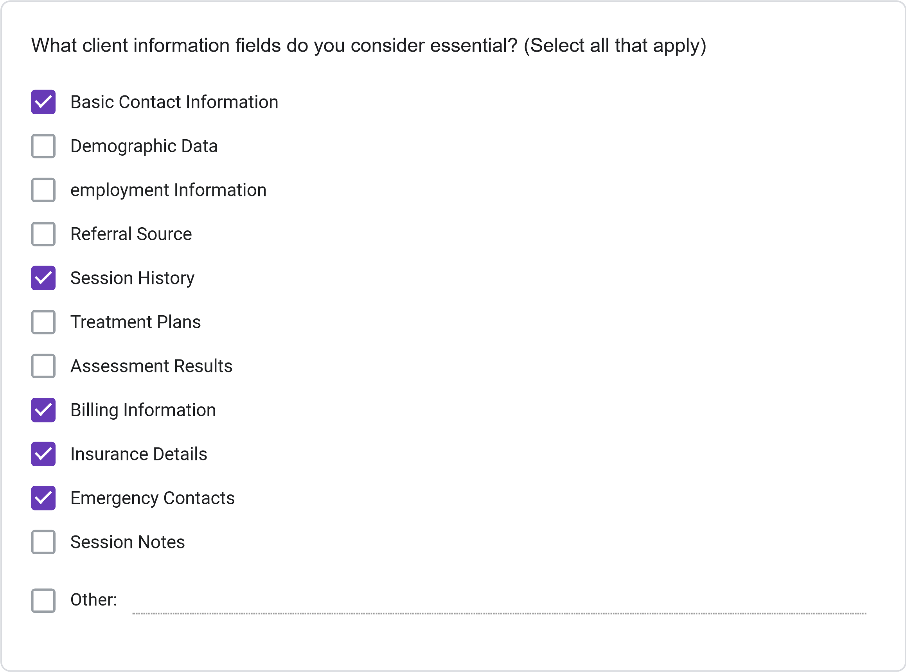
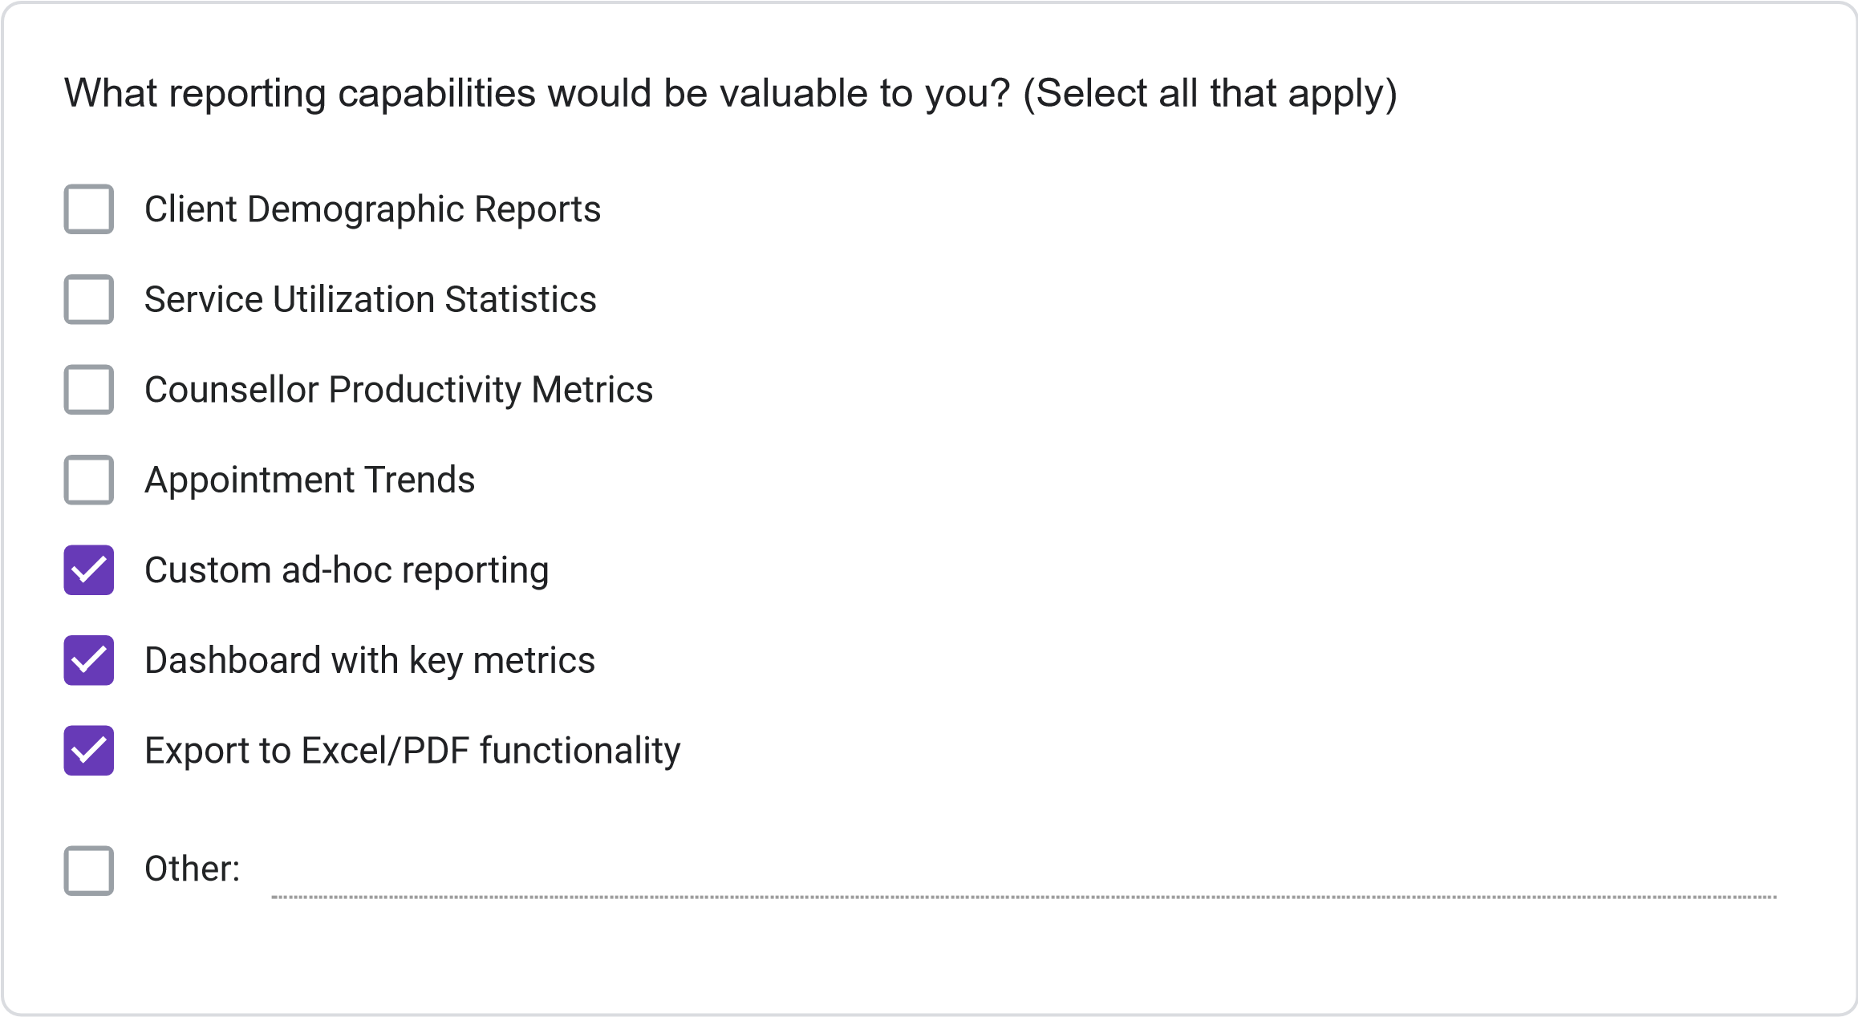
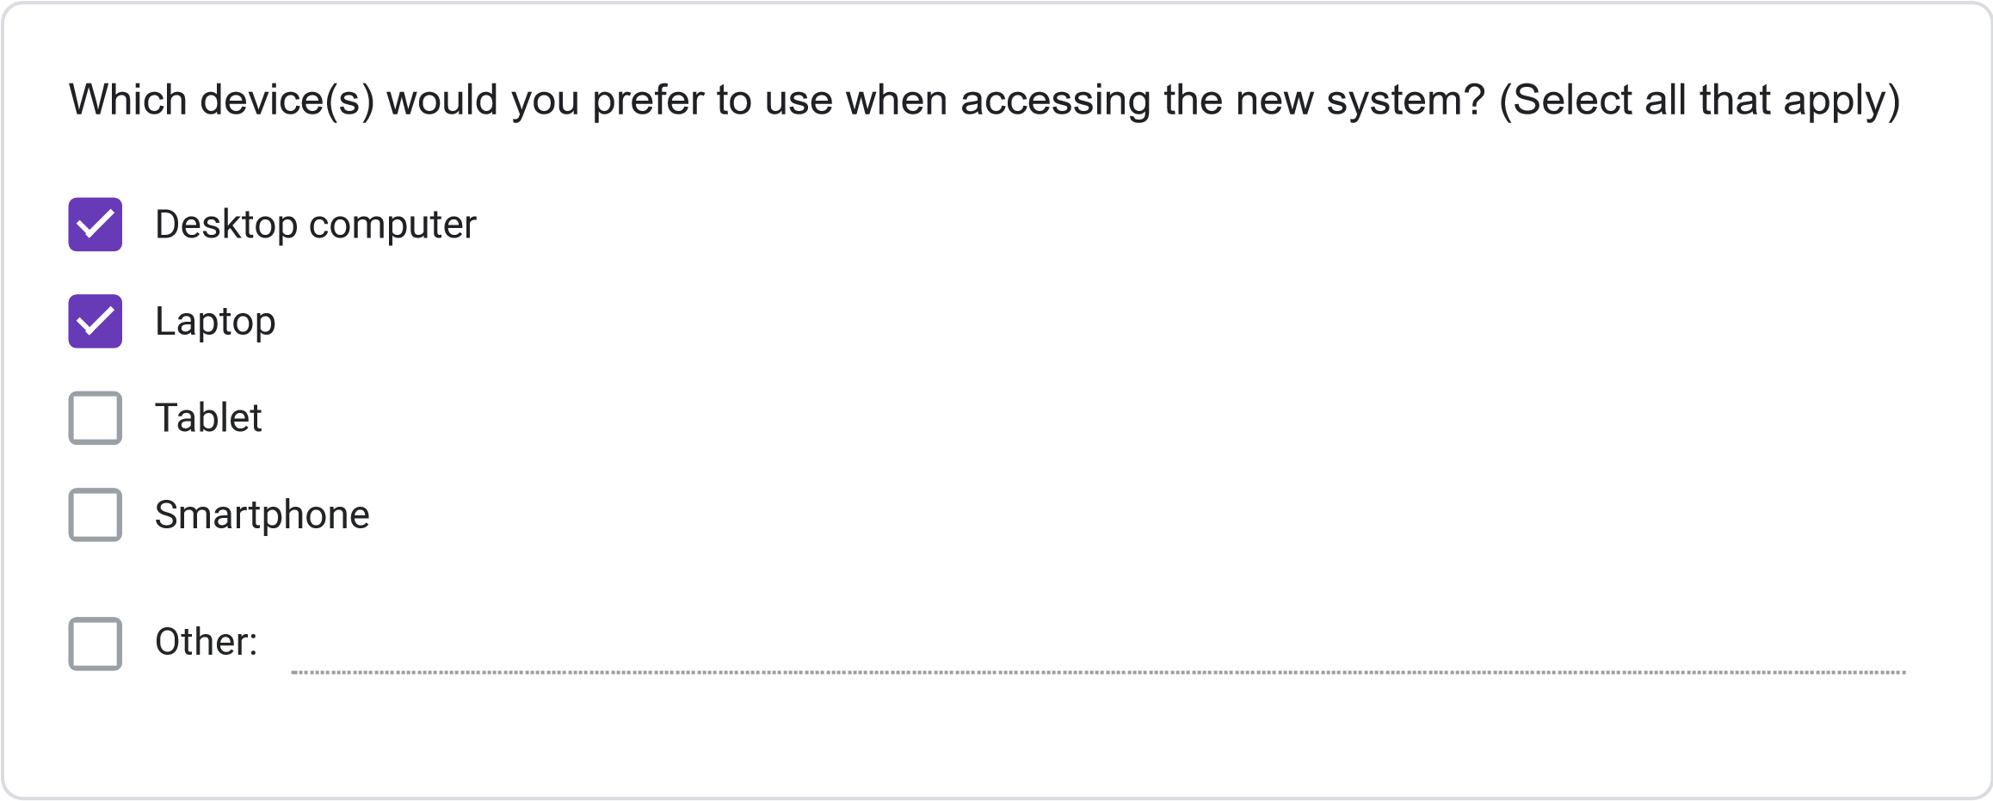
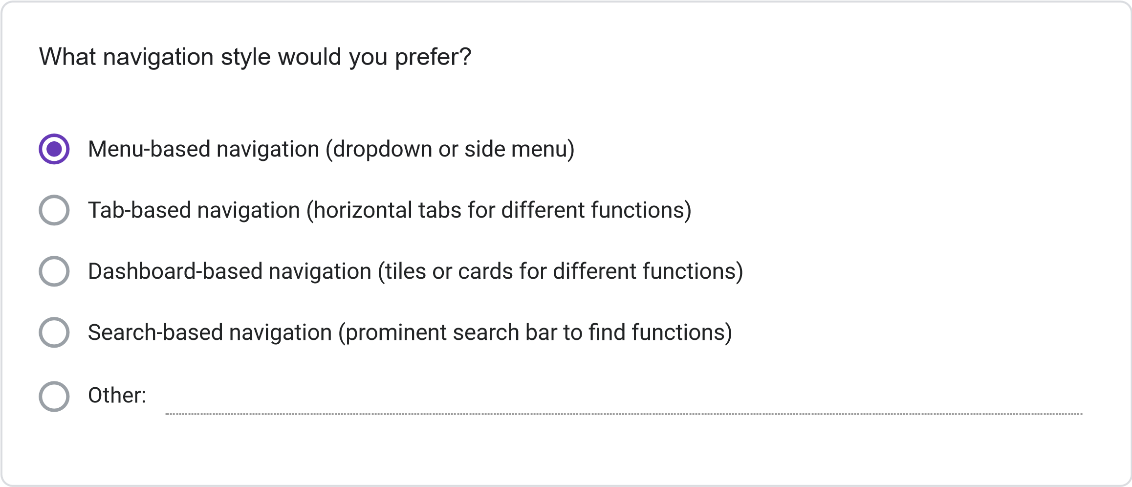
=
11
. Please rate your preference for the following user interface elements: (1 = Not Preferred, 2
Slightly Preferred, 3 = Neutral, 4 = Preferred, 5 = Strongly Preferred)
1
2
3
4
5
Dashboard with
summary
information
Visual calendar
display
Tabs for
different
functions
Search
functionality
Color-coding for
different
information
types
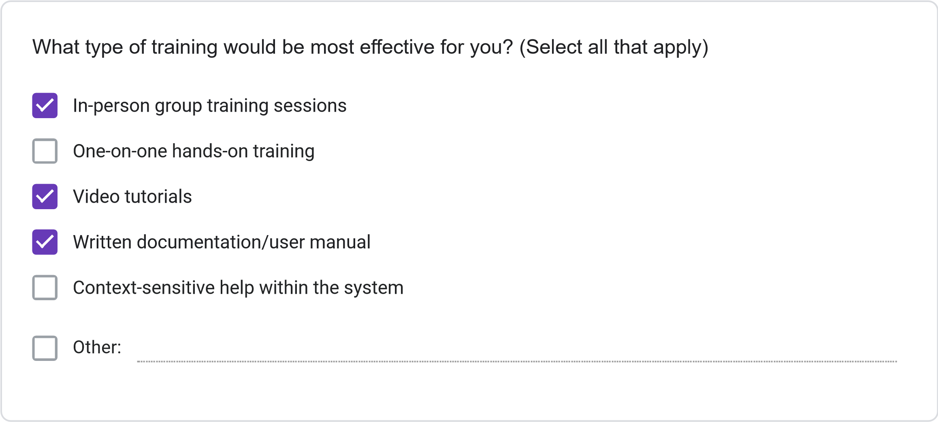
Less than 2 hours
2-4
hours
4-8
hours
More than 8 hours
How much time would you be willing to invest in training for the new system?
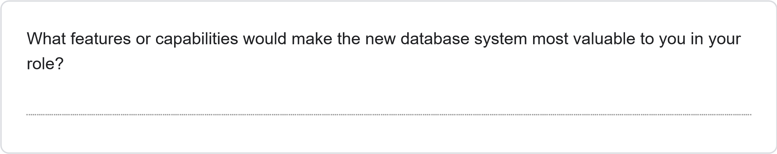
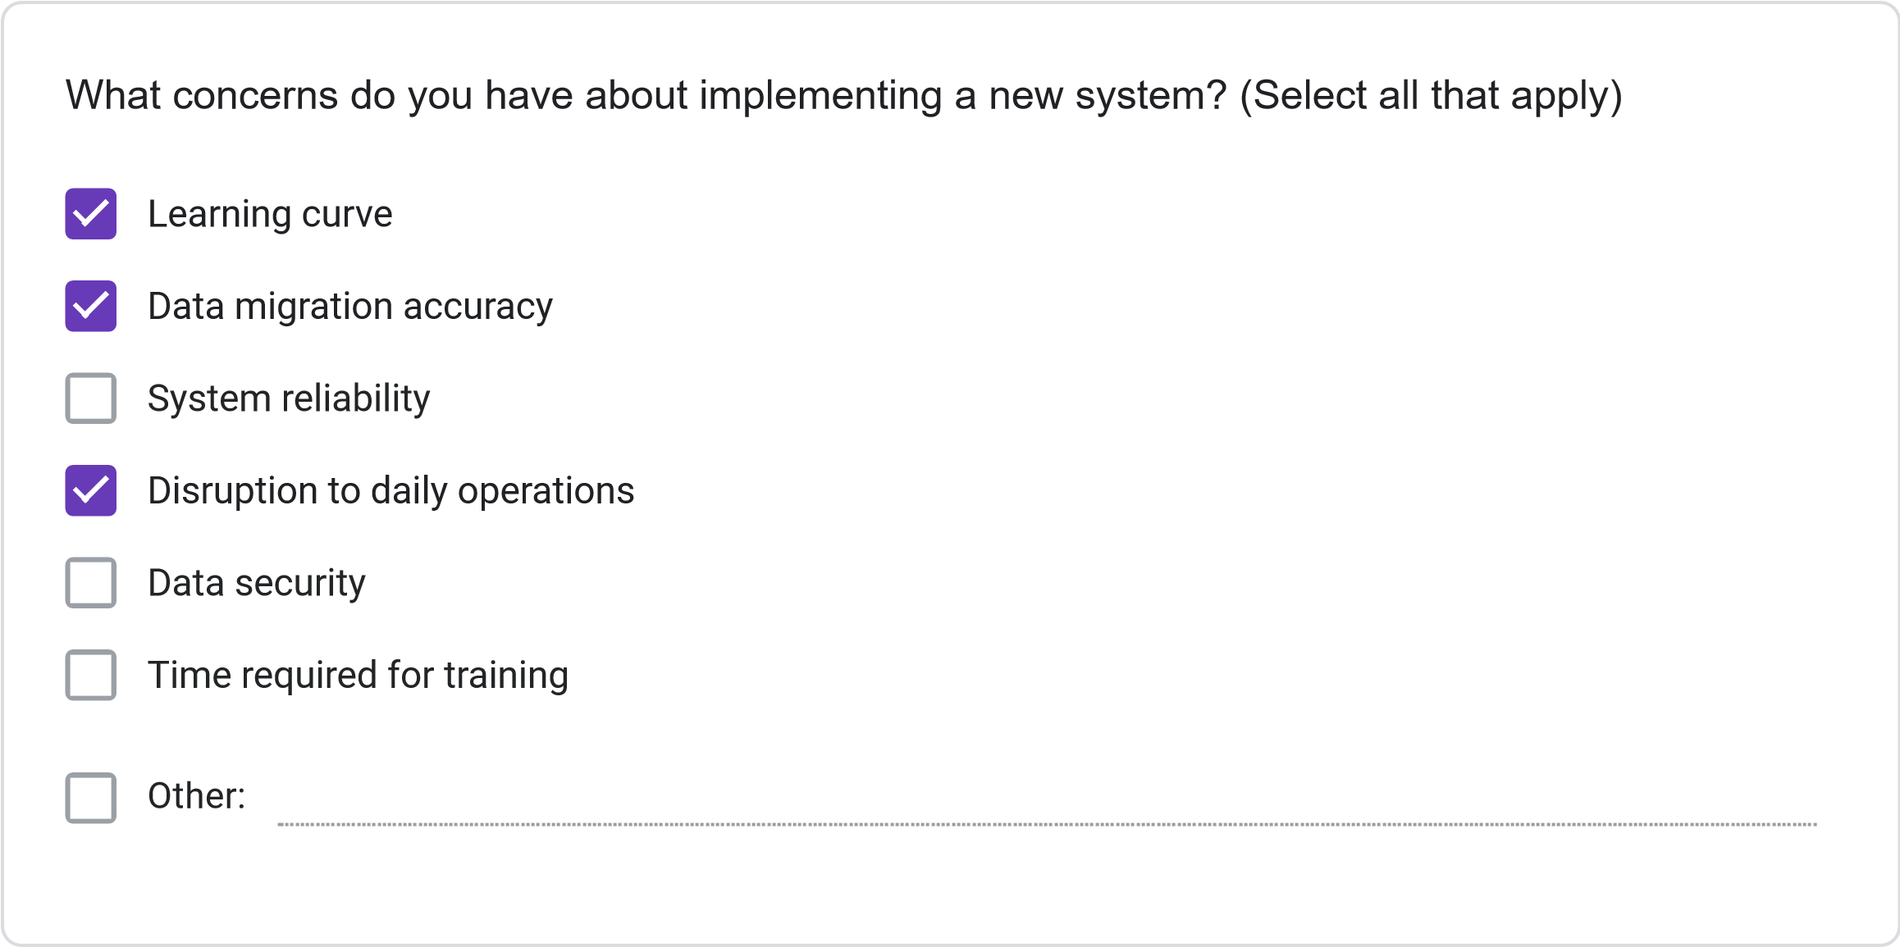
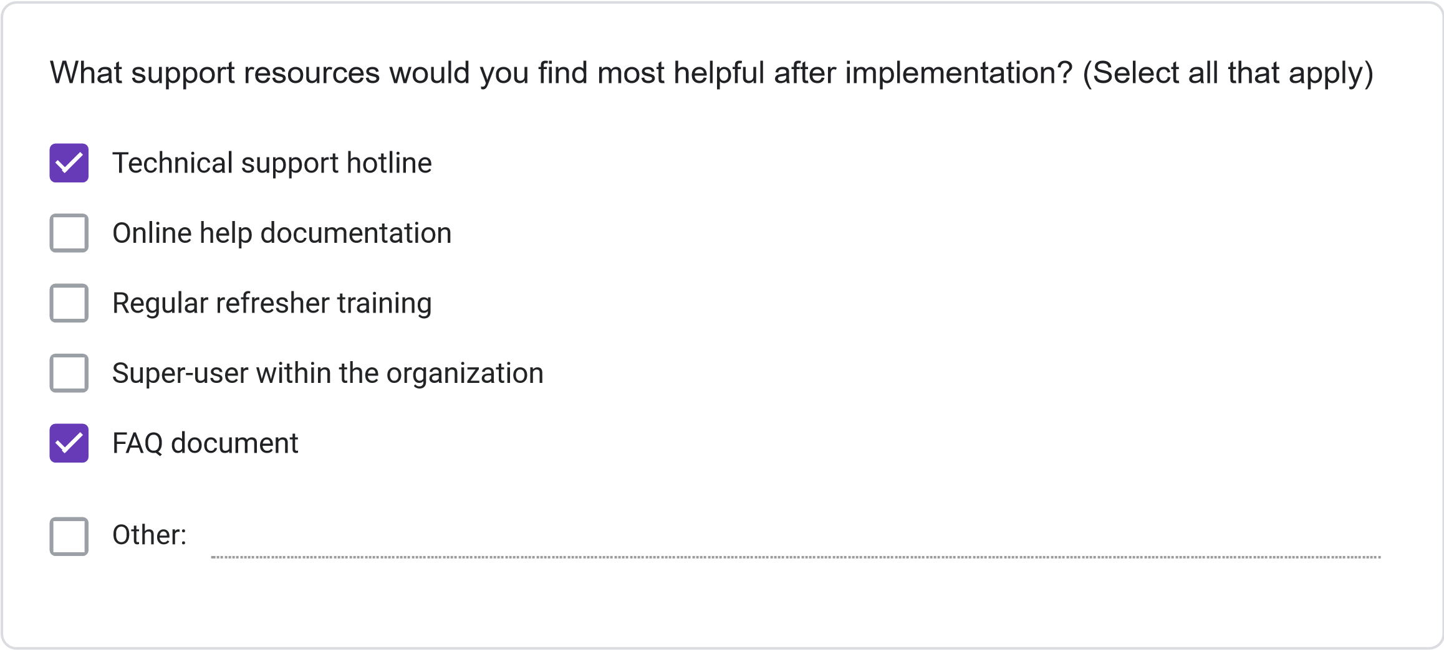
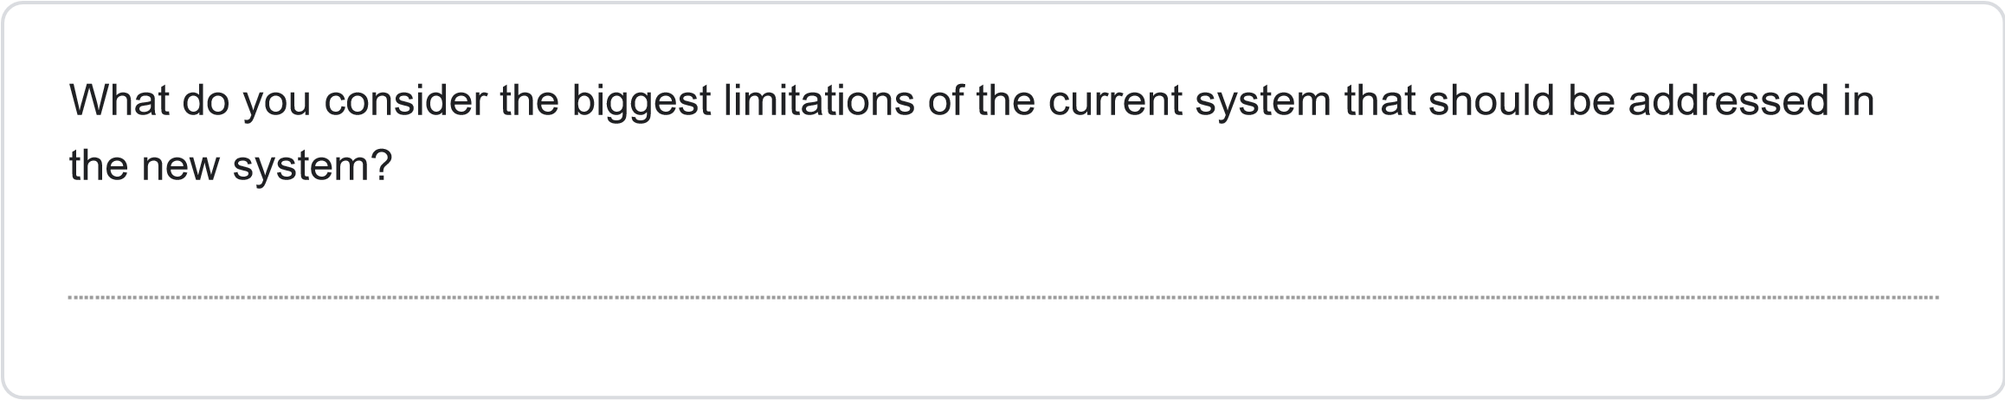
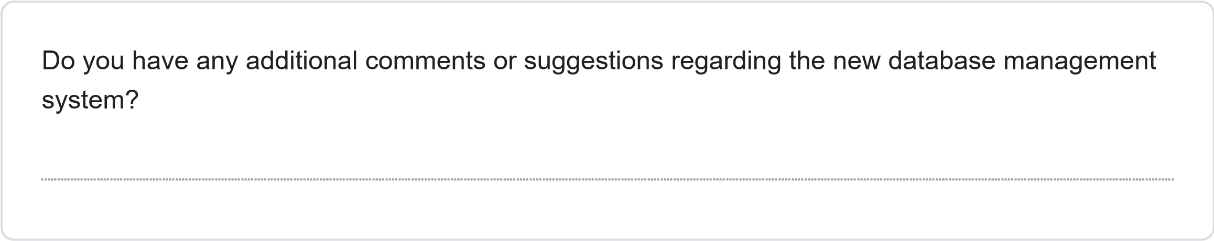
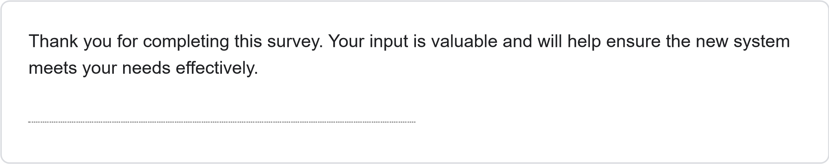
This content is neither created nor endorsed by Google.
Forms
JOSAL CONSULTING DATABASE MANAGEMENT SYSTEM PROJECT REQUIREMENTS SURVEY
Less than 1 Year
1-3
Years
4-6
years
More than 6 years
How long have you been working at Josal Consulting?
This survey aims to gather specific requirements for the new database management system for Josal Consulting. Your responses will help ensure the system meets user needs and improves operational efficiency. The survey should take approximately 15-20 minutes to complete.
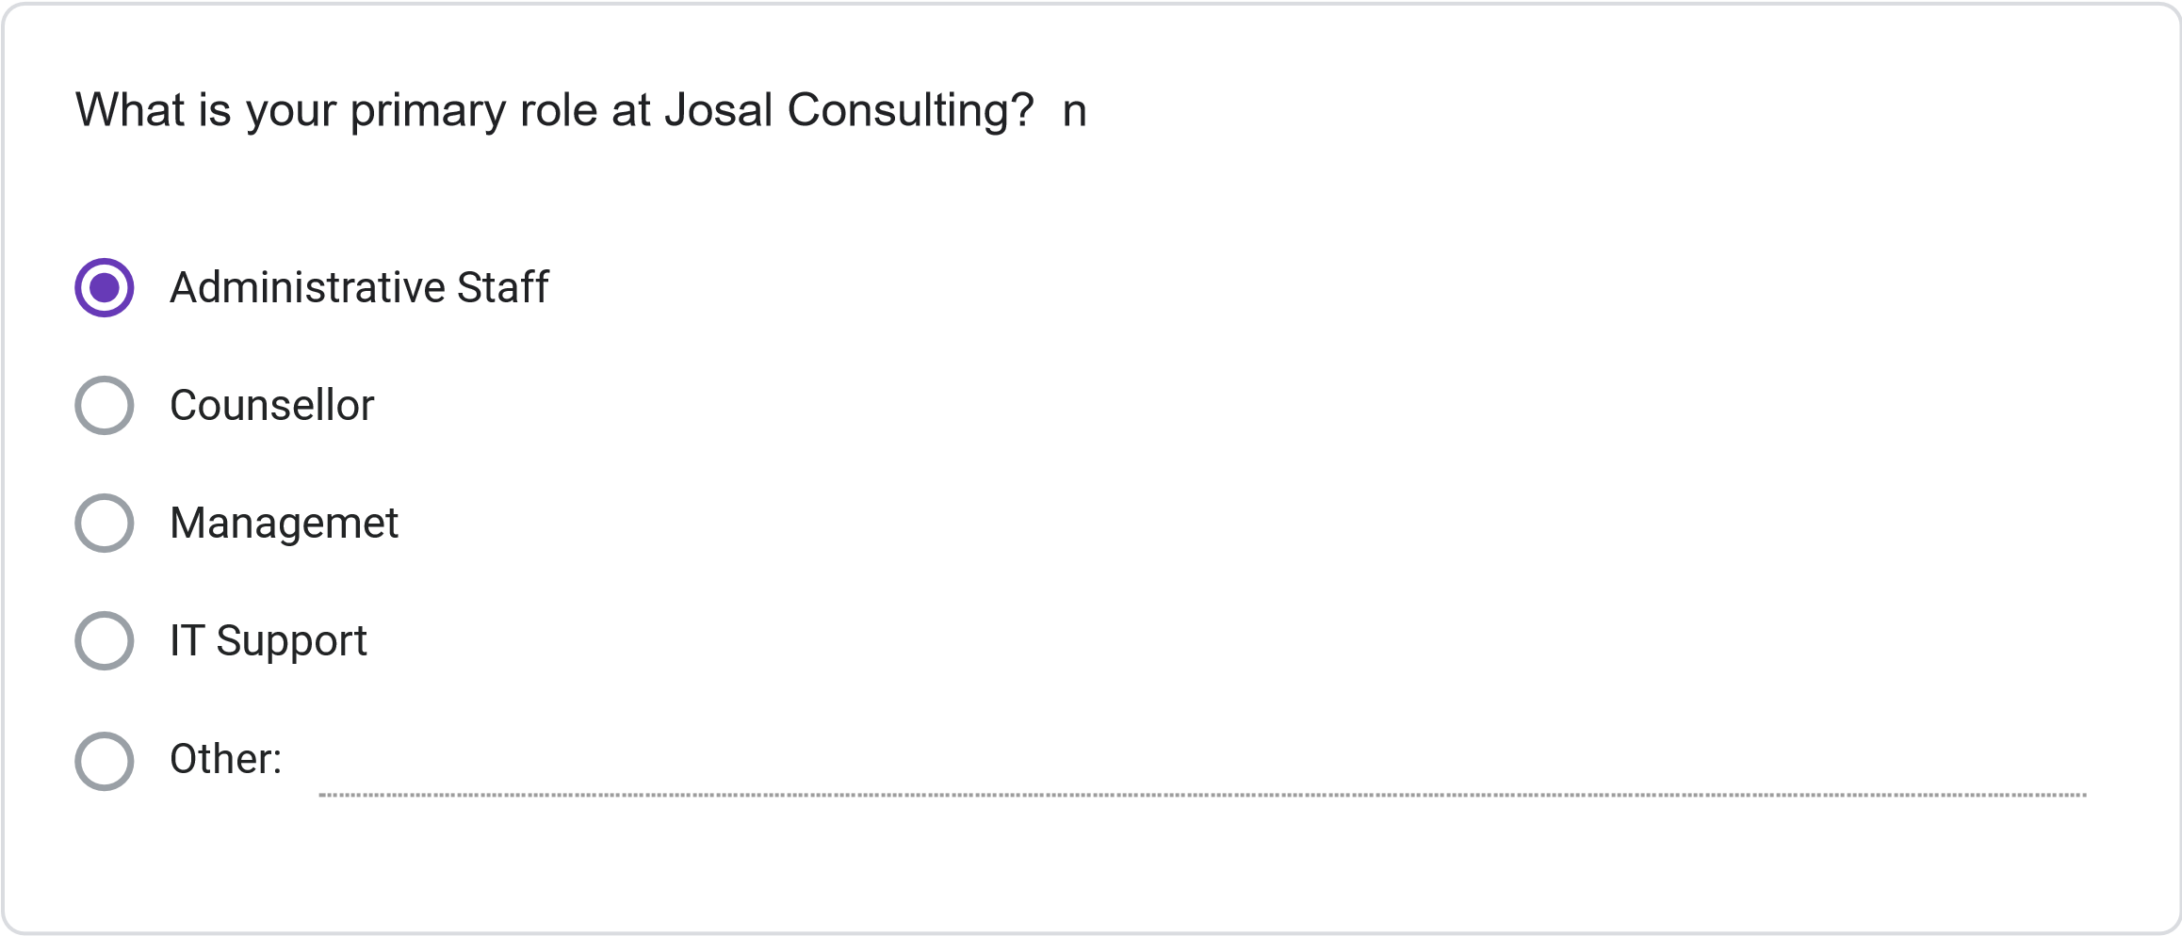
Multiple times daily
Daily
Several times per Week
Weekly or less Frequently
How frequently do you use the current information management system?
Please rate your satisfaction with the following: (1 = Not Preferred, 2 = Slightly Preferred, 3 =
Neutral, 4 = Preferred, 5 = Strongly Preferred)
1
2
3
4
5
Ease of finding
client information
Scheduling
capabilities
Accuracy of
information
Report generation
Data security
System
speed/performance
Less than 30 minutes
30
minutes to 1 hour
1-2
hours
More than 2 hours
On average, how much time do you spend per day on administrative tasks using the current
system?
How often do you encounter the following issues with the current system? (1 = Never, 2 = Rarely,
3
= Sometimes, 4 = Often, 5 = Very Often)
1
2
3
4
5
Schedulint
Conflics
Difficulty Finiding
Client
Information
System Errors or
Crashes
Duplicate or
Inconsistent
Data
Inability to
generate needed
reports
SECTION 3: NEW SYSTEM REQUIREMENTS
Please rate the importance of the following features for the new database system: (1 = Not
Important, 2 = Slightly Important, 3 = Moderately Important, 4 = Important, 5 = Very Important)
1
2
3
4
5
Integrated
calendar/scheduling
system
Client history tracking
Automated conflict
detection
Custom report
generation
Mobile access
capability
Document attachment
functionality
Automated
reminders/notifications
Role-based access
controls
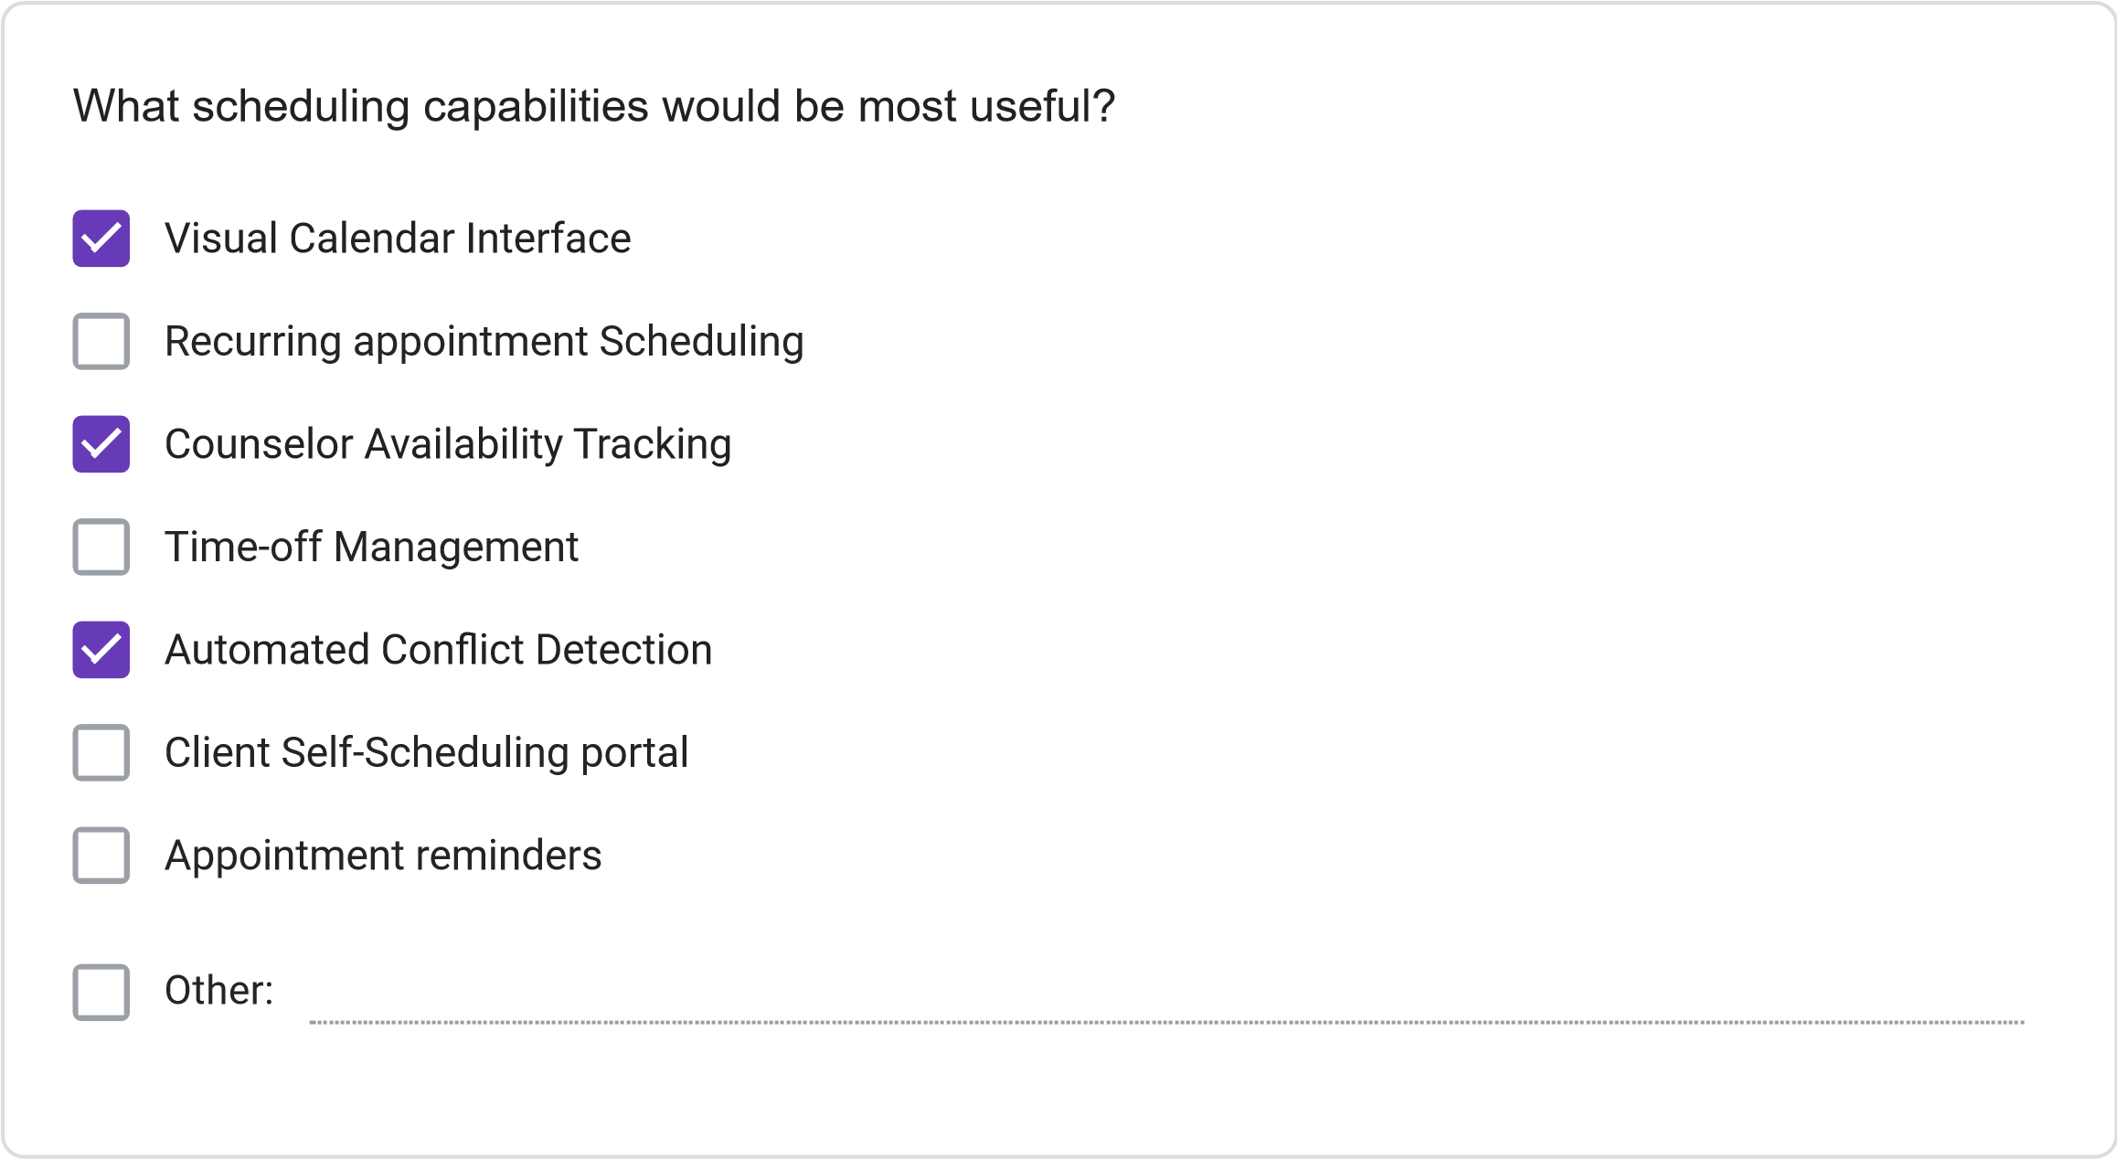
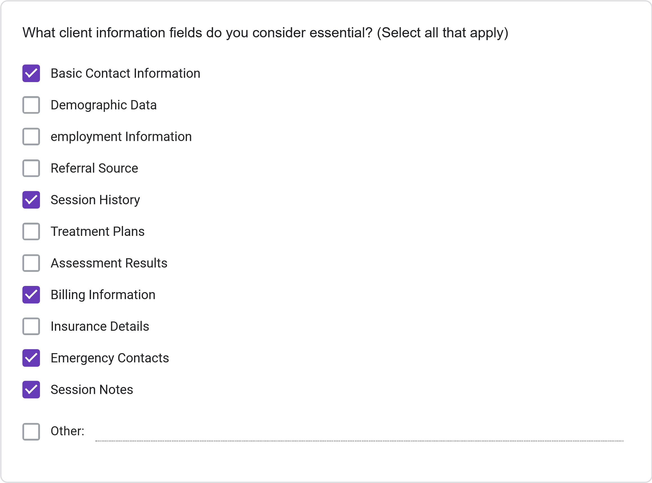
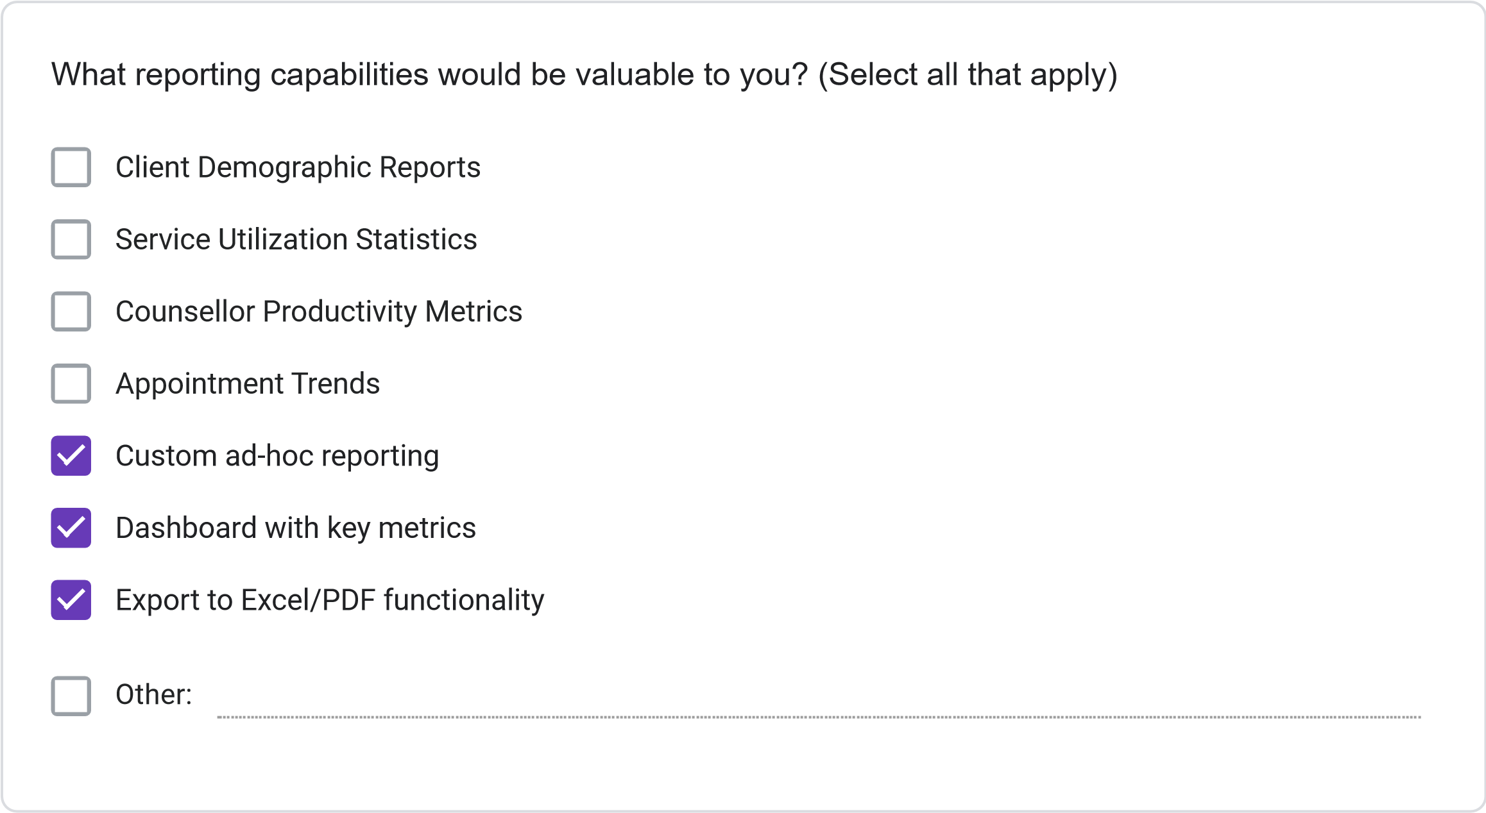
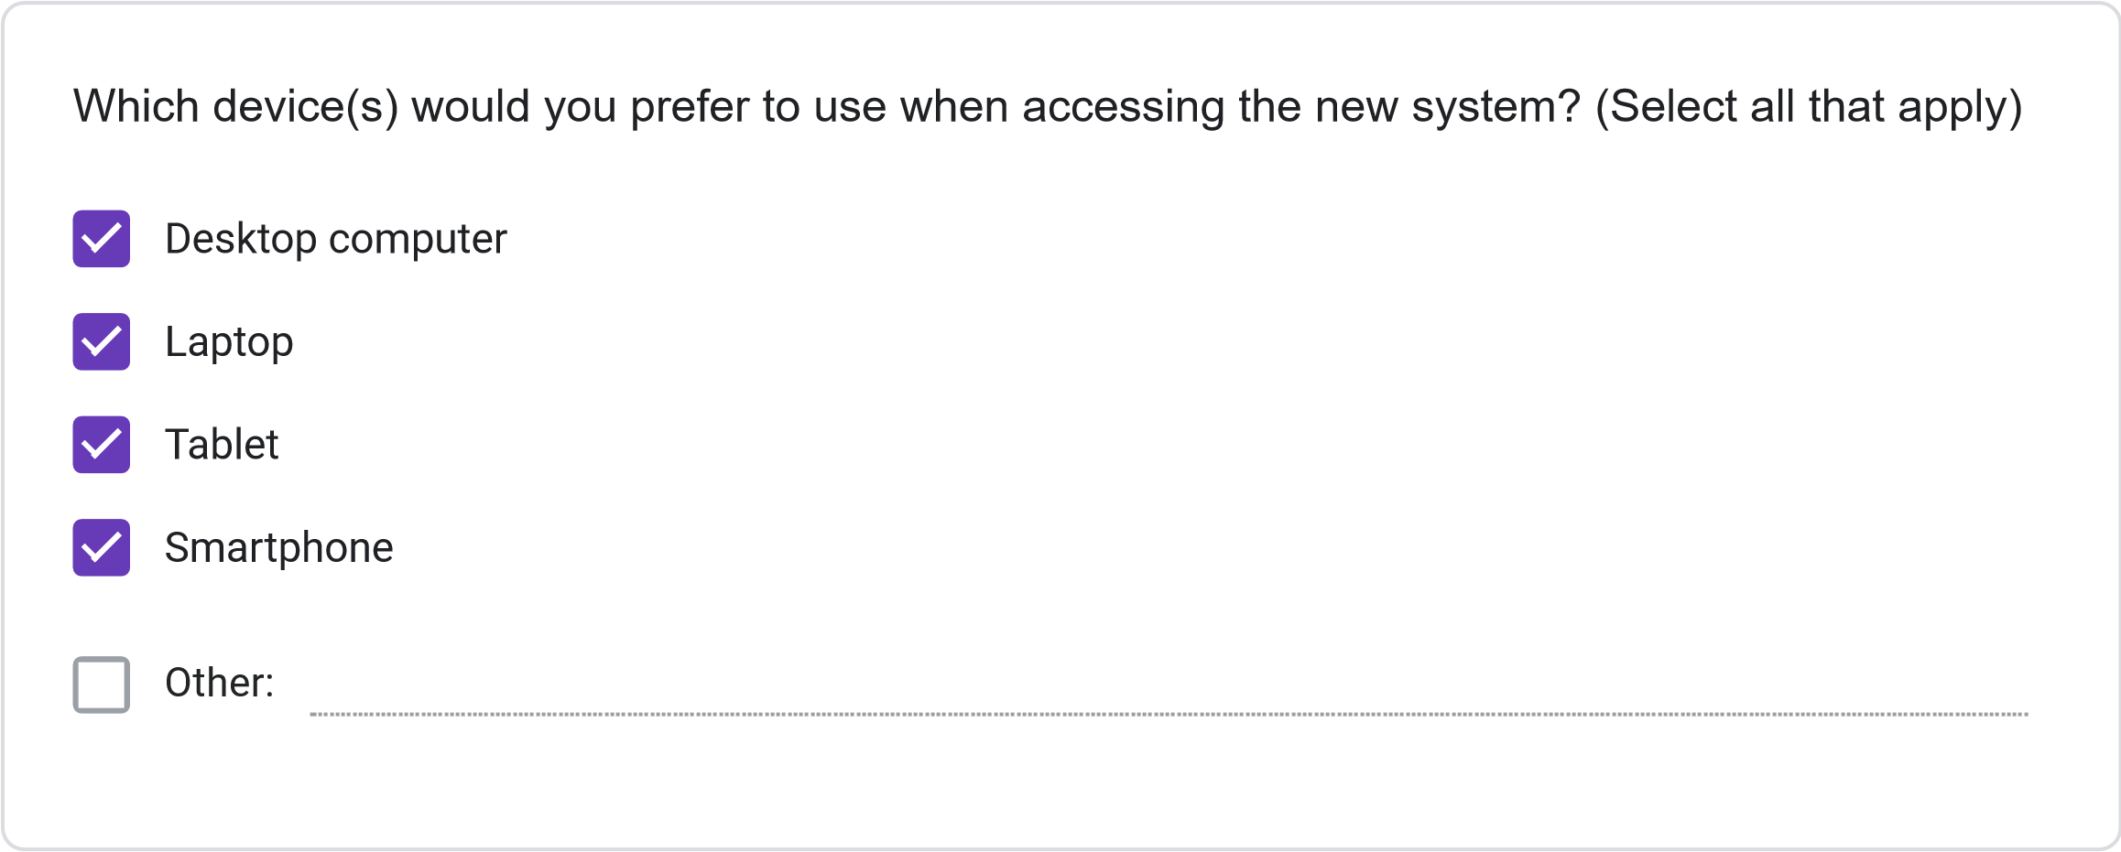
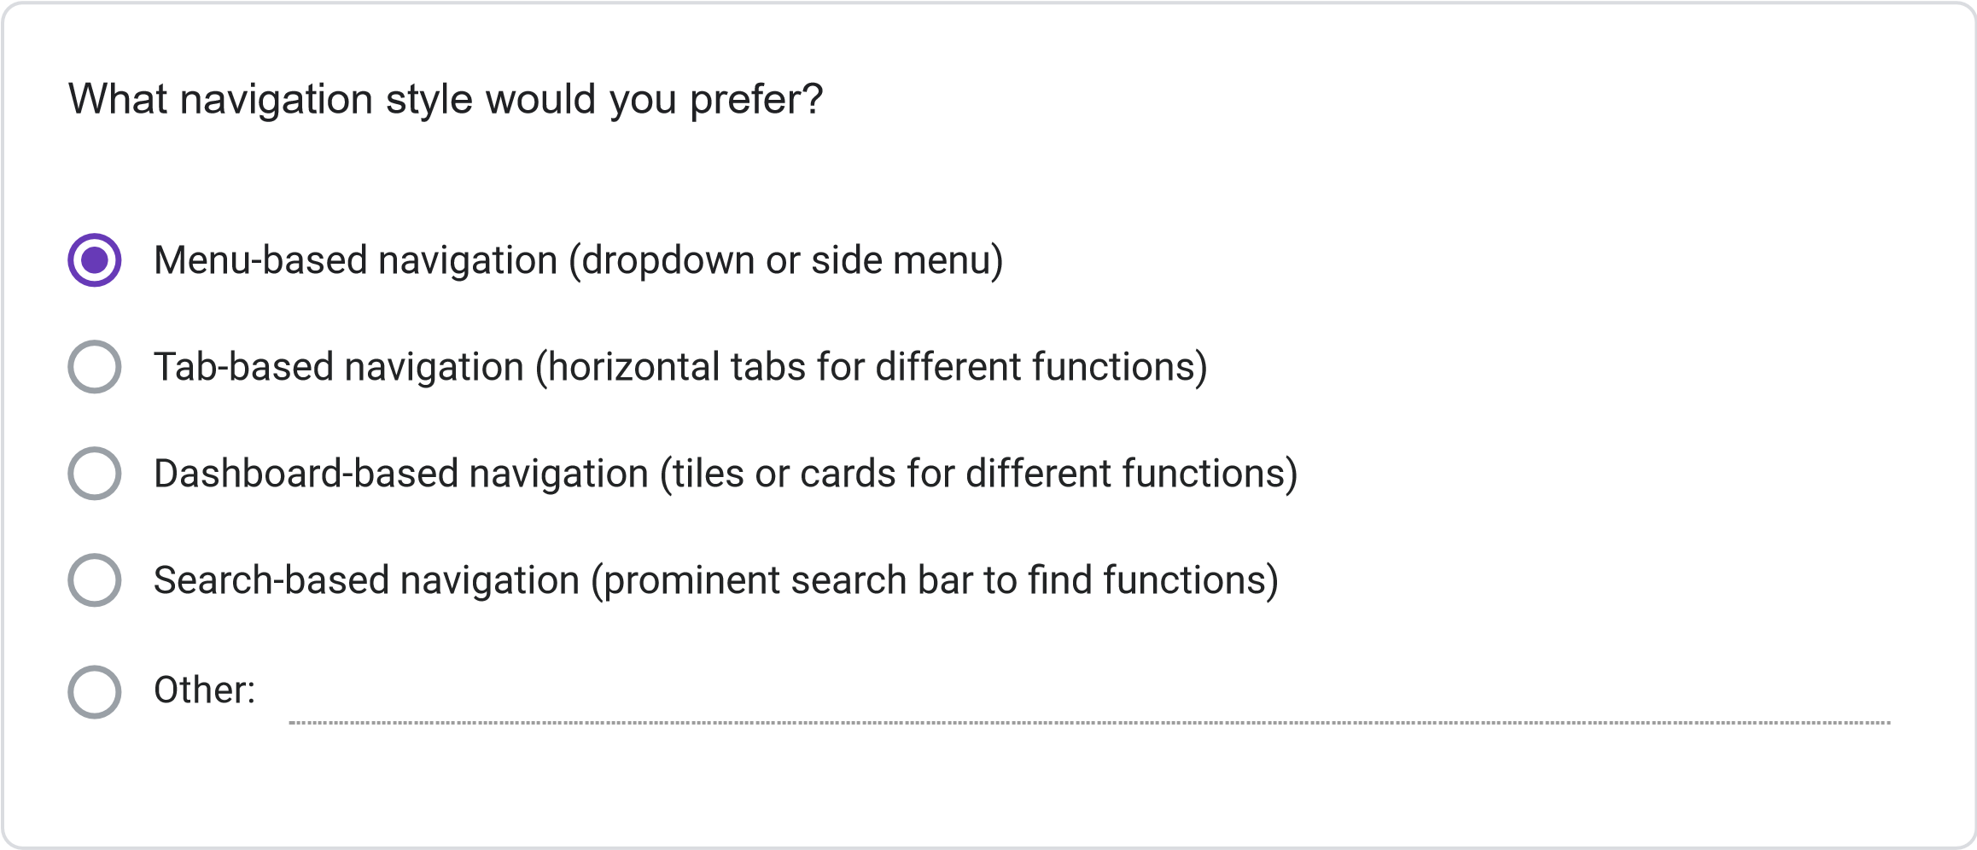
=
11
. Please rate your preference for the following user interface elements: (1 = Not Preferred, 2
Slightly Preferred, 3 = Neutral, 4 = Preferred, 5 = Strongly Preferred)
1
2
3
4
5
Dashboard with
summary
information
Visual calendar
display
Tabs for
different
functions
Search
functionality
Color-coding for
different
information
types
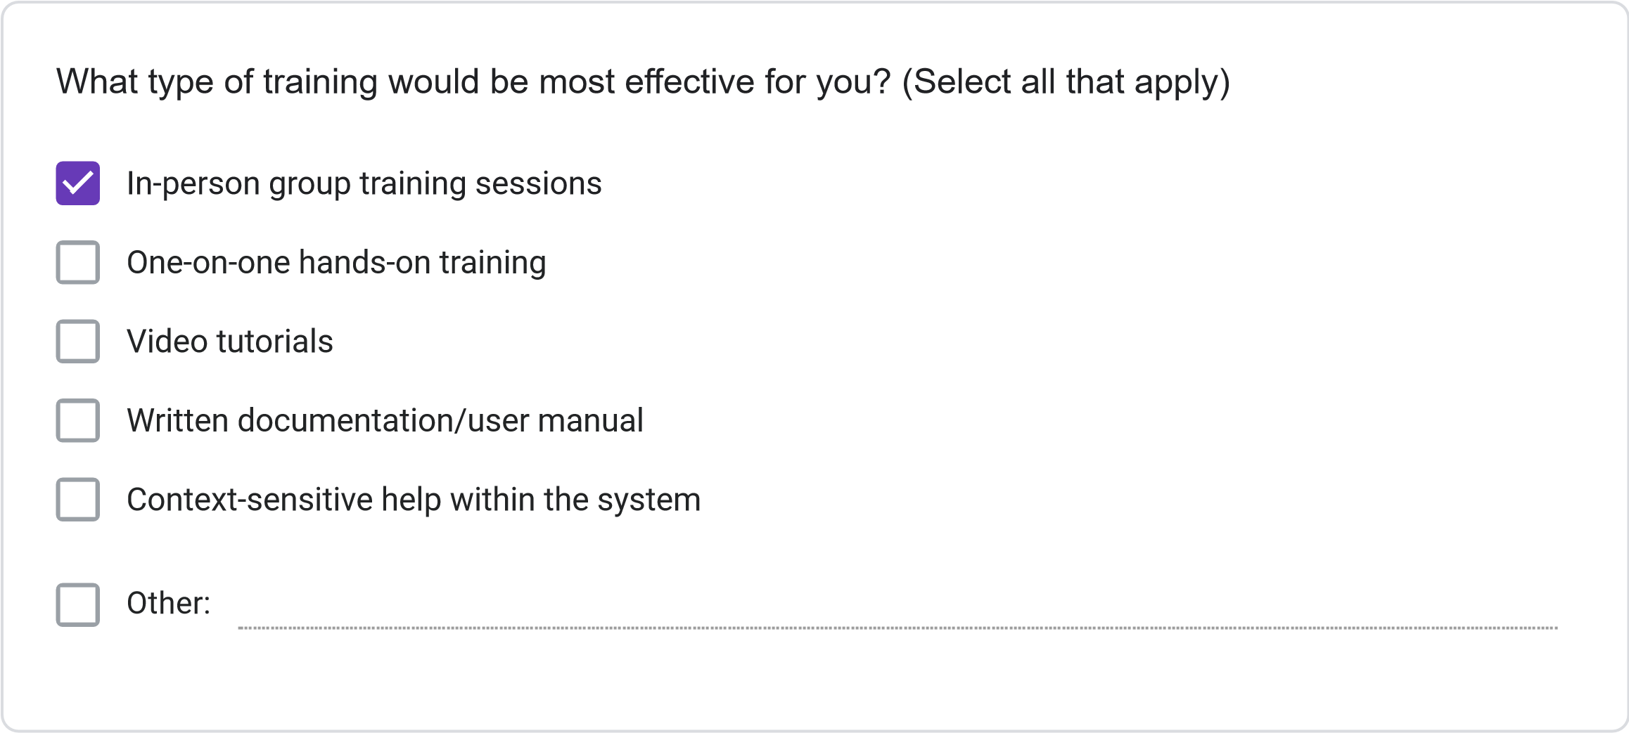
Less than 2 hours
2-4
hours
4-8
hours
More than 8 hours
How much time would you be willing to invest in training for the new system?
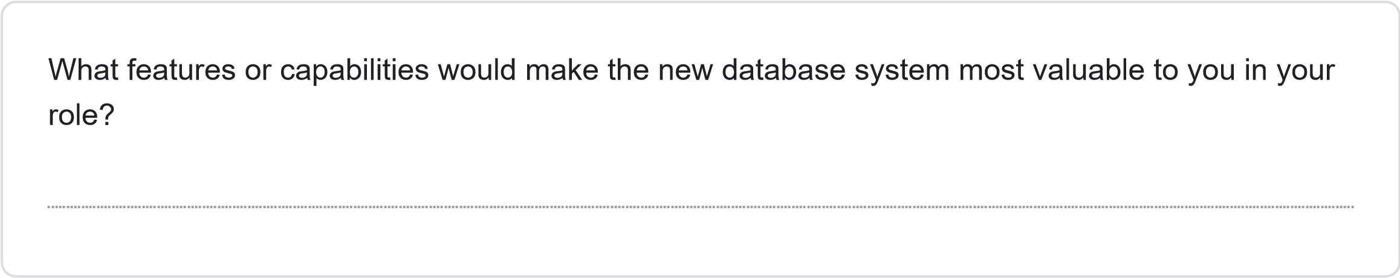
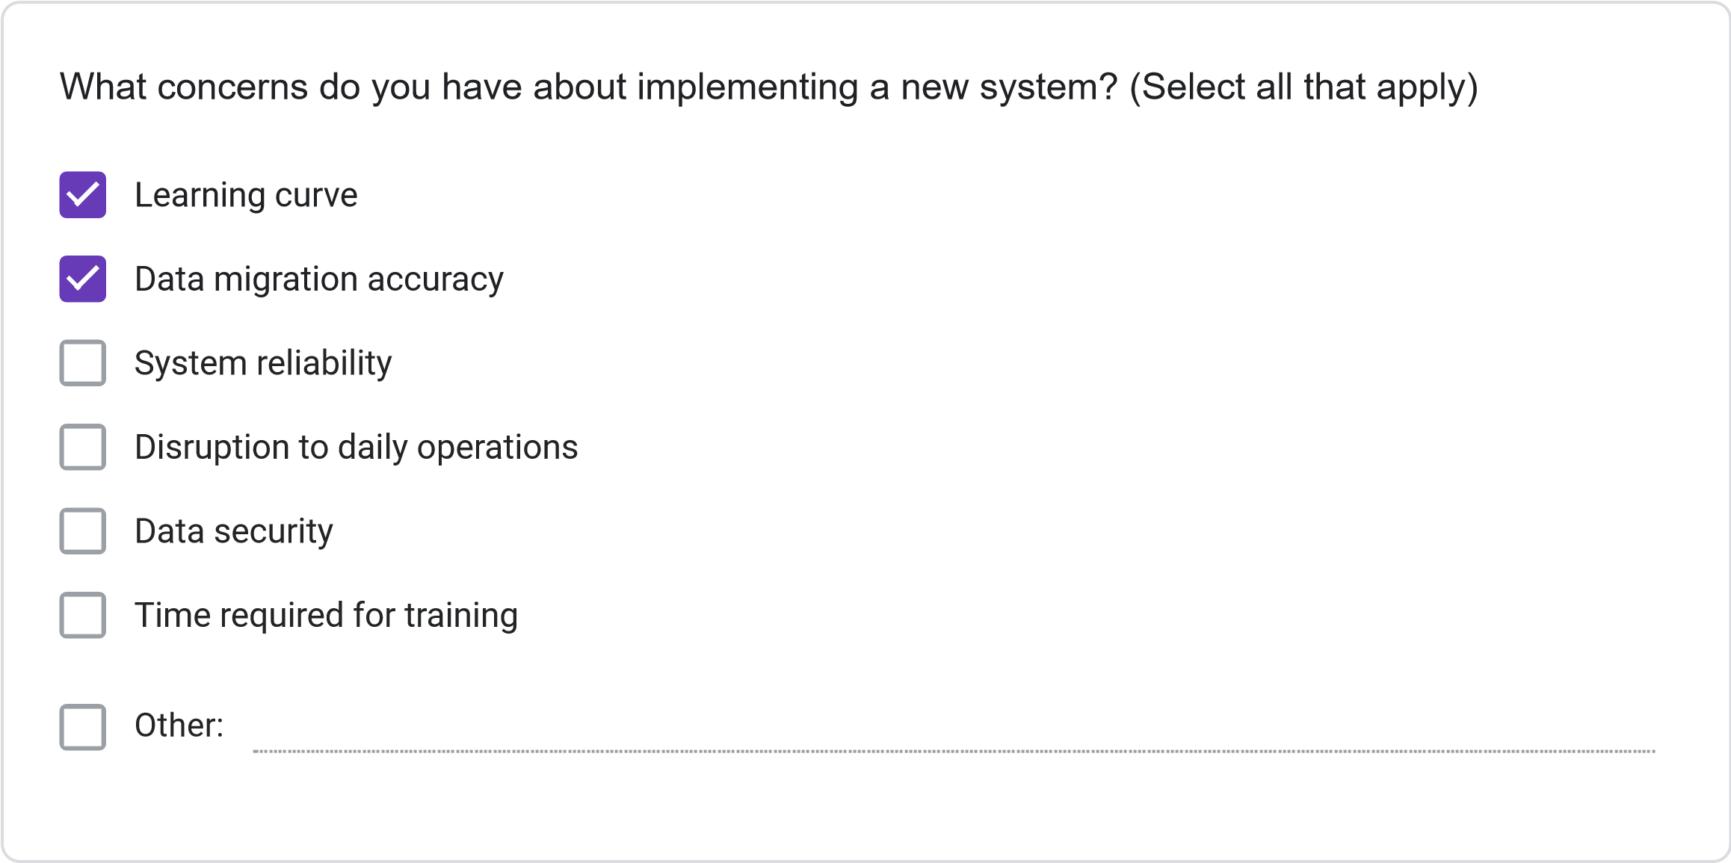
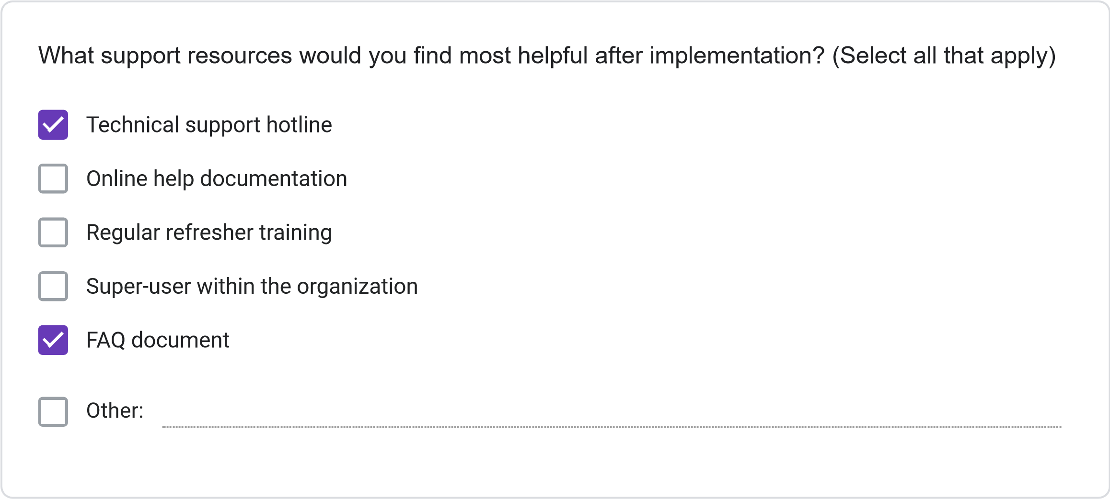
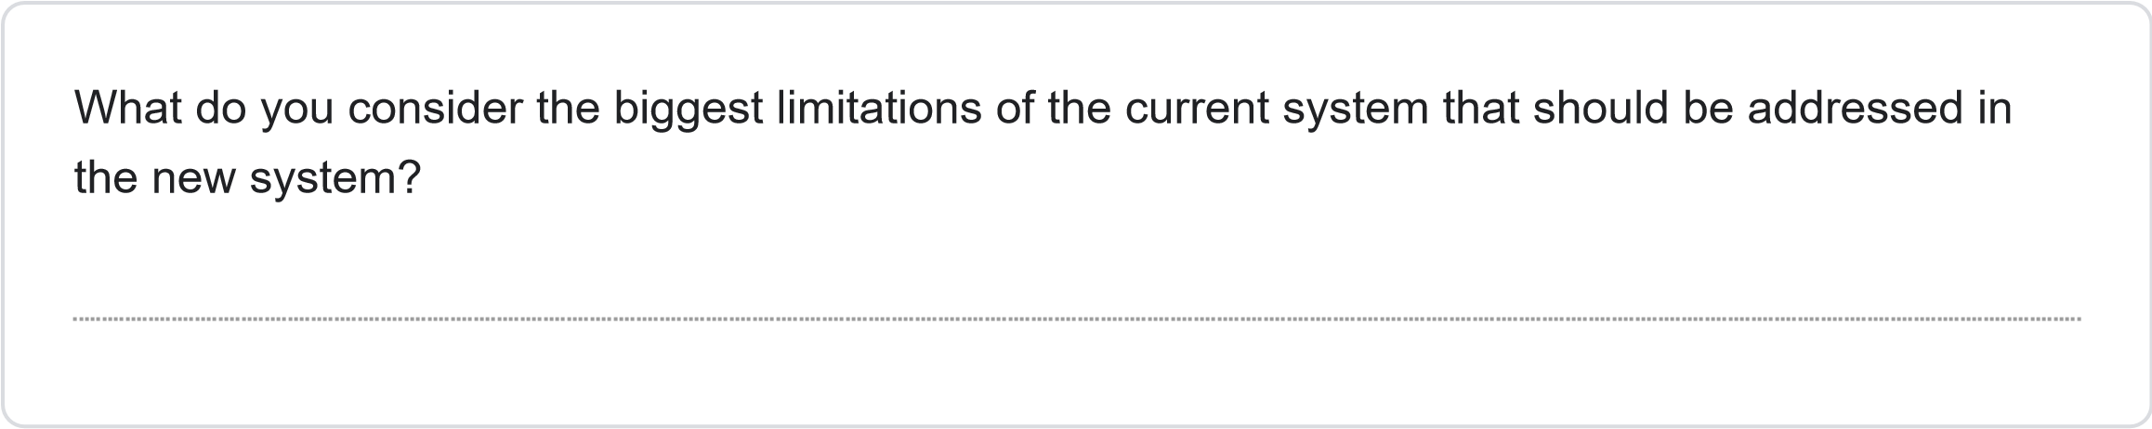
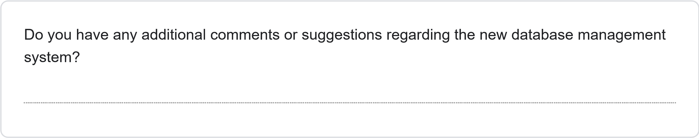
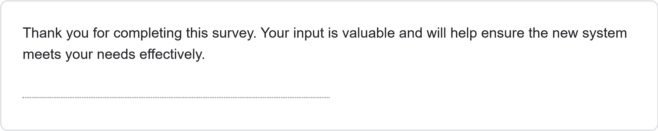
This content is neither created nor endorsed by Google.
Forms
JOSAL CONSULTING DATABASE MANAGEMENT SYSTEM PROJECT REQUIREMENTS SURVEY
Less than 1 Year
1-3
Years
4-6
years
More than 6 years
How long have you been working at Josal Consulting?
This survey aims to gather specific requirements for the new database management system for Josal Consulting. Your responses will help ensure the system meets user needs and improves operational efficiency. The survey should take approximately 15-20 minutes to complete.
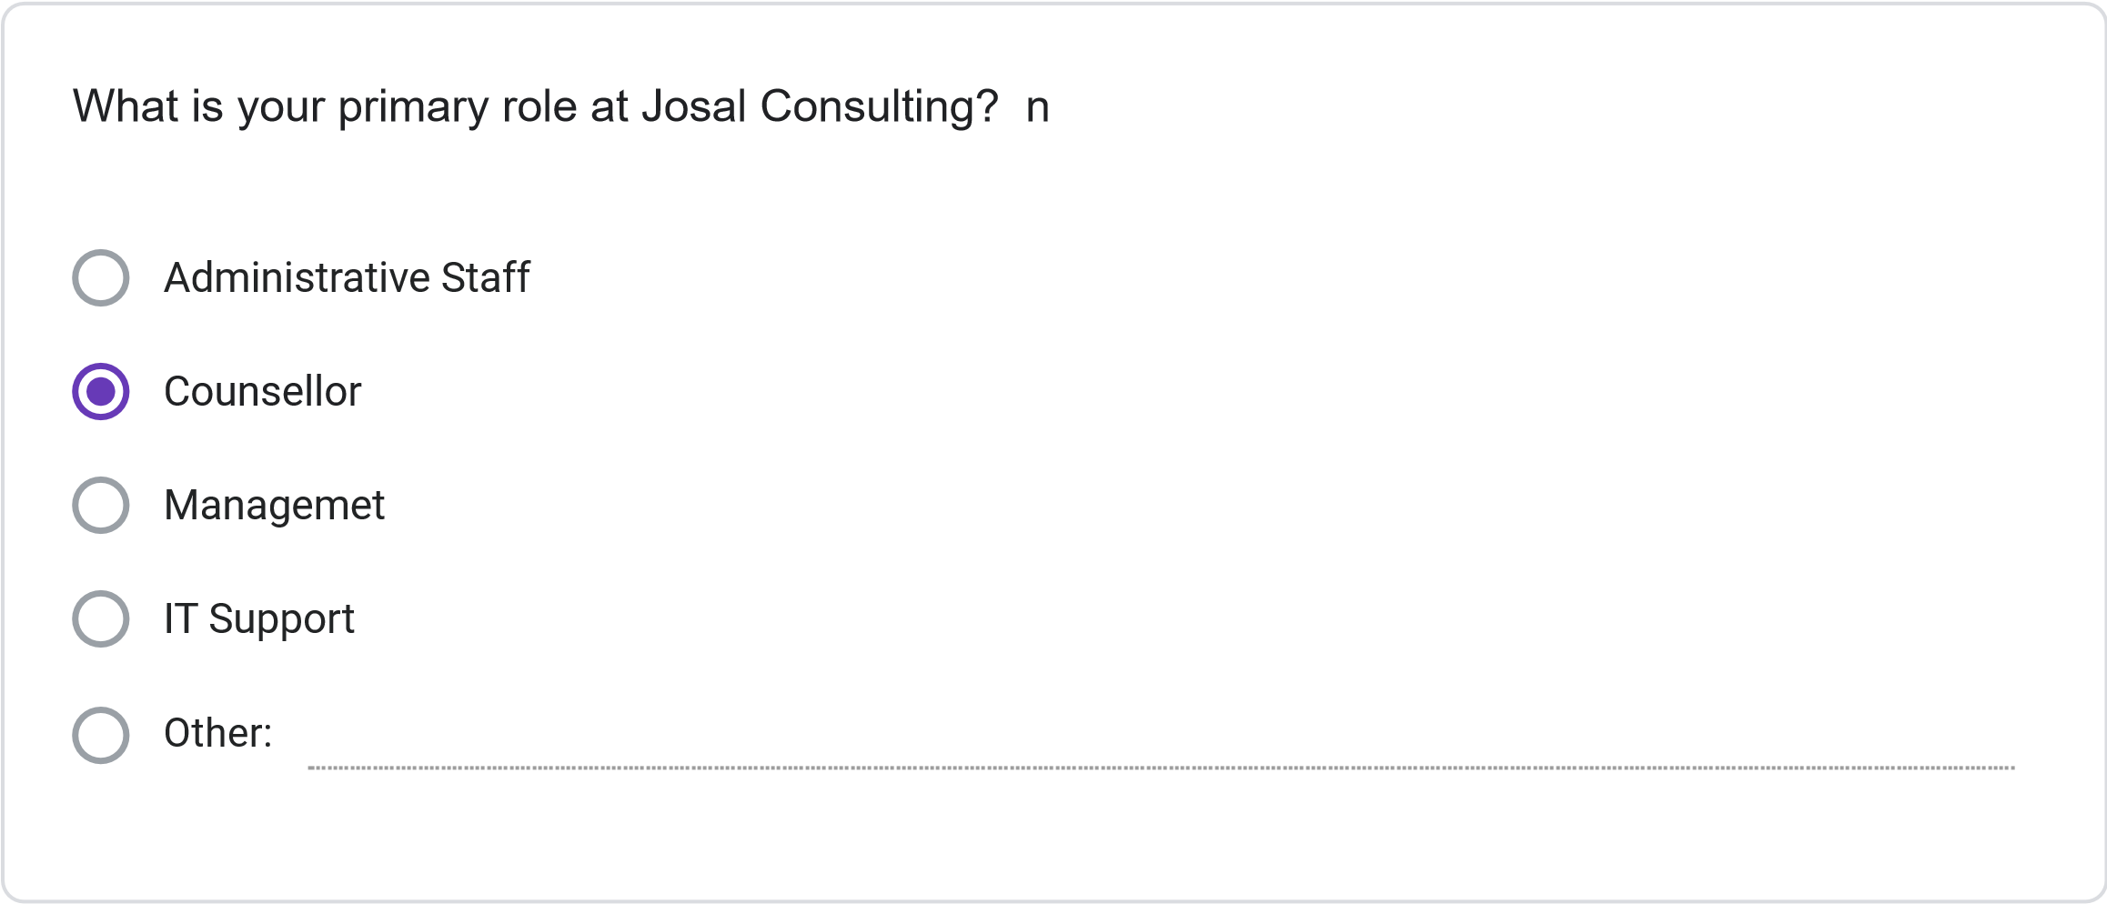
Multiple times daily
Daily
Several times per Week
Weekly or less Frequently
How frequently do you use the current information management system?
Please rate your satisfaction with the following: (1 = Not Preferred, 2 = Slightly Preferred, 3 =
Neutral, 4 = Preferred, 5 = Strongly Preferred)
1
2
3
4
5
Ease of finding
client information
Scheduling
capabilities
Accuracy of
information
Report generation
Data security
System
speed/performance
Less than 30 minutes
30
minutes to 1 hour
1-2
hours
More than 2 hours
On average, how much time do you spend per day on administrative tasks using the current
system?
How often do you encounter the following issues with the current system? (1 = Never, 2 = Rarely,
3
= Sometimes, 4 = Often, 5 = Very Often)
1
2
3
4
5
Schedulint
Conflics
Difficulty Finiding
Client
Information
System Errors or
Crashes
Duplicate or
Inconsistent
Data
Inability to
generate needed
reports
SECTION 3: NEW SYSTEM REQUIREMENTS
Please rate the importance of the following features for the new database system: (1 = Not
Important, 2 = Slightly Important, 3 = Moderately Important, 4 = Important, 5 = Very Important)
1
2
3
4
5
Integrated
calendar/scheduling
system
Client history tracking
Automated conflict
detection
Custom report
generation
Mobile access
capability
Document attachment
functionality
Automated
reminders/notifications
Role-based access
controls
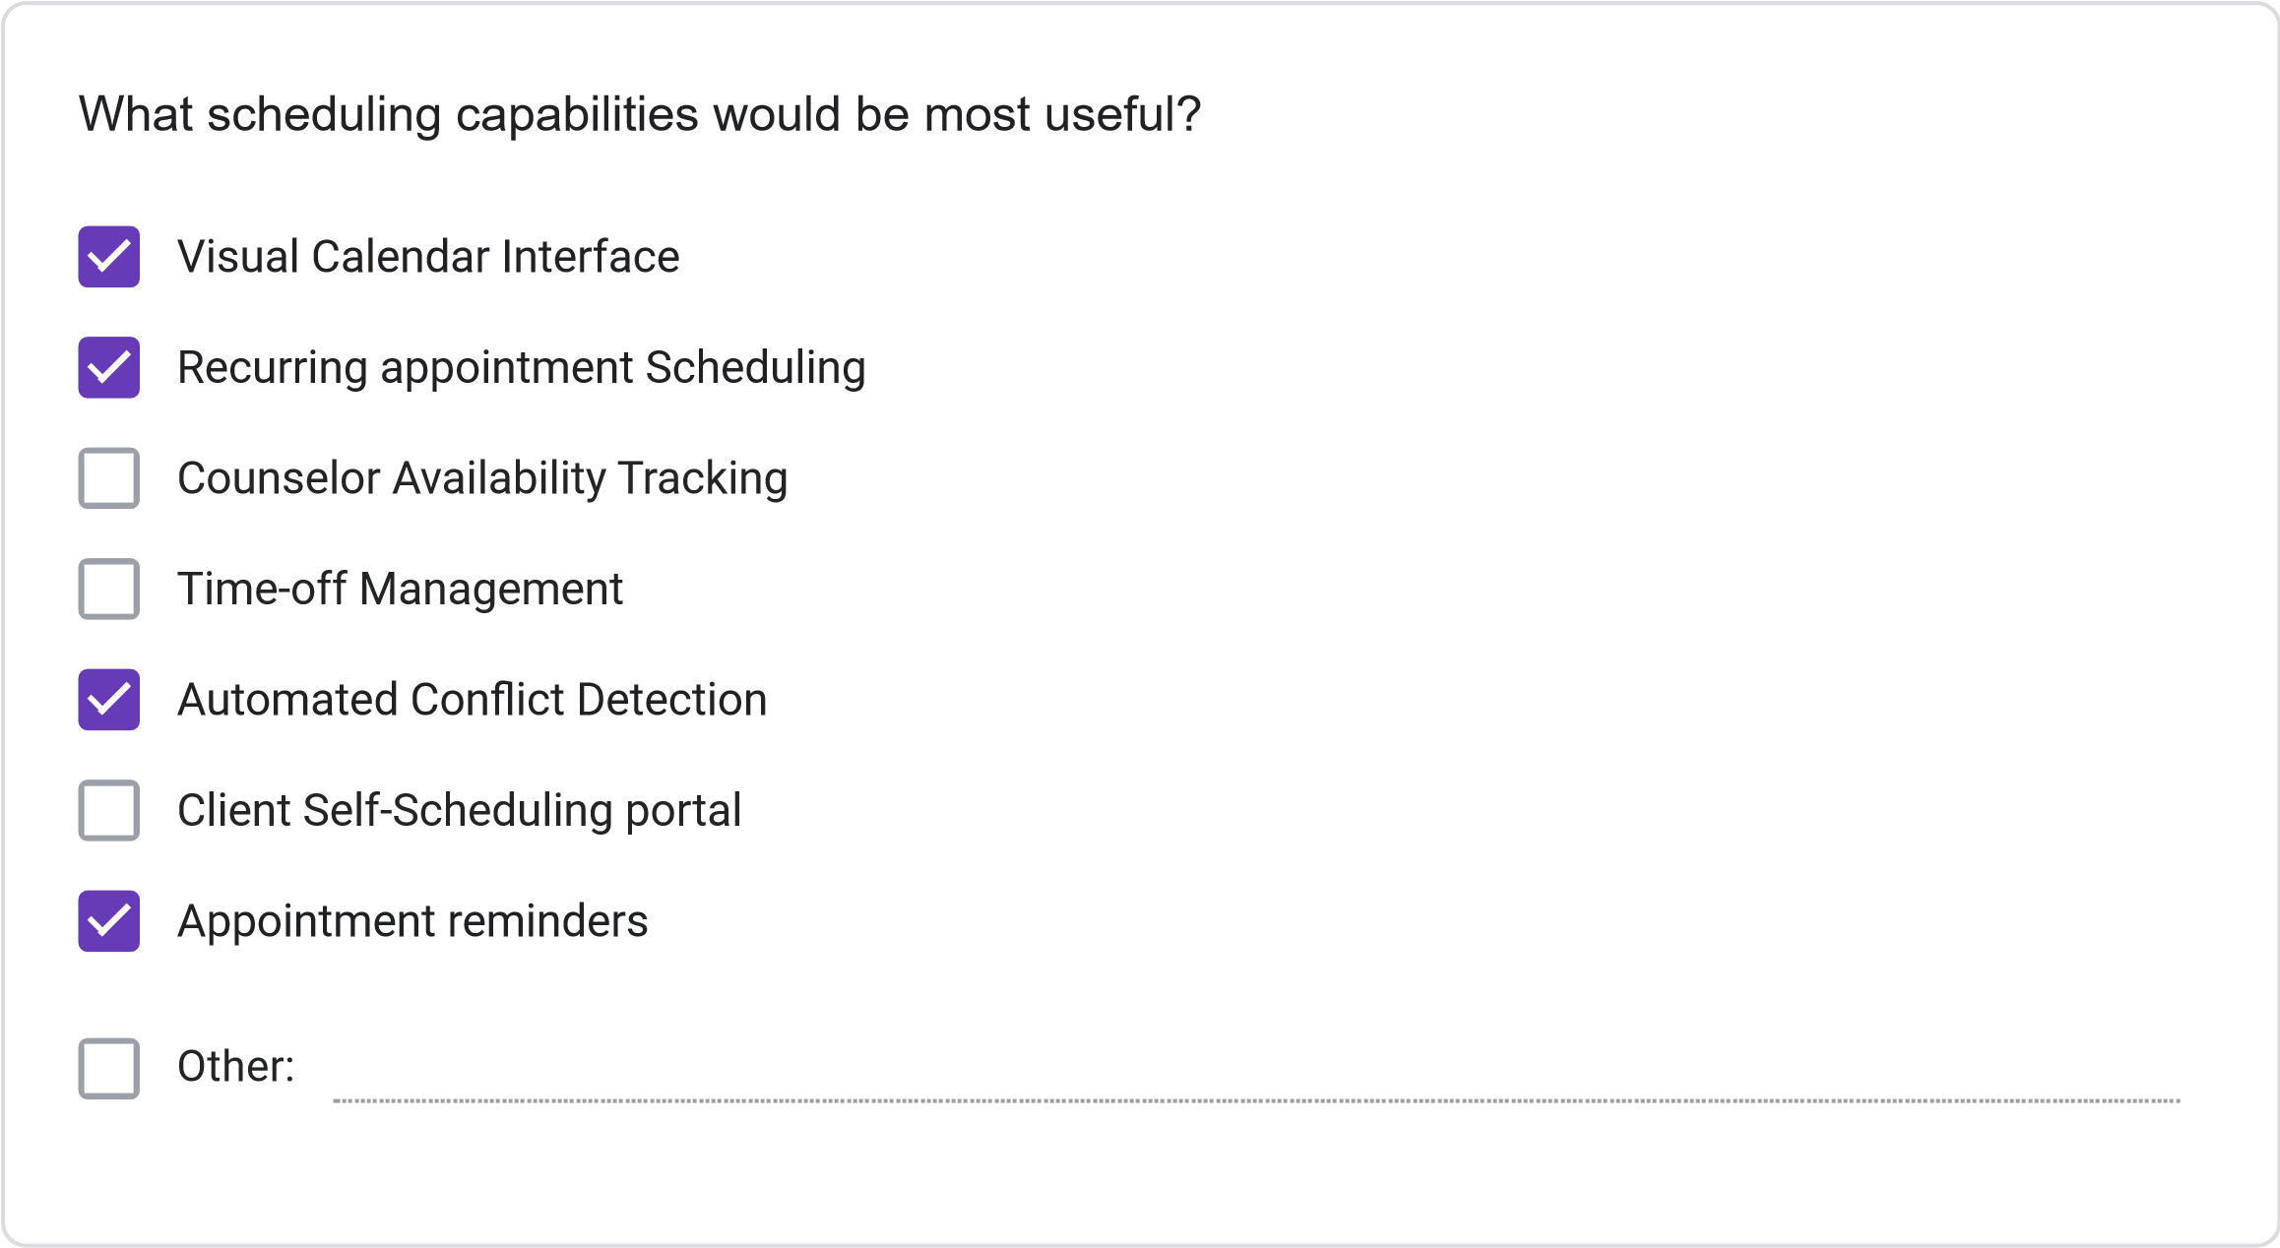
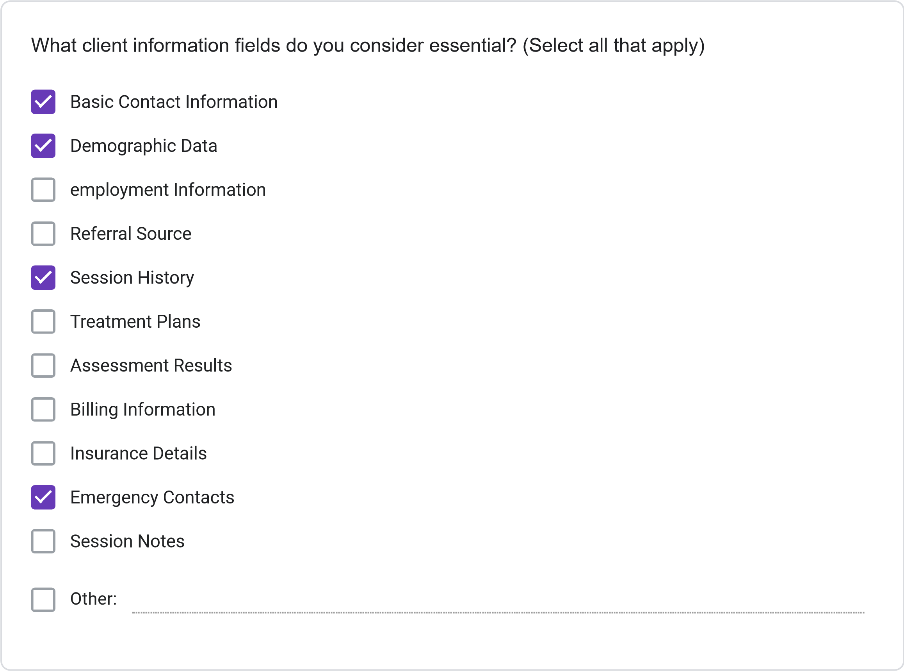
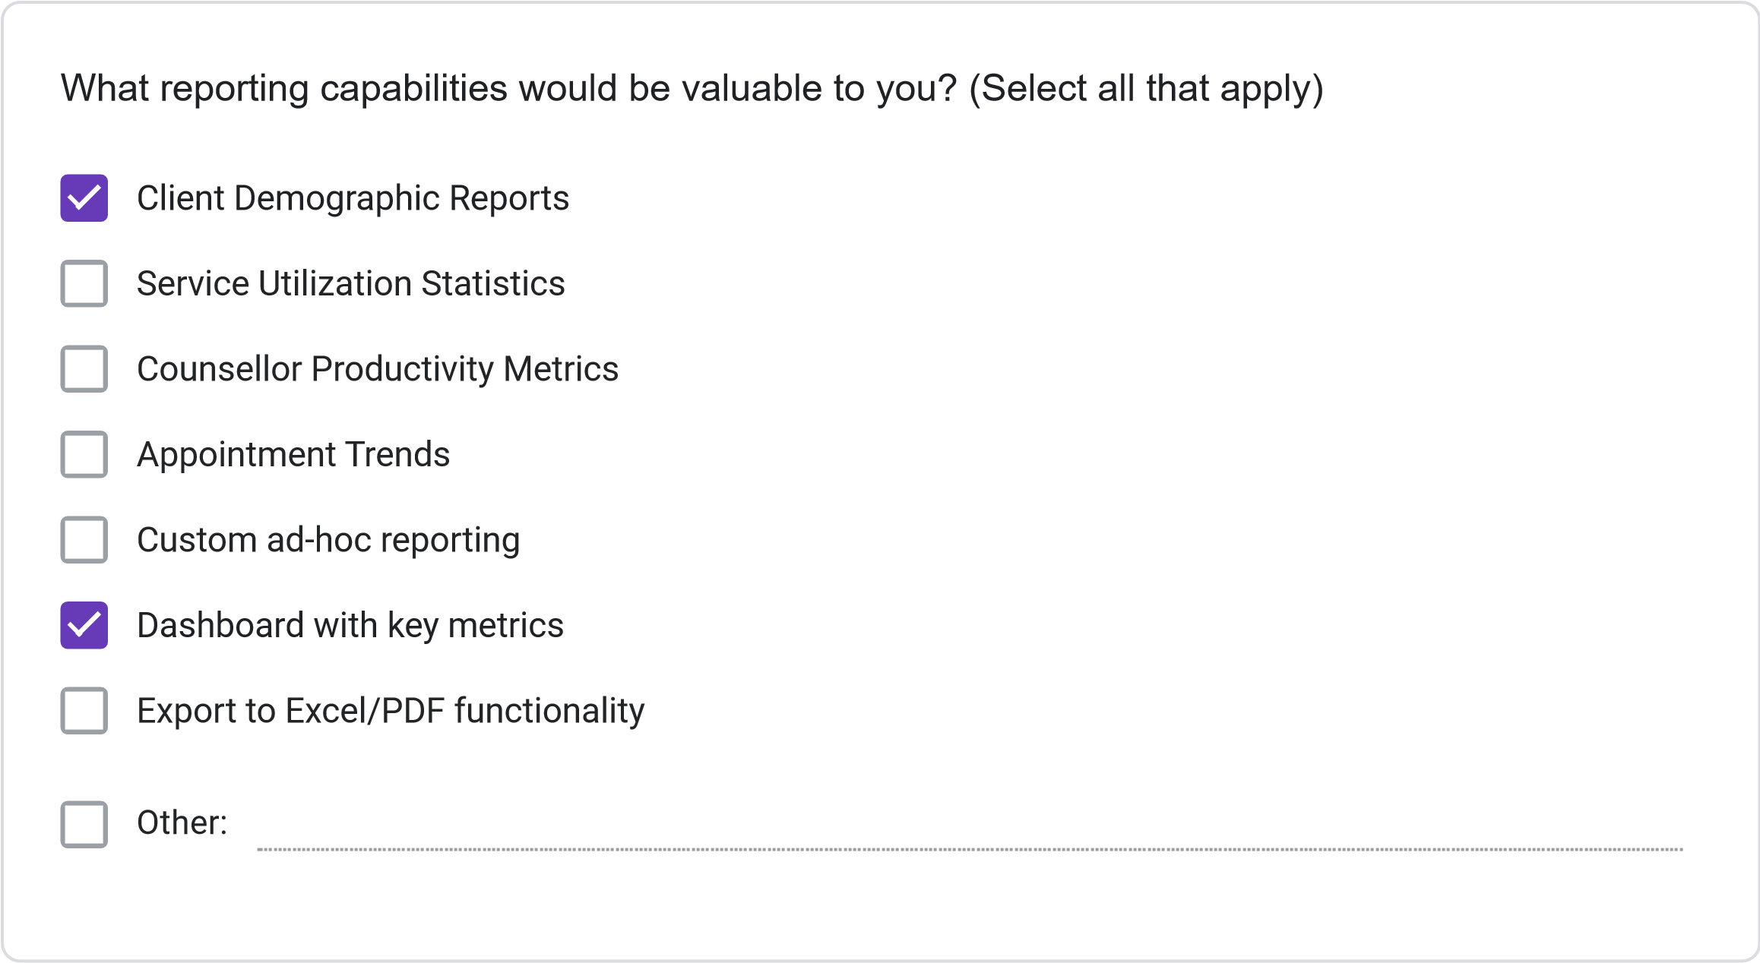
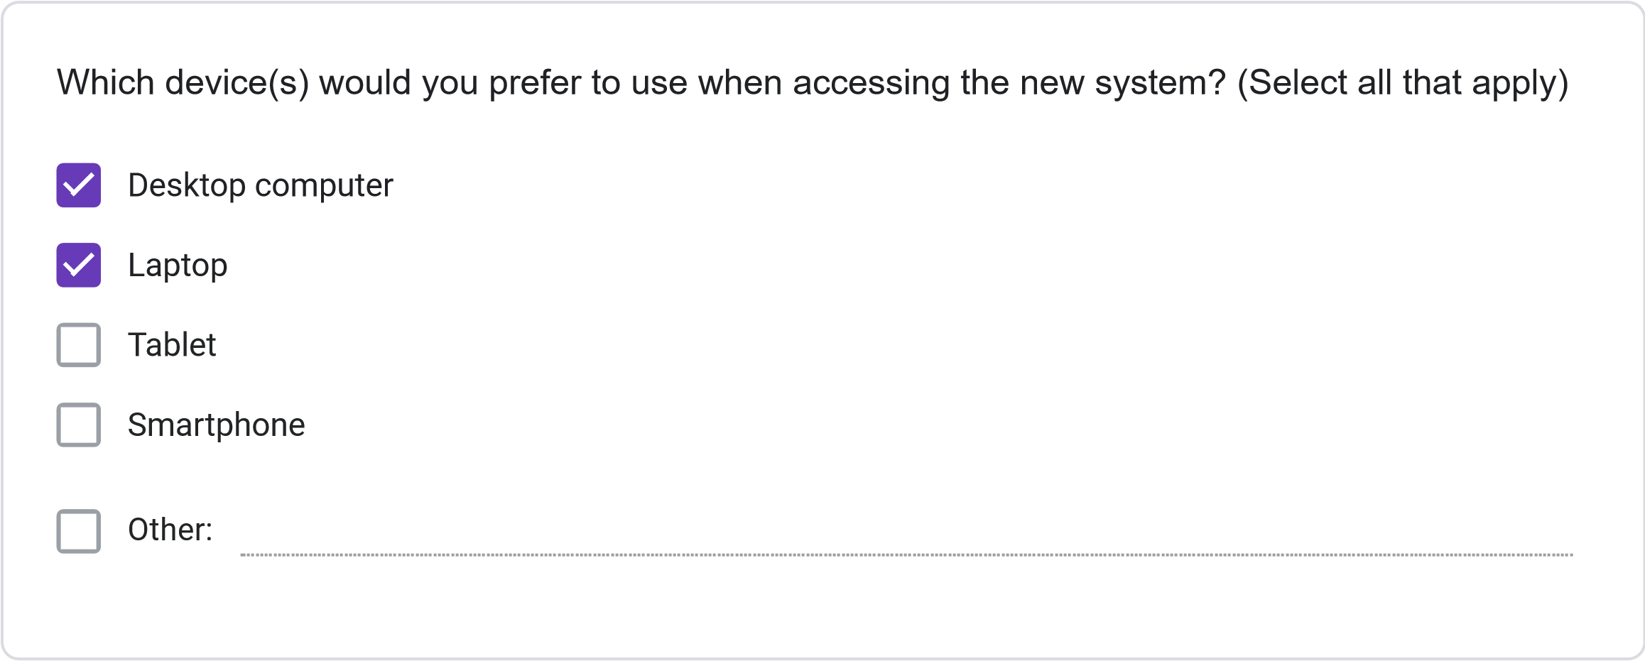
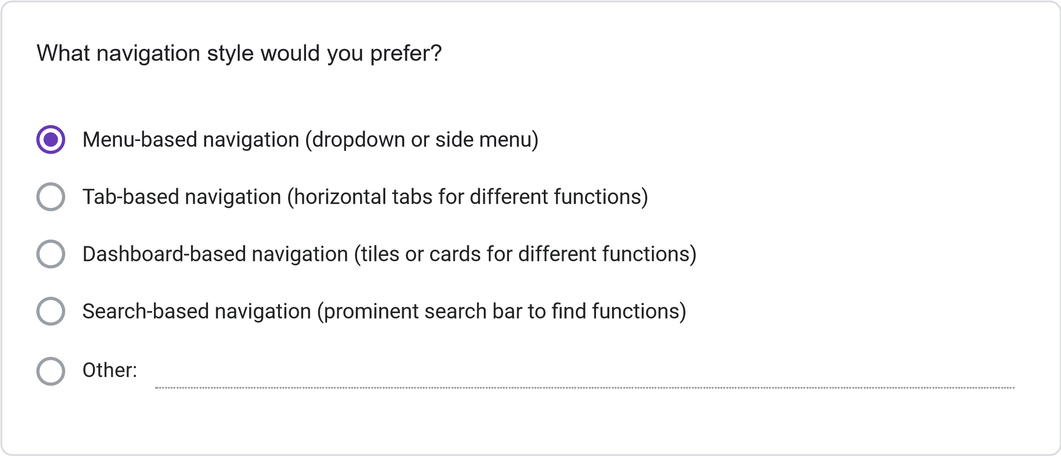
=
11
. Please rate your preference for the following user interface elements: (1 = Not Preferred, 2
Slightly Preferred, 3 = Neutral, 4 = Preferred, 5 = Strongly Preferred)
1
2
3
4
5
Dashboard with
summary
information
Visual calendar
display
Tabs for
different
functions
Search
functionality
Color-coding for
different
information
types
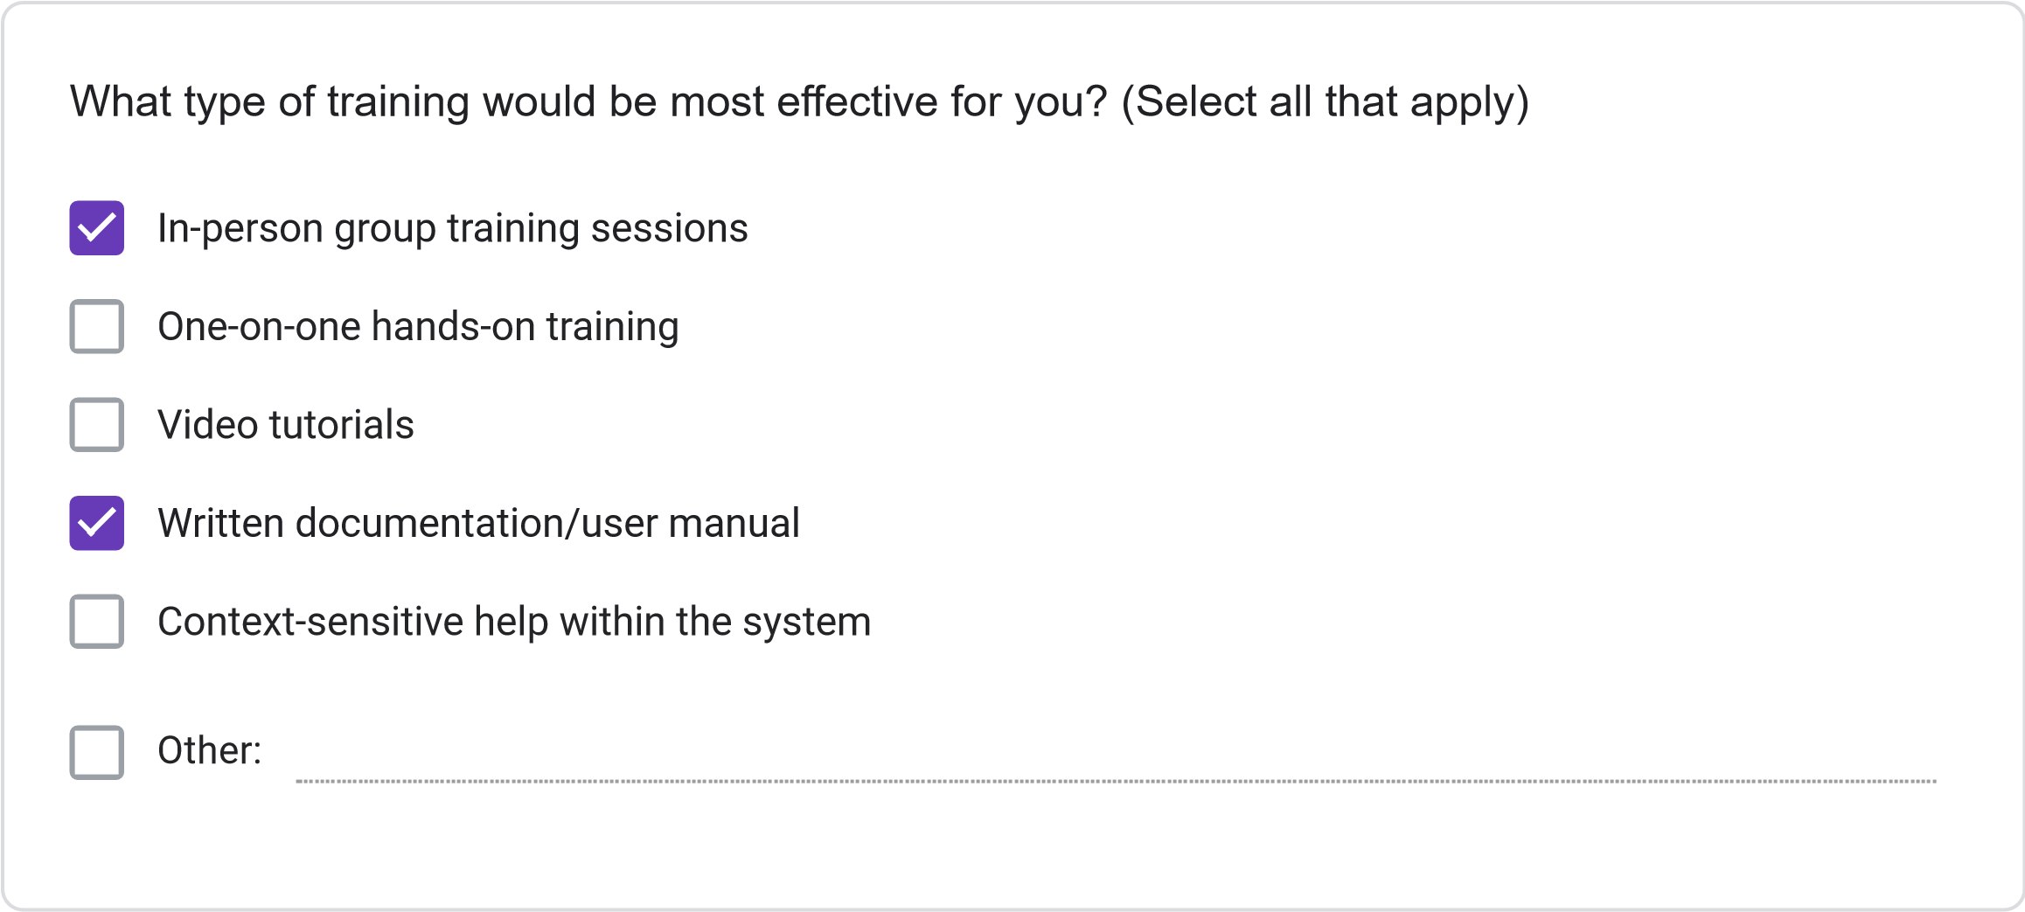
Less than 2 hours
2-4
hours
4-8
hours
More than 8 hours
How much time would you be willing to invest in training for the new system?
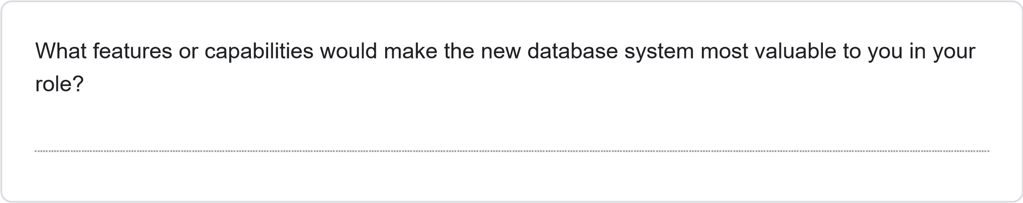
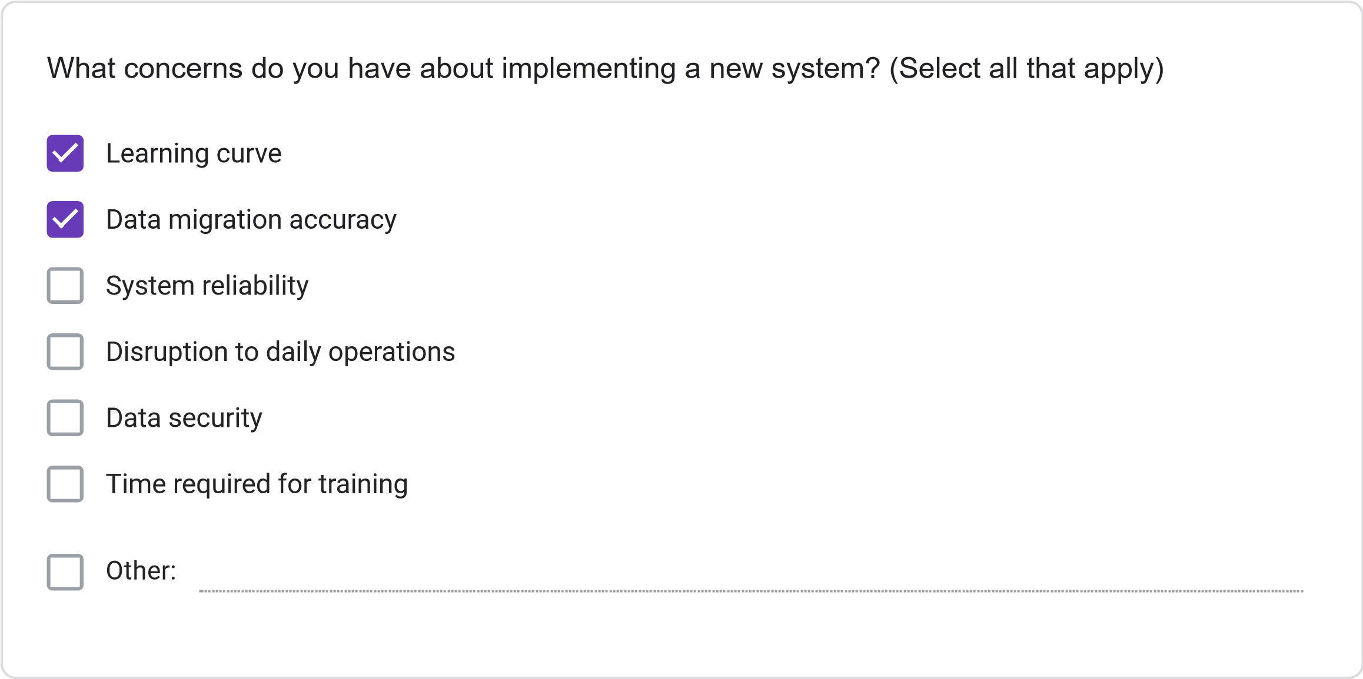
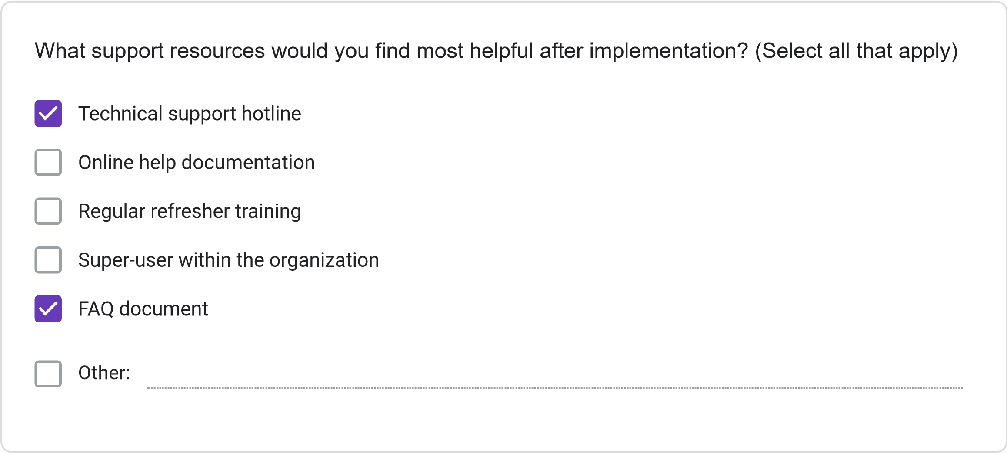
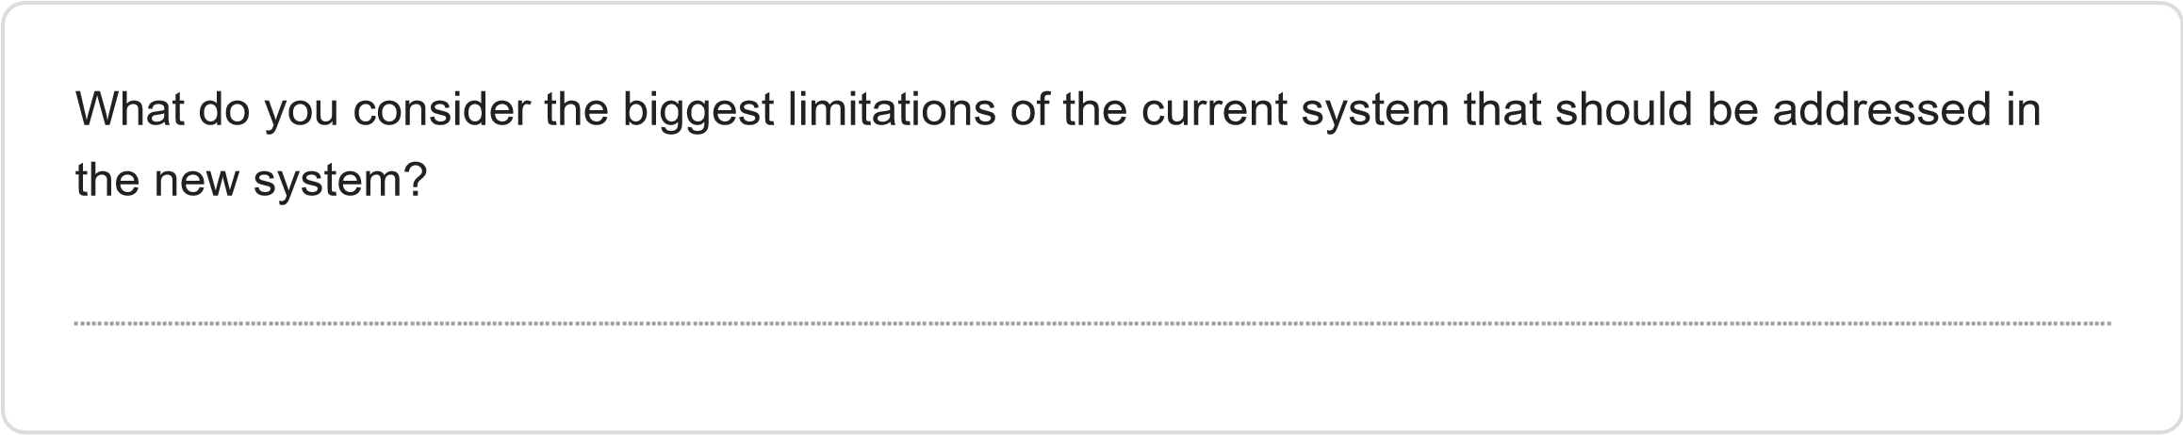
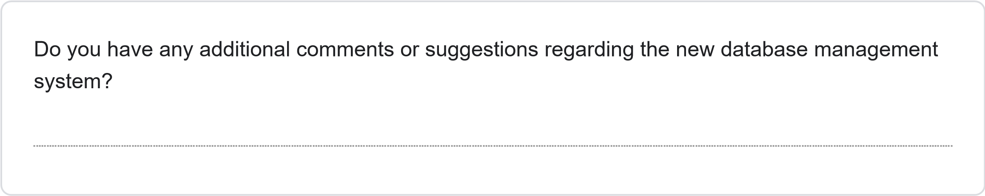
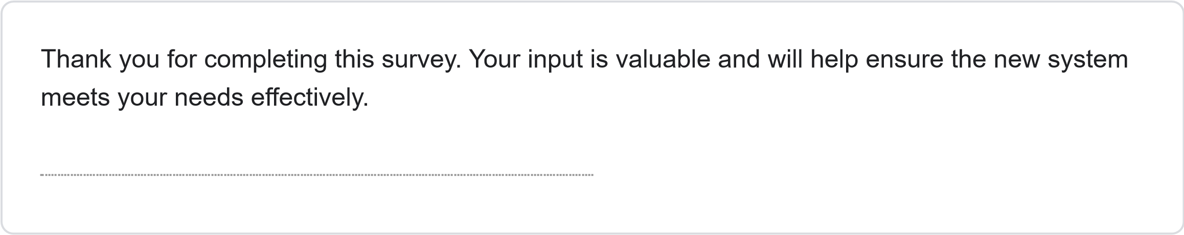
This content is neither created nor endorsed by Google.
Forms
JOSAL CONSULTING DATABASE MANAGEMENT SYSTEM PROJECT REQUIREMENTS SURVEY
Less than 1 Year
1-3
Years
4-6
years
More than 6 years
How long have you been working at Josal Consulting?
This survey aims to gather specific requirements for the new database management system for Josal Consulting. Your responses will help ensure the system meets user needs and improves operational efficiency. The survey should take approximately 15-20 minutes to complete.
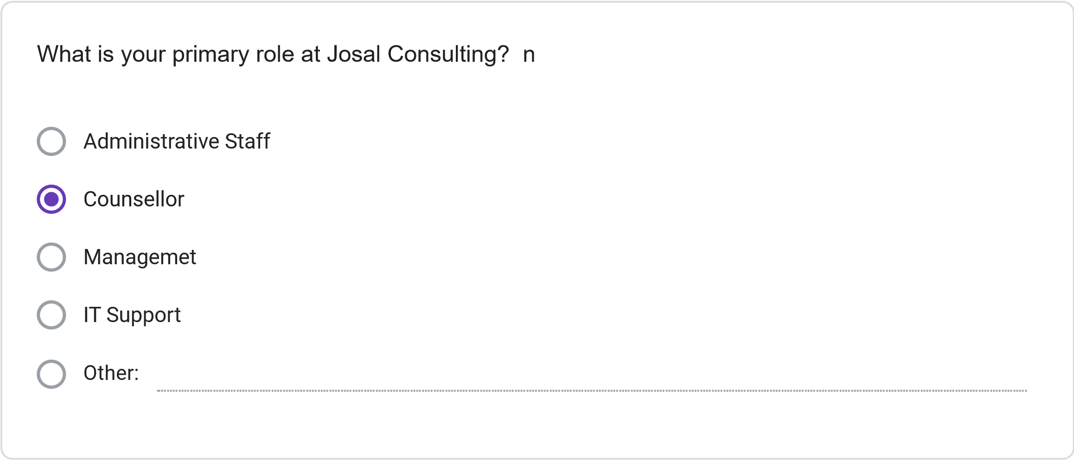
Multiple times daily
Daily
Several times per Week
Weekly or less Frequently
How frequently do you use the current information management system?
Please rate your satisfaction with the following: (1 = Not Preferred, 2 = Slightly Preferred, 3 =
Neutral, 4 = Preferred, 5 = Strongly Preferred)
1
2
3
4
5
Ease of finding
client information
Scheduling
capabilities
Accuracy of
information
Report generation
Data security
System
speed/performance
Less than 30 minutes
30
minutes to 1 hour
1-2
hours
More than 2 hours
On average, how much time do you spend per day on administrative tasks using the current
system?
How often do you encounter the following issues with the current system? (1 = Never, 2 = Rarely,
3
= Sometimes, 4 = Often, 5 = Very Often)
1
2
3
4
5
Schedulint
Conflics
Difficulty Finiding
Client
Information
System Errors or
Crashes
Duplicate or
Inconsistent
Data
Inability to
generate needed
reports
SECTION 3: NEW SYSTEM REQUIREMENTS
Please rate the importance of the following features for the new database system: (1 = Not
Important, 2 = Slightly Important, 3 = Moderately Important, 4 = Important, 5 = Very Important)
1
2
3
4
5
Integrated
calendar/scheduling
system
Client history tracking
Automated conflict
detection
Custom report
generation
Mobile access
capability
Document attachment
functionality
Automated
reminders/notifications
Role-based access
controls
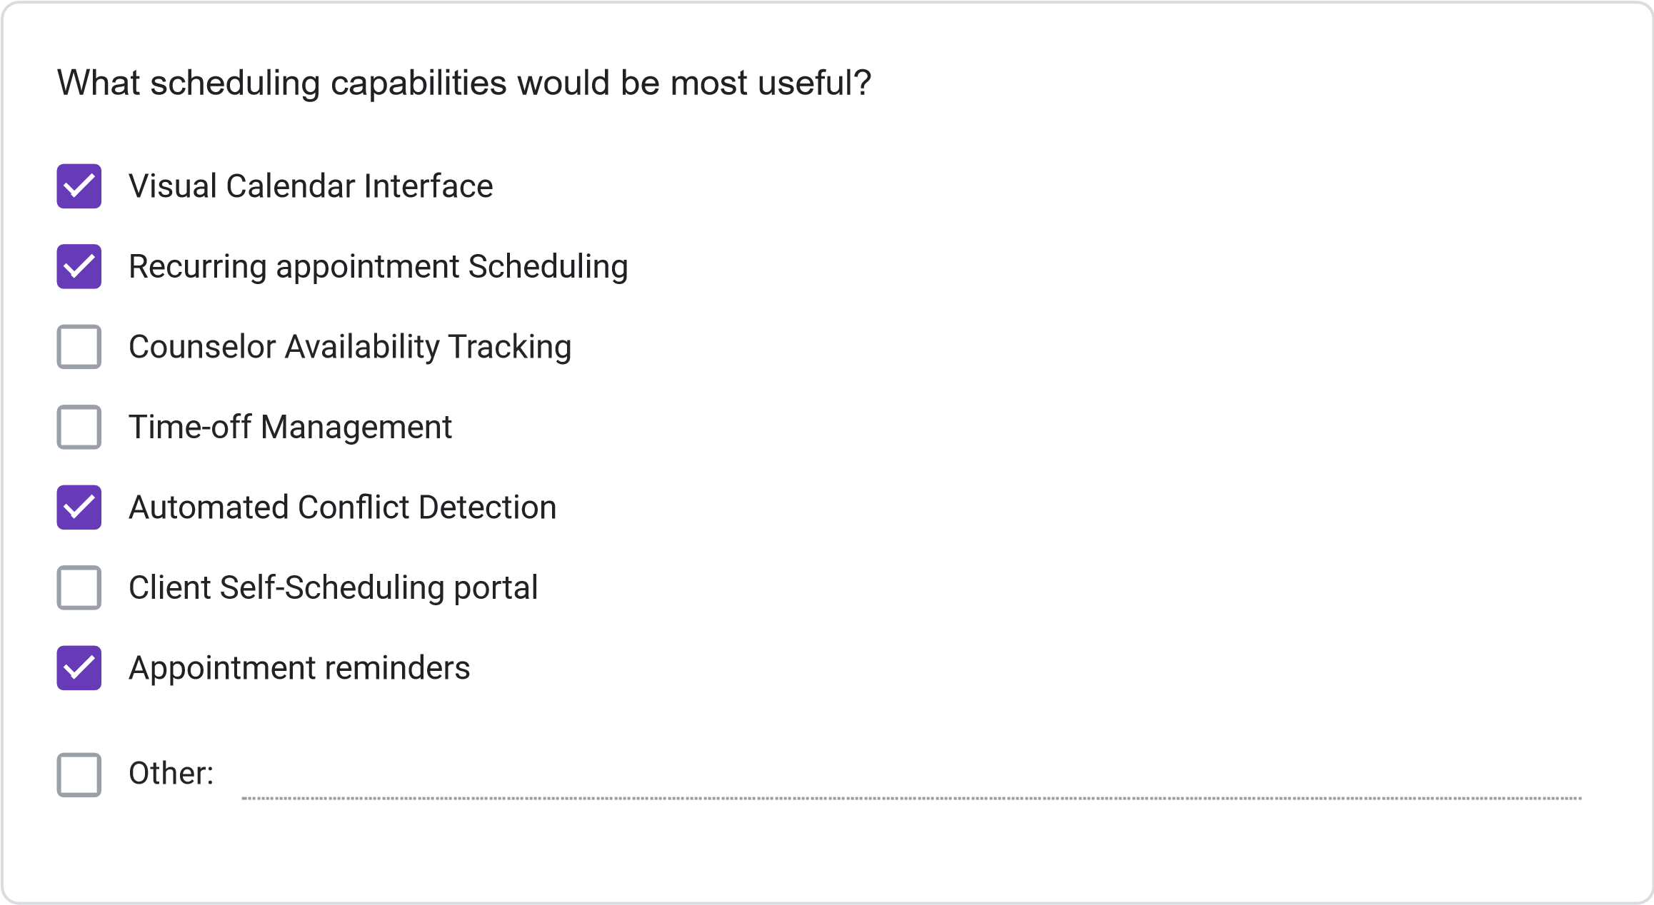
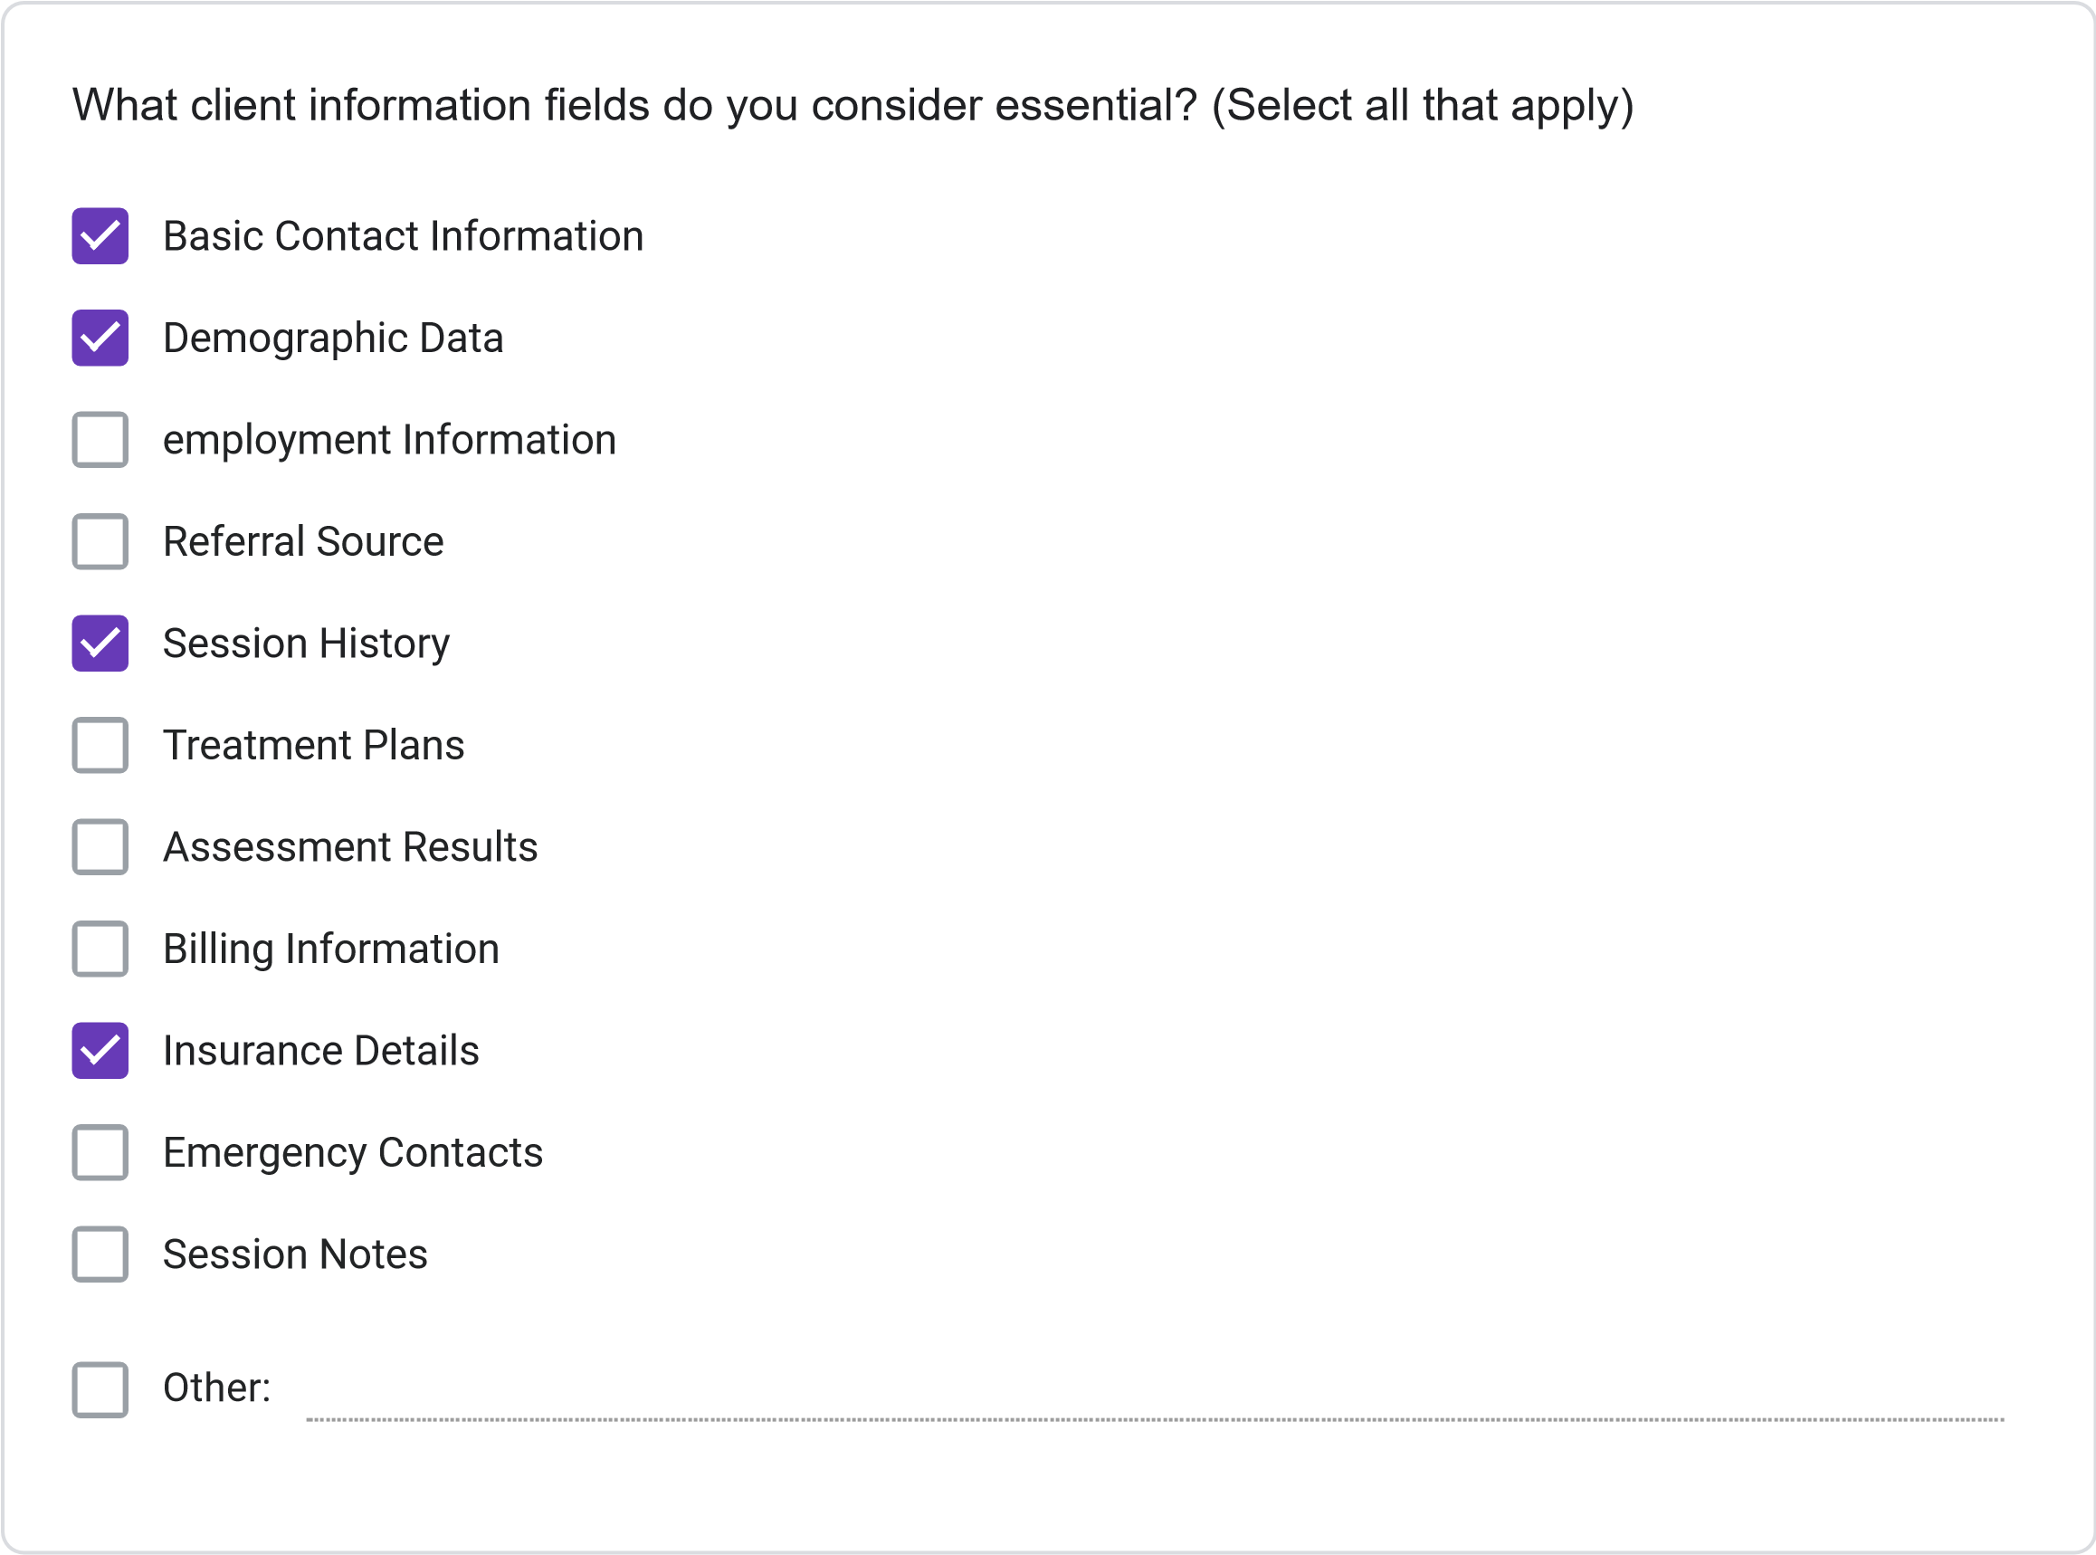
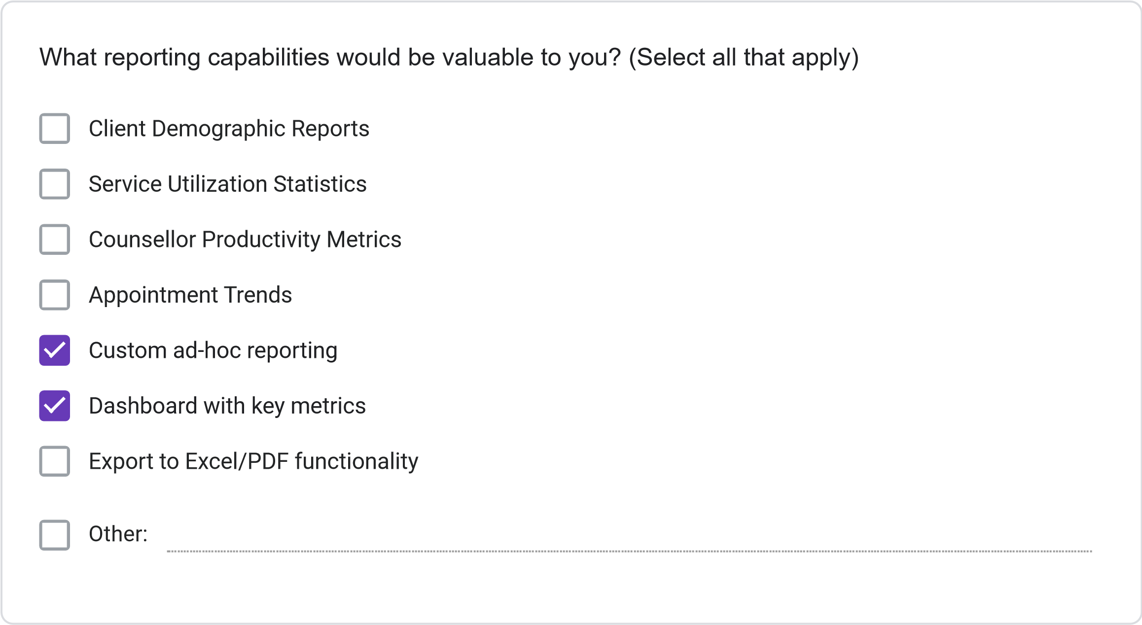
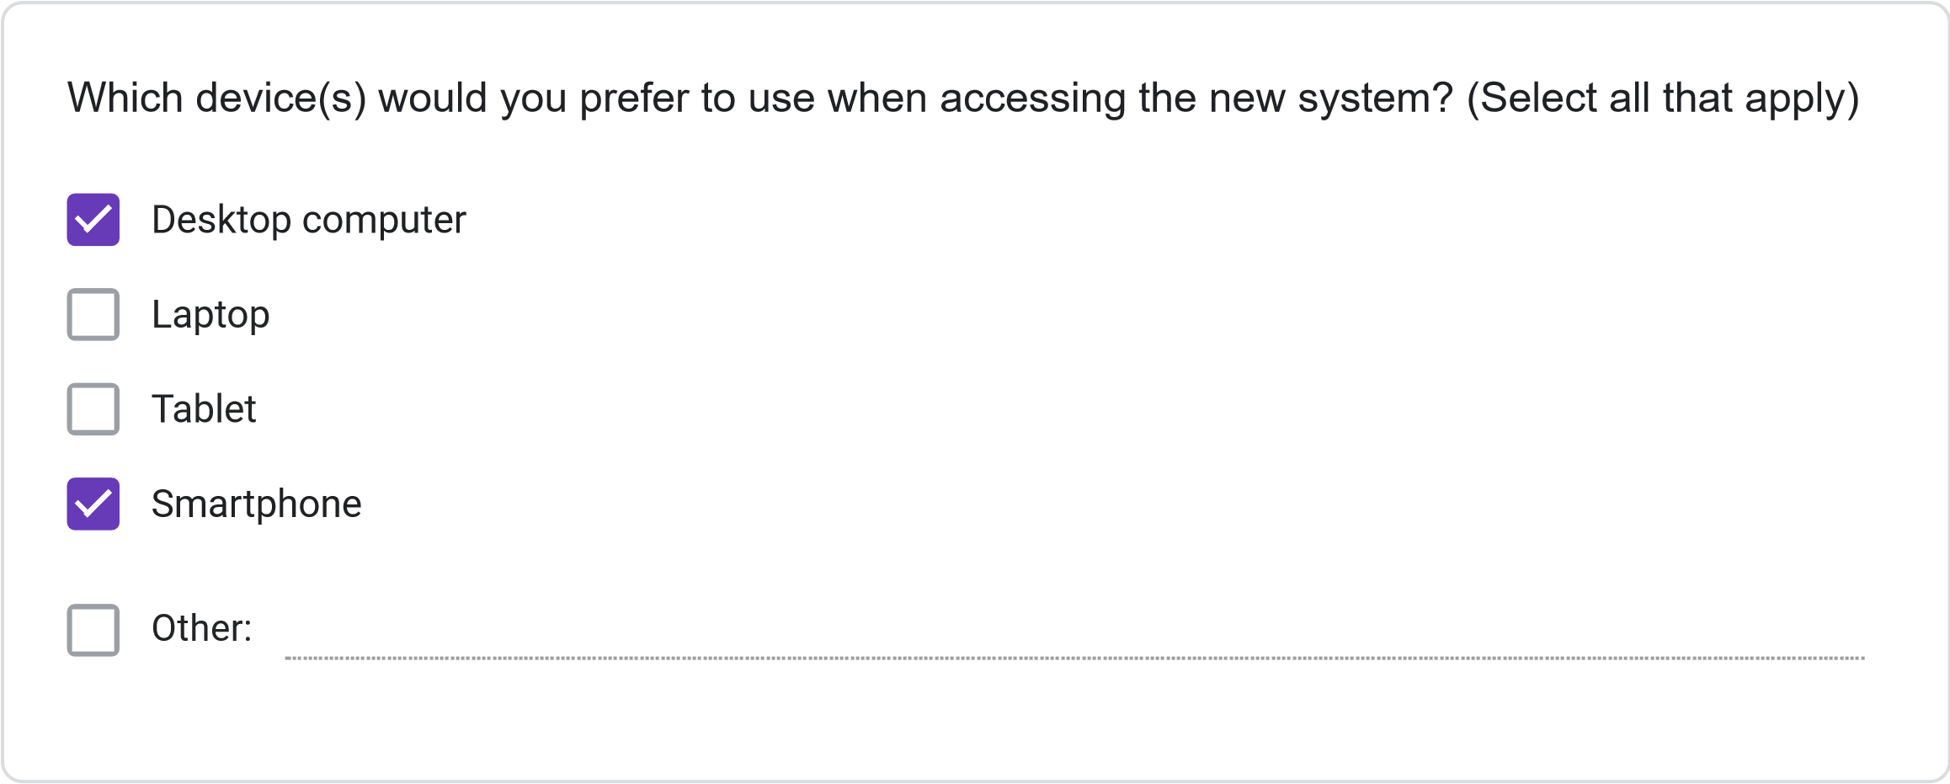
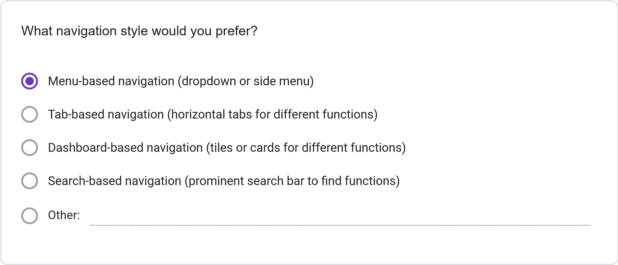
. Please rate your preference for the following user interface elements: (1 = Not Preferred, 2
11
=
Slightly Preferred, 3 = Neutral, 4 = Preferred, 5 = Strongly Preferred)
1
2
3
4
5
Dashboard with
summary
information
Visual calendar
display
Tabs for
different
functions
Search
functionality
Color-coding for
different
information
types
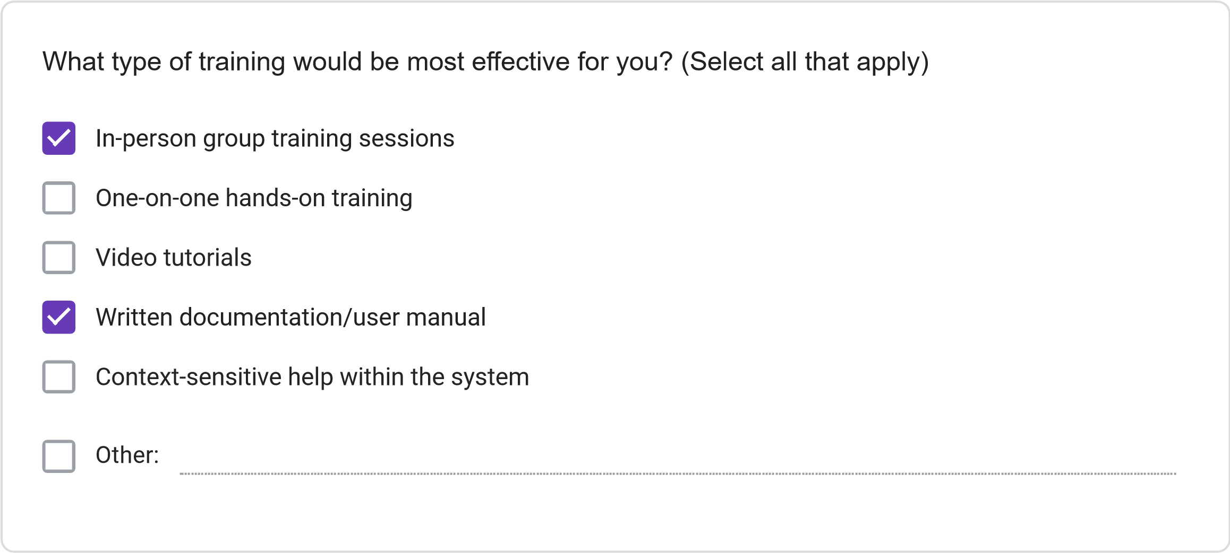
Less than 2 hours
2-4
hours
4-8
hours
More than 8 hours
How much time would you be willing to invest in training for the new system?
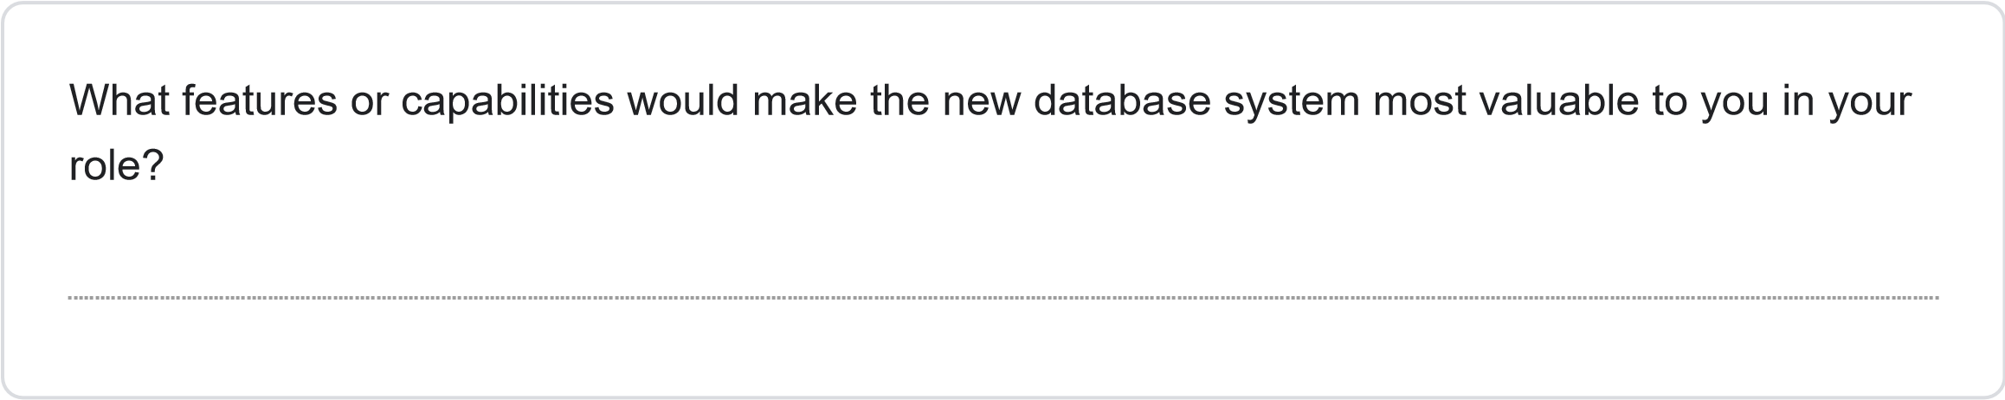
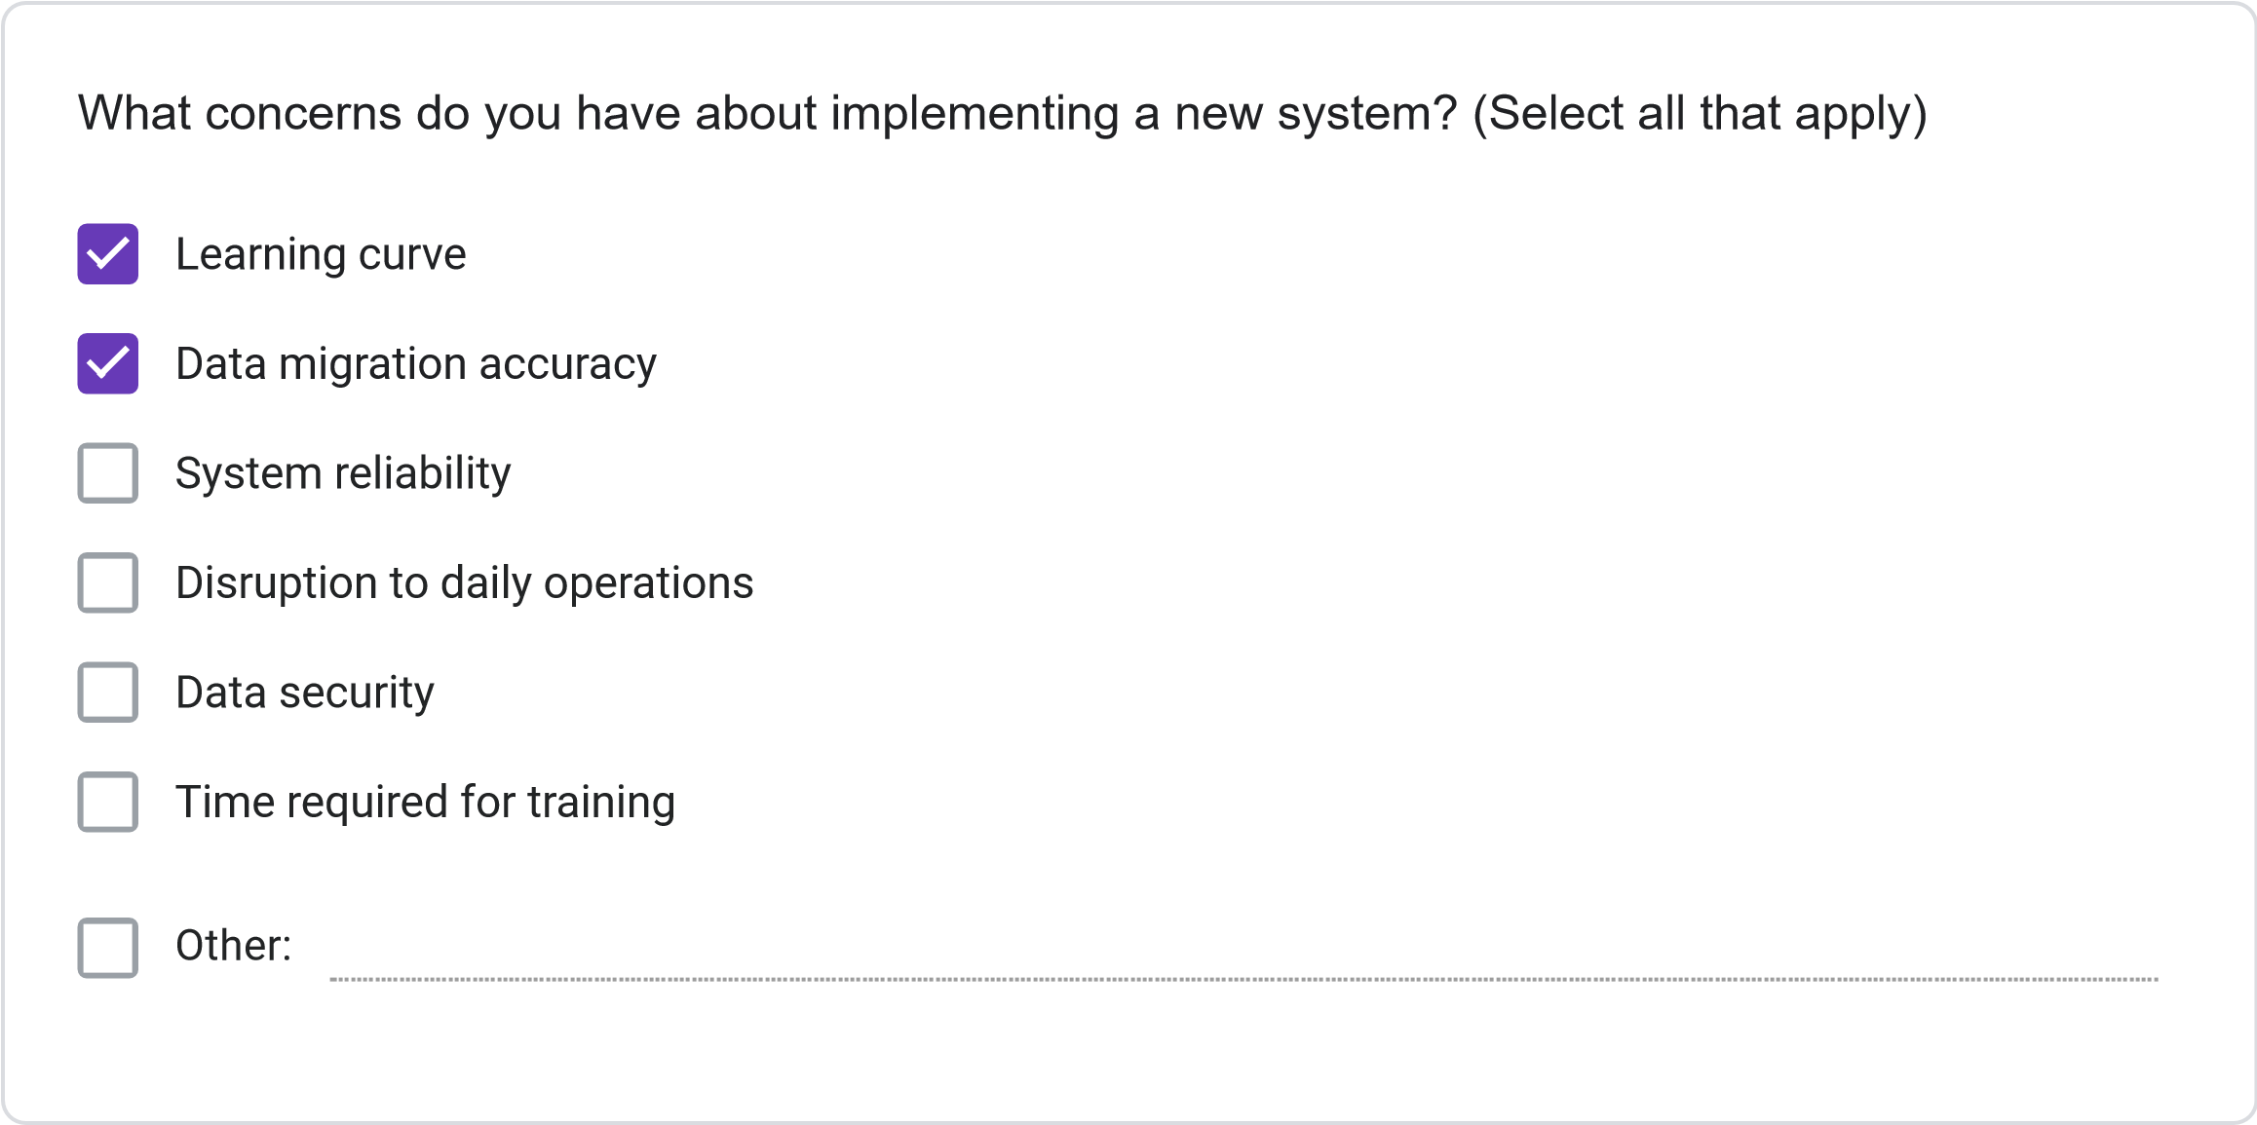
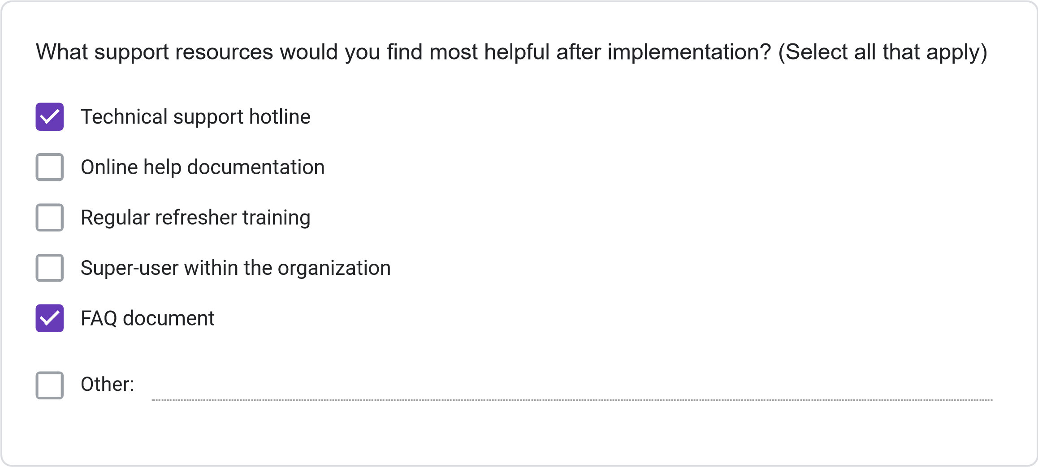
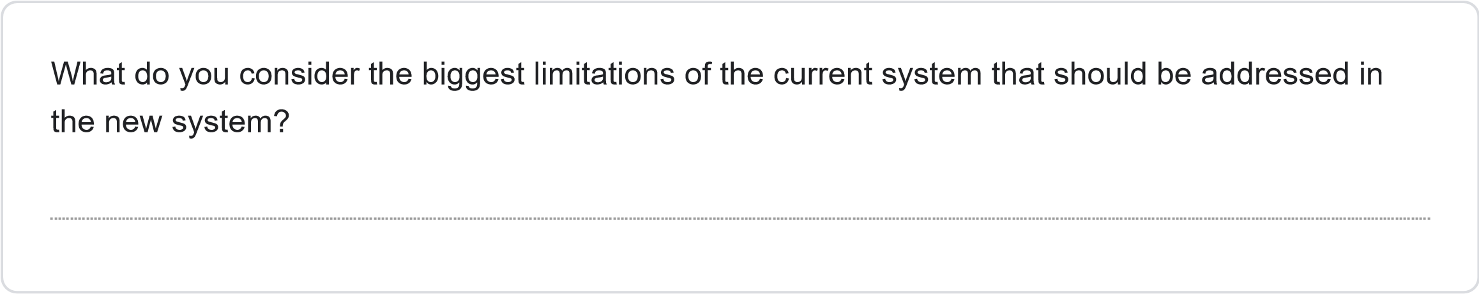
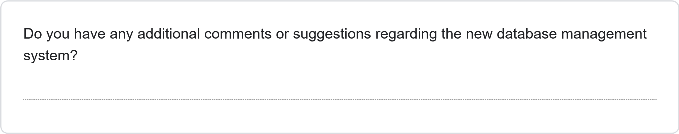
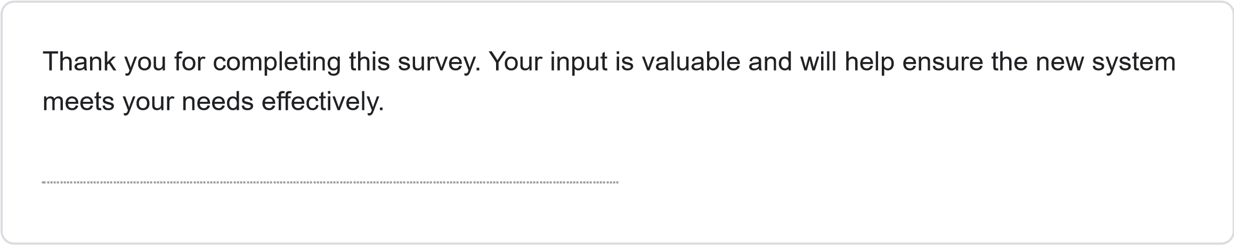
This content is neither created nor endorsed by Google.
Forms
JOSAL CONSULTING DATABASE MANAGEMENT SYSTEM PROJECT REQUIREMENTS SURVEY
Less than 1 Year
1-3
Years
4-6
years
More than 6 years
How long have you been working at Josal Consulting?
This survey aims to gather specific requirements for the new database management system for Josal Consulting. Your responses will help ensure the system meets user needs and improves operational efficiency. The survey should take approximately 15-20 minutes to complete.
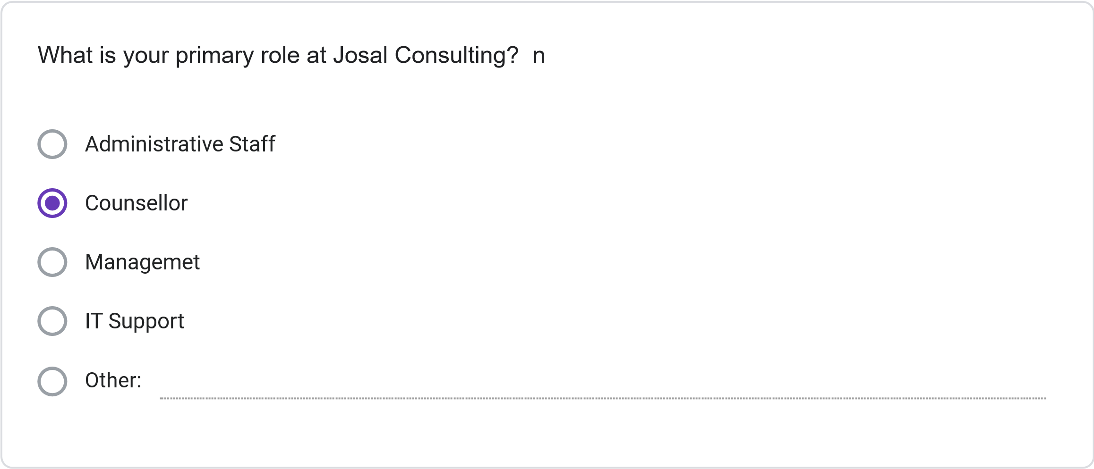
Multiple times daily
Daily
Several times per Week
Weekly or less Frequently
How frequently do you use the current information management system?
Please rate your satisfaction with the following: (1 = Not Preferred, 2 = Slightly Preferred, 3 =
Neutral, 4 = Preferred, 5 = Strongly Preferred)
1
2
3
4
5
Ease of finding
client information
Scheduling
capabilities
Accuracy of
information
Report generation
Data security
System
speed/performance
Less than 30 minutes
30
minutes to 1 hour
1-2
hours
More than 2 hours
On average, how much time do you spend per day on administrative tasks using the current
system?
How often do you encounter the following issues with the current system? (1 = Never, 2 = Rarely,
3
= Sometimes, 4 = Often, 5 = Very Often)
1
2
3
4
5
Schedulint
Conflics
Difficulty Finiding
Client
Information
System Errors or
Crashes
Duplicate or
Inconsistent
Data
Inability to
generate needed
reports
SECTION 3: NEW SYSTEM REQUIREMENTS
Please rate the importance of the following features for the new database system: (1 = Not
Important, 2 = Slightly Important, 3 = Moderately Important, 4 = Important, 5 = Very Important)
1
2
3
4
5
Integrated
calendar/scheduling
system
Client history tracking
Automated conflict
detection
Custom report
generation
Mobile access
capability
Document attachment
functionality
Automated
reminders/notifications
Role-based access
controls
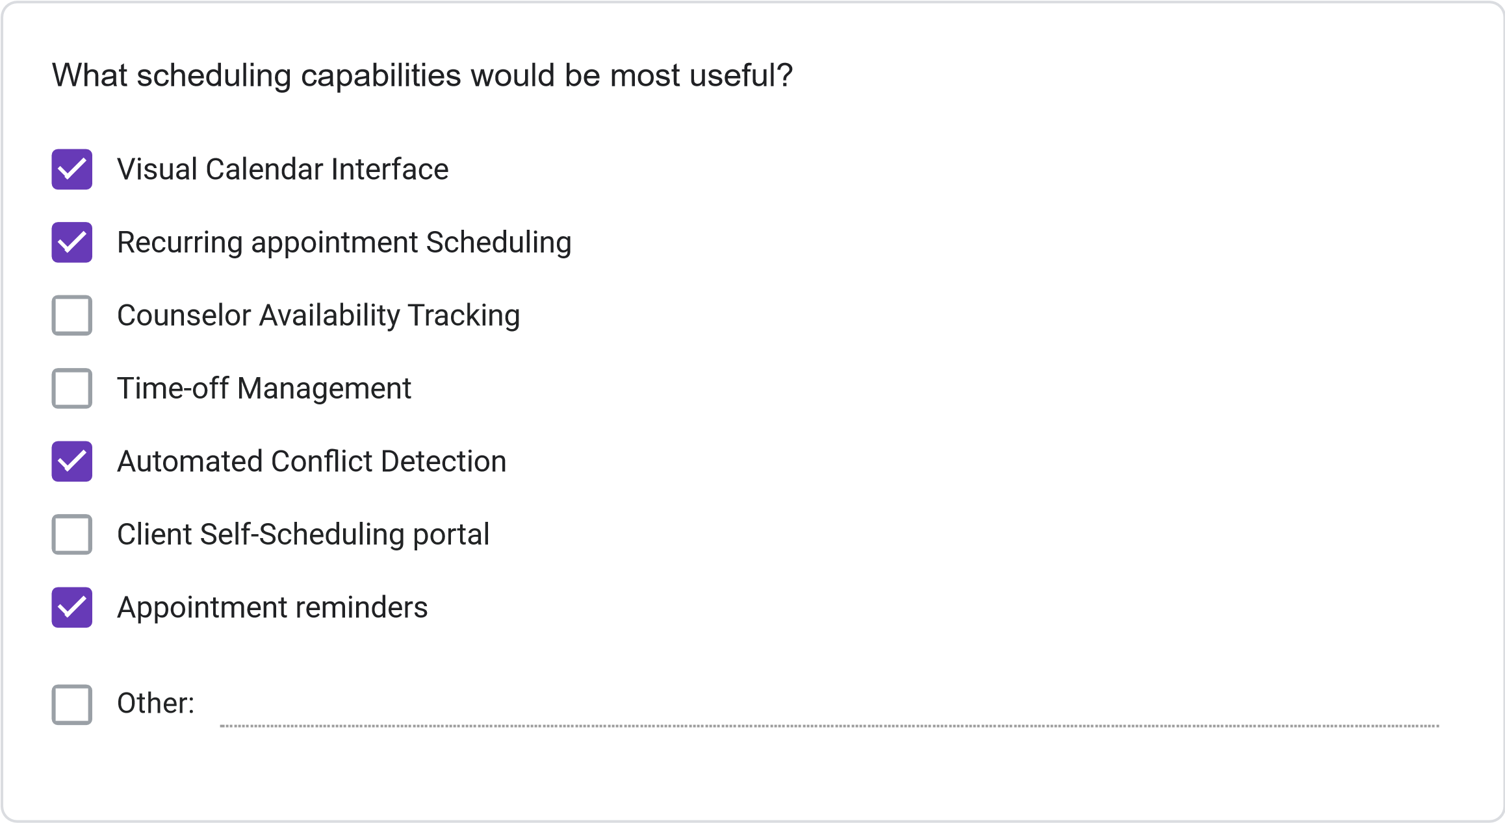
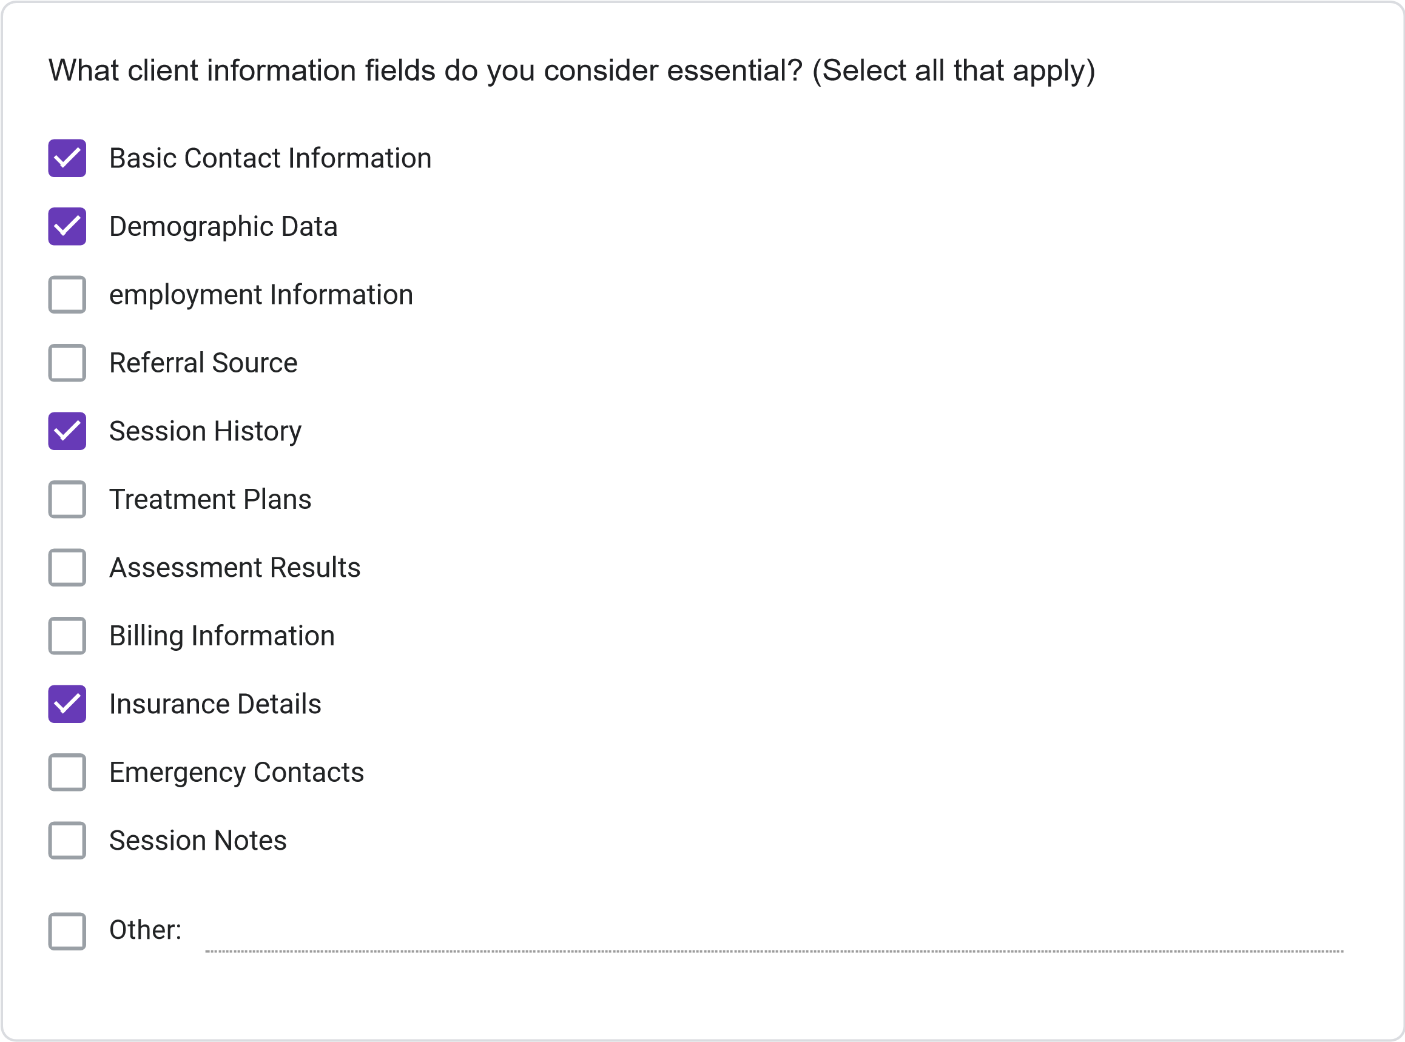
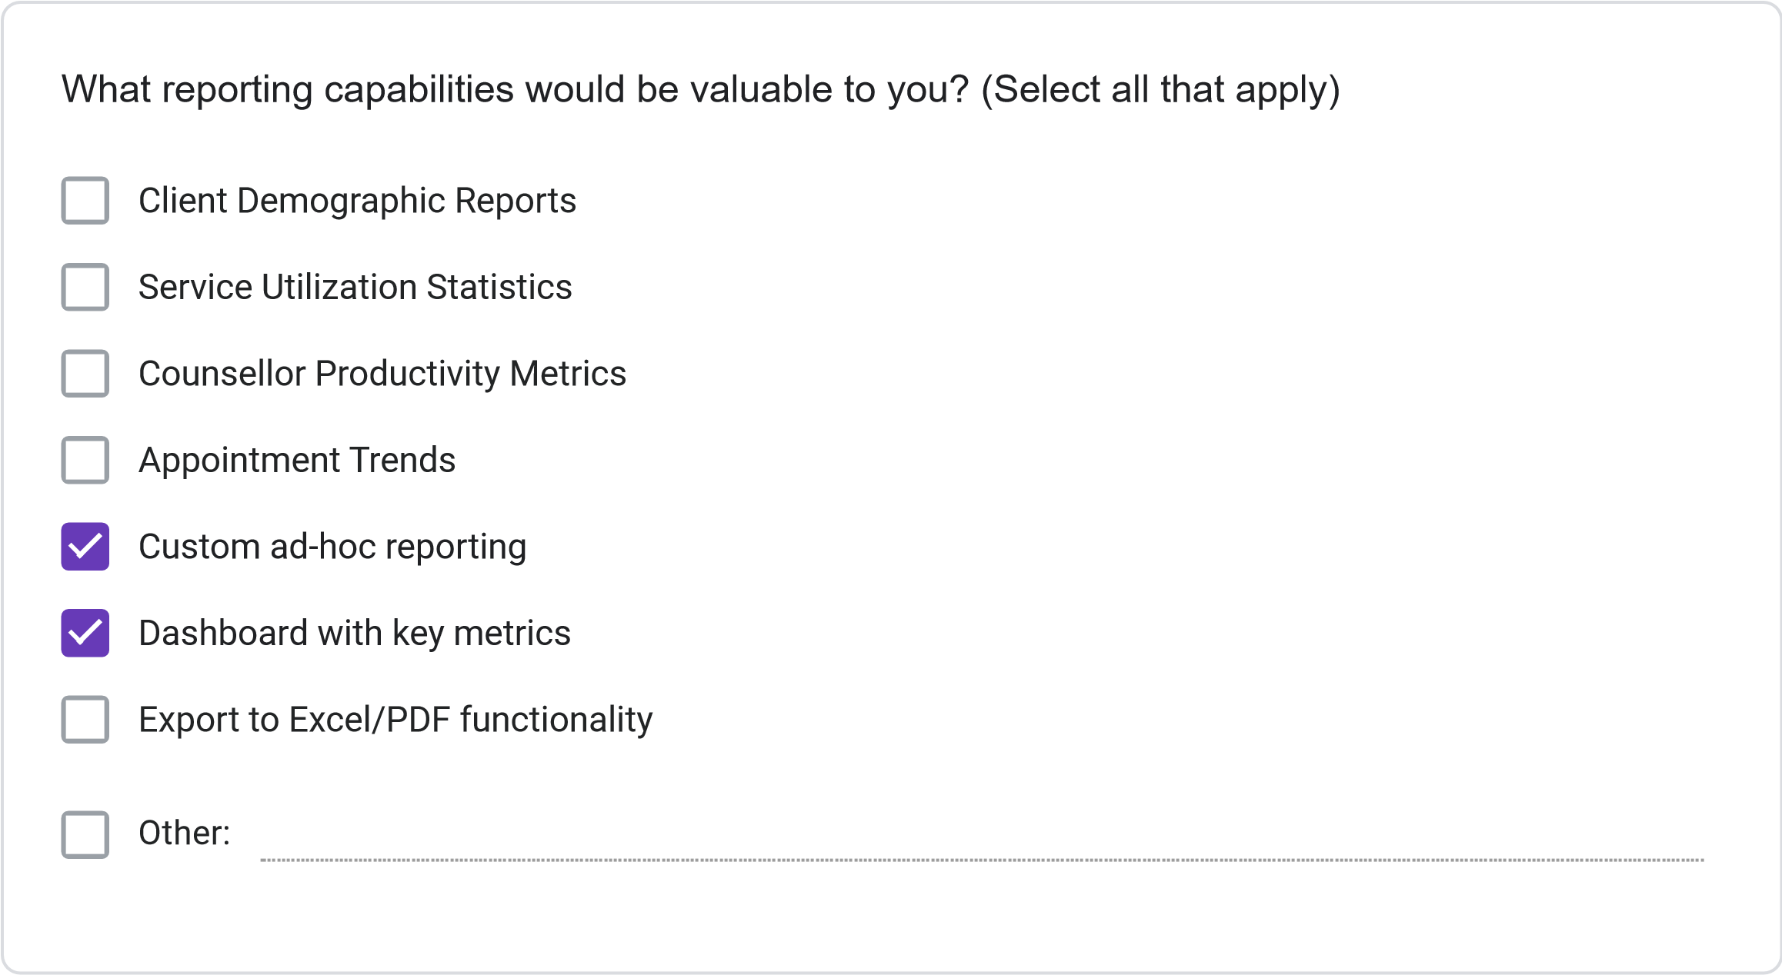
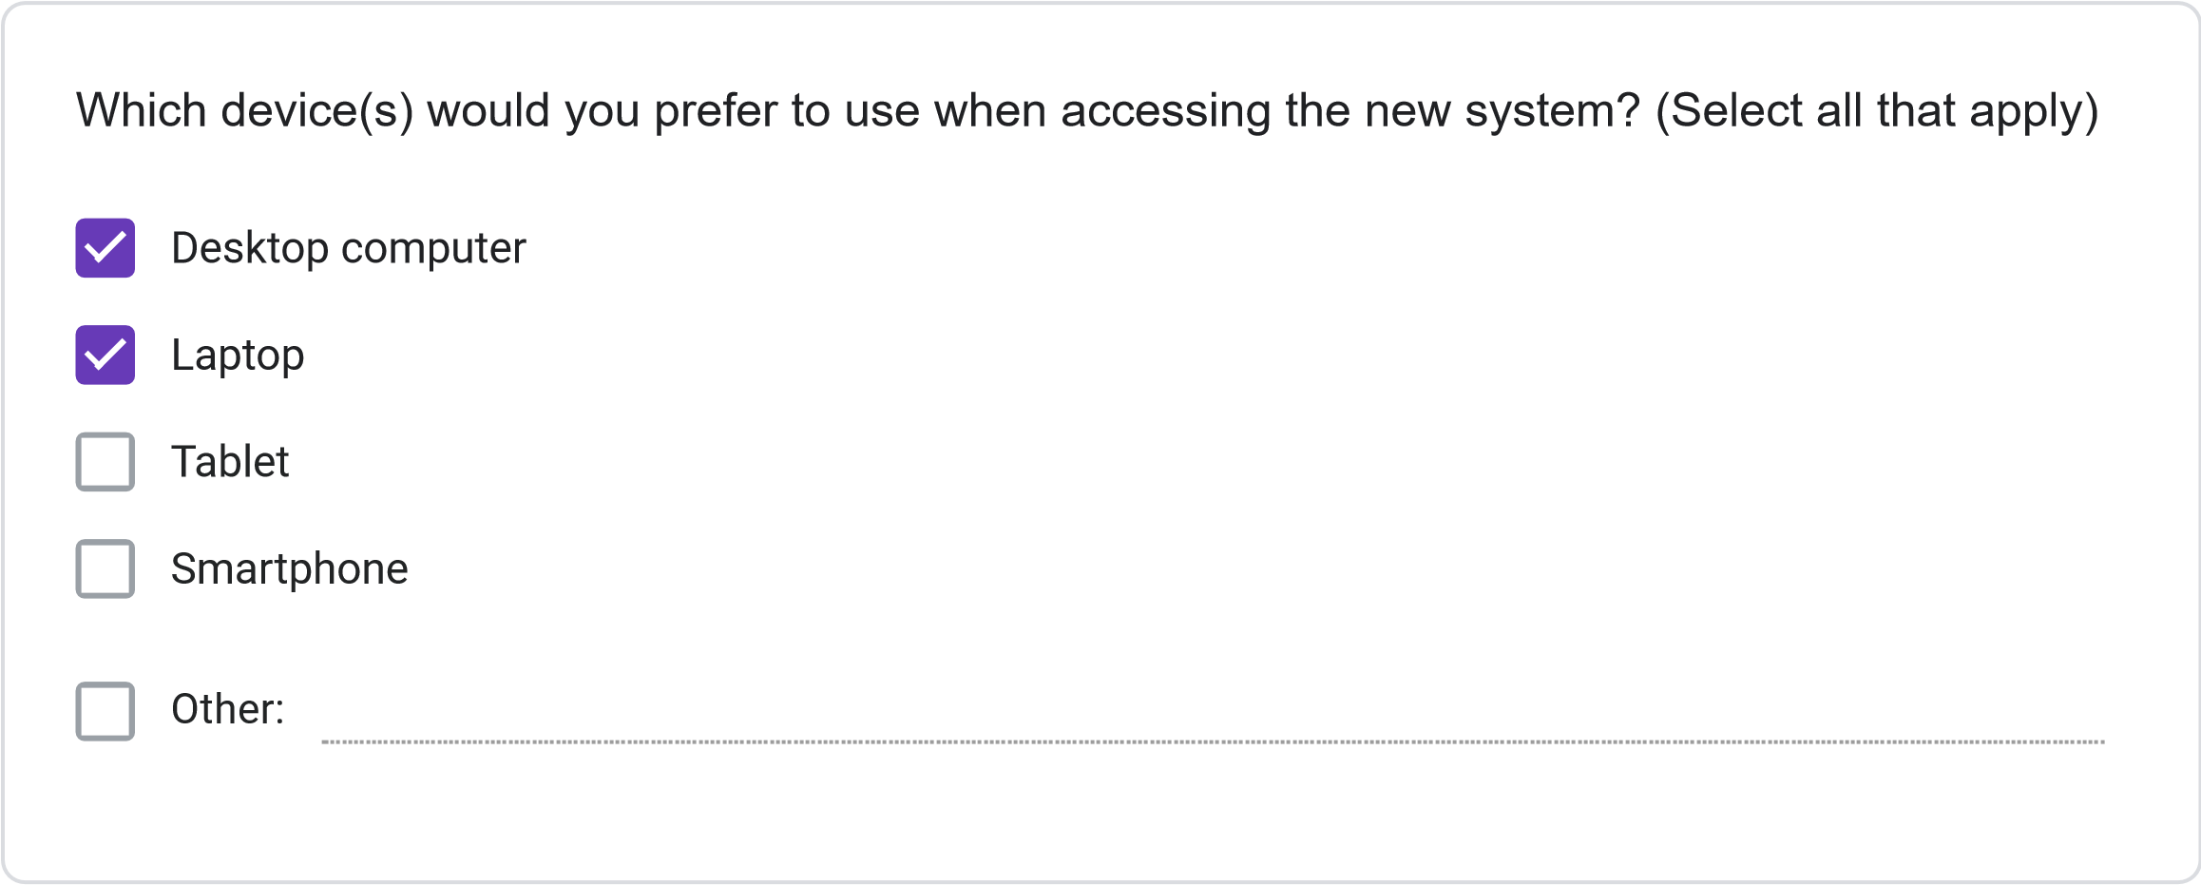
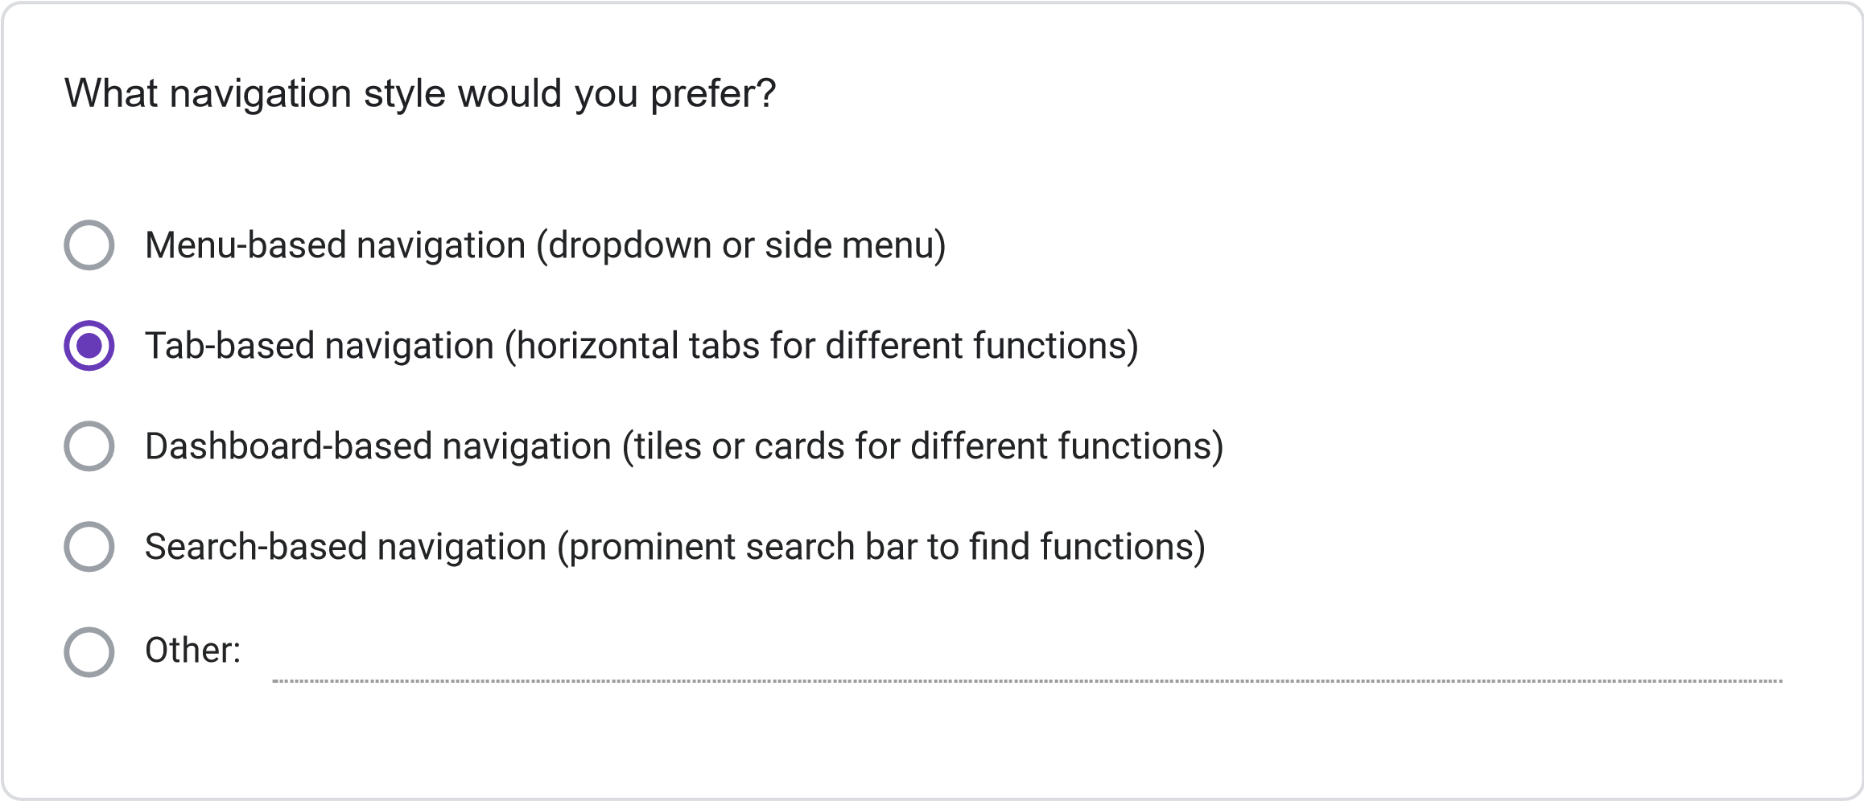
=
11
. Please rate your preference for the following user interface elements: (1 = Not Preferred, 2
Slightly Preferred, 3 = Neutral, 4 = Preferred, 5 = Strongly Preferred)
1
2
3
4
5
Dashboard with
summary
information
Visual calendar
display
Tabs for
different
functions
Search
functionality
Color-coding for
different
information
types
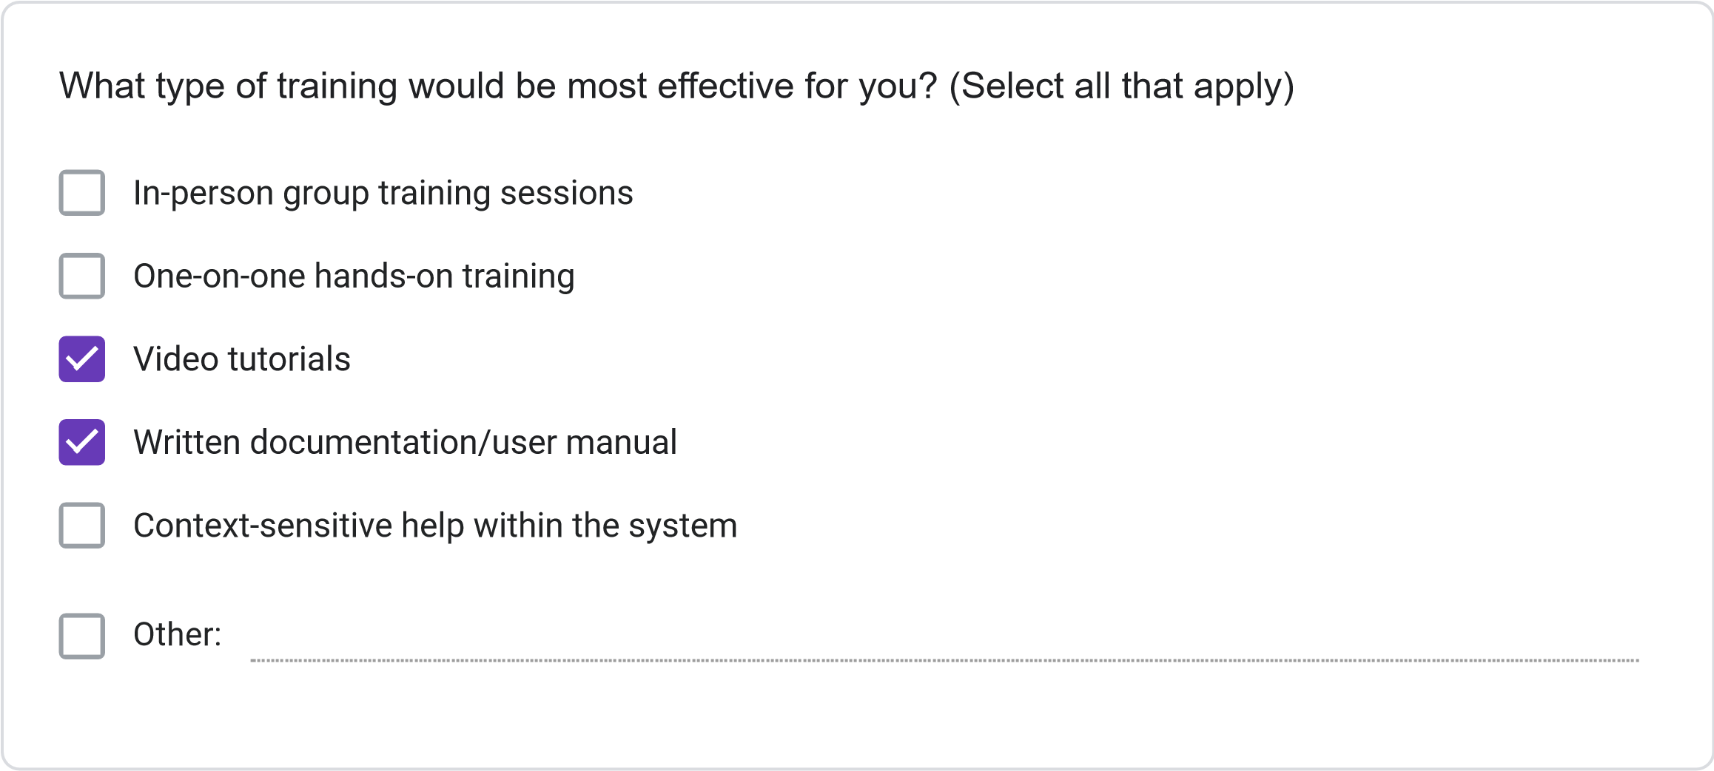
Less than 2 hours
2-4
hours
4-8
hours
More than 8 hours
How much time would you be willing to invest in training for the new system?
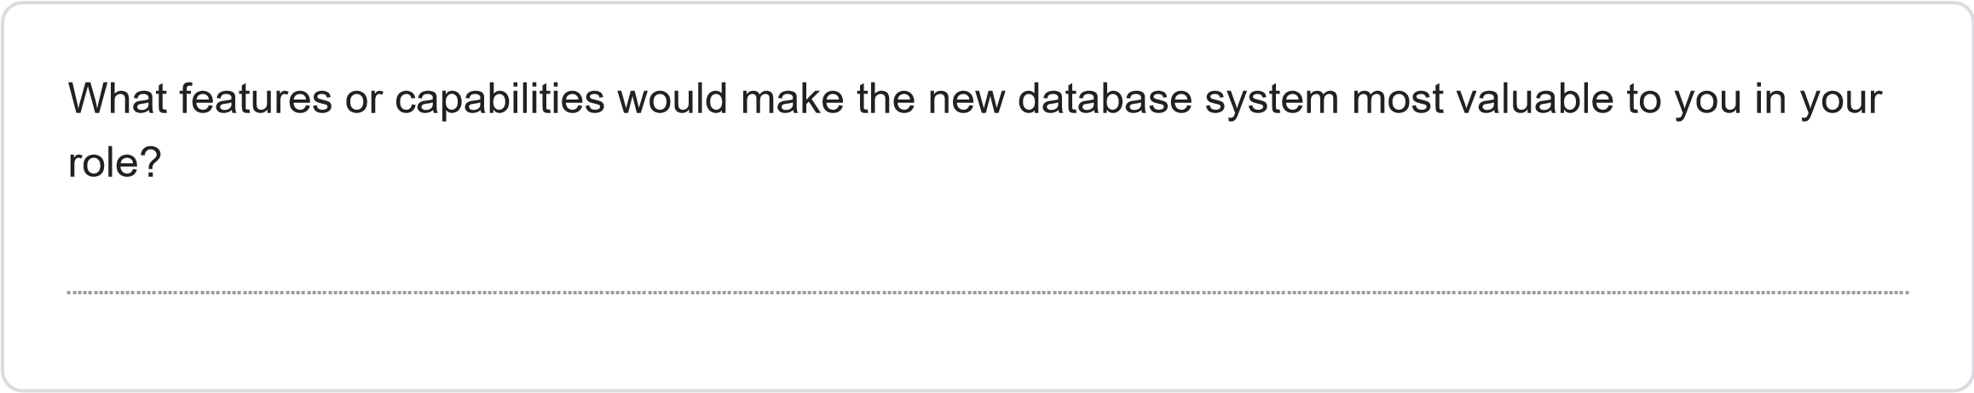
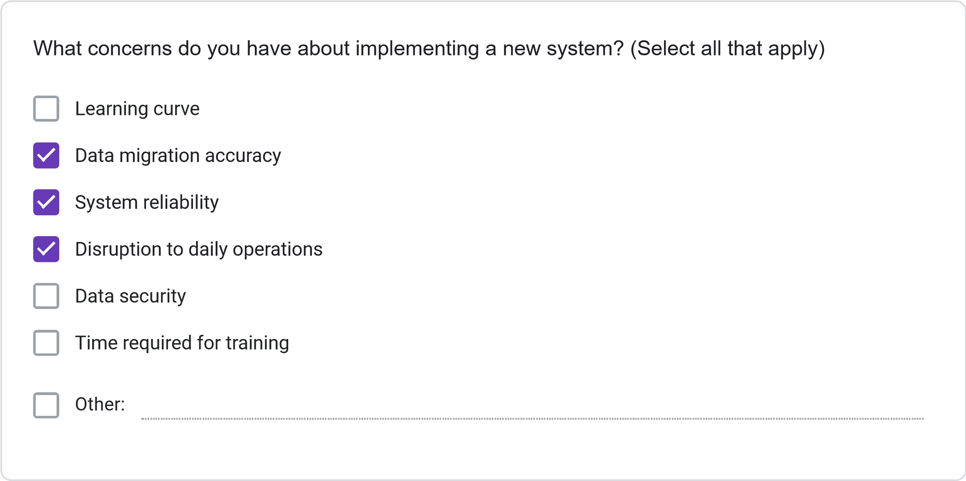
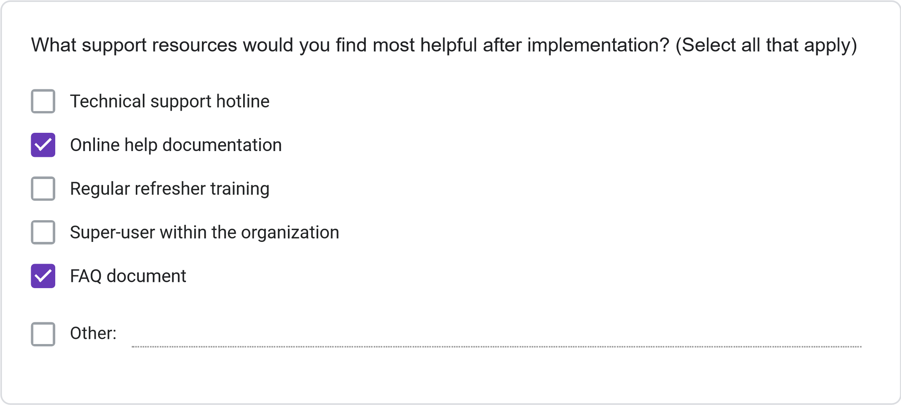
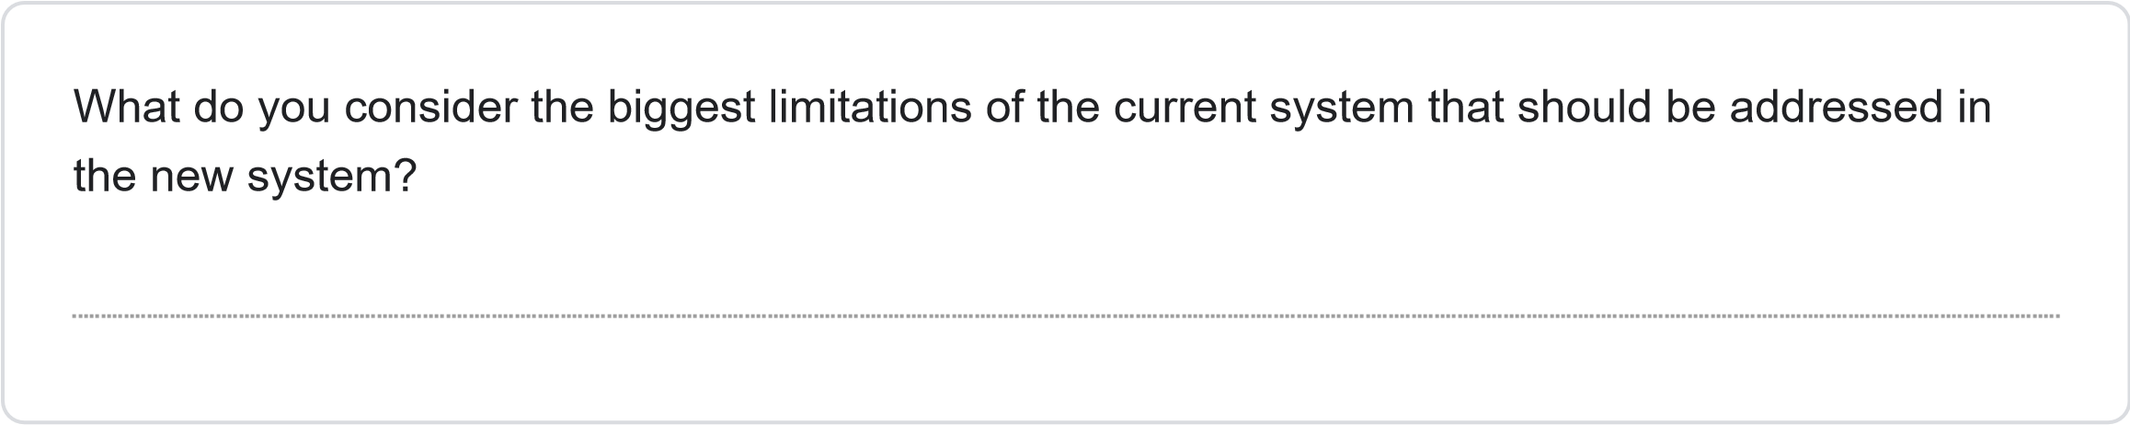
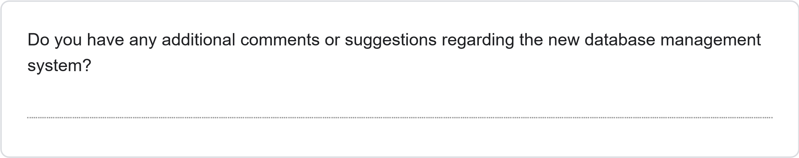
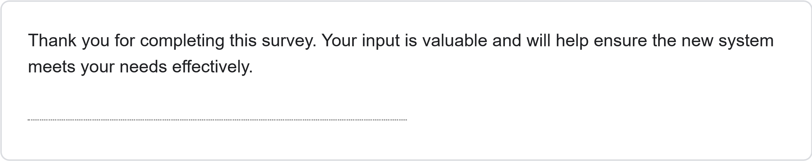
This content is neither created nor endorsed by Google.
Forms
JOSAL CONSULTING DATABASE MANAGEMENT SYSTEM PROJECT REQUIREMENTS SURVEY
Less than 1 Year
1-3
Years
4-6
years
More than 6 years
How long have you been working at Josal Consulting?
This survey aims to gather specific requirements for the new database management system for Josal Consulting. Your responses will help ensure the system meets user needs and improves operational efficiency. The survey should take approximately 15-20 minutes to complete.
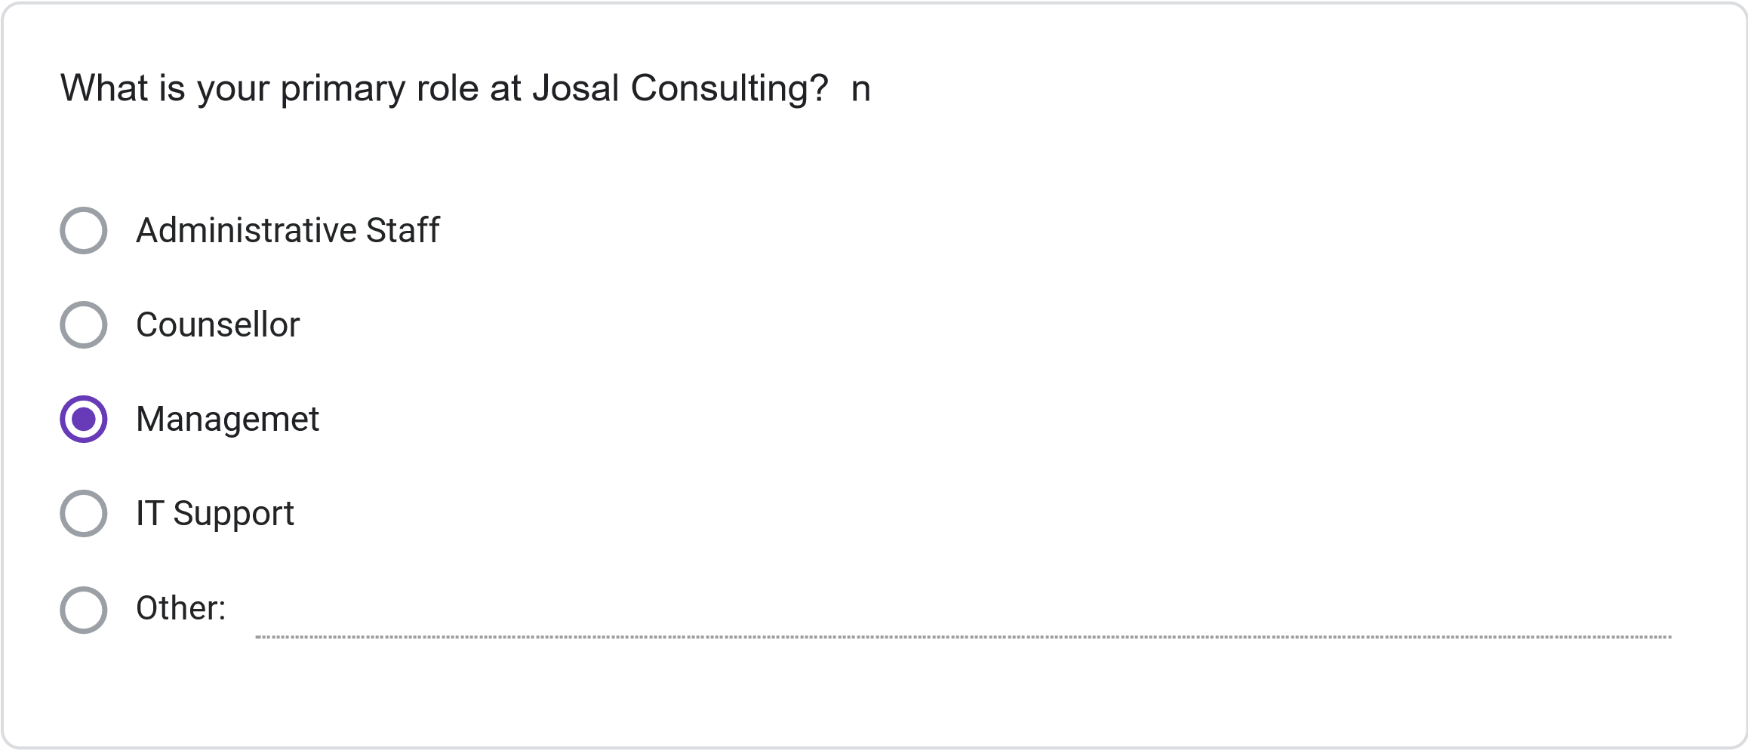
Multiple times daily
Daily
Several times per Week
Weekly or less Frequently
How frequently do you use the current information management system?
Please rate your satisfaction with the following: (1 = Not Preferred, 2 = Slightly Preferred, 3 =
Neutral, 4 = Preferred, 5 = Strongly Preferred)
1
2
3
4
5
Ease of finding
client information
Scheduling
capabilities
Accuracy of
information
Report generation
Data security
System
speed/performance
Less than 30 minutes
30
minutes to 1 hour
1-2
hours
More than 2 hours
On average, how much time do you spend per day on administrative tasks using the current
system?
How often do you encounter the following issues with the current system? (1 = Never, 2 = Rarely,
3
= Sometimes, 4 = Often, 5 = Very Often)
1
2
3
4
5
Schedulint
Conflics
Difficulty Finiding
Client
Information
System Errors or
Crashes
Duplicate or
Inconsistent
Data
Inability to
generate needed
reports
SECTION 3: NEW SYSTEM REQUIREMENTS
Please rate the importance of the following features for the new database system: (1 = Not
Important, 2 = Slightly Important, 3 = Moderately Important, 4 = Important, 5 = Very Important)
1
2
3
4
5
Integrated
calendar/scheduling
system
Client history tracking
Automated conflict
detection
Custom report
generation
Mobile access
capability
Document attachment
functionality
Automated
reminders/notifications
Role-based access
controls
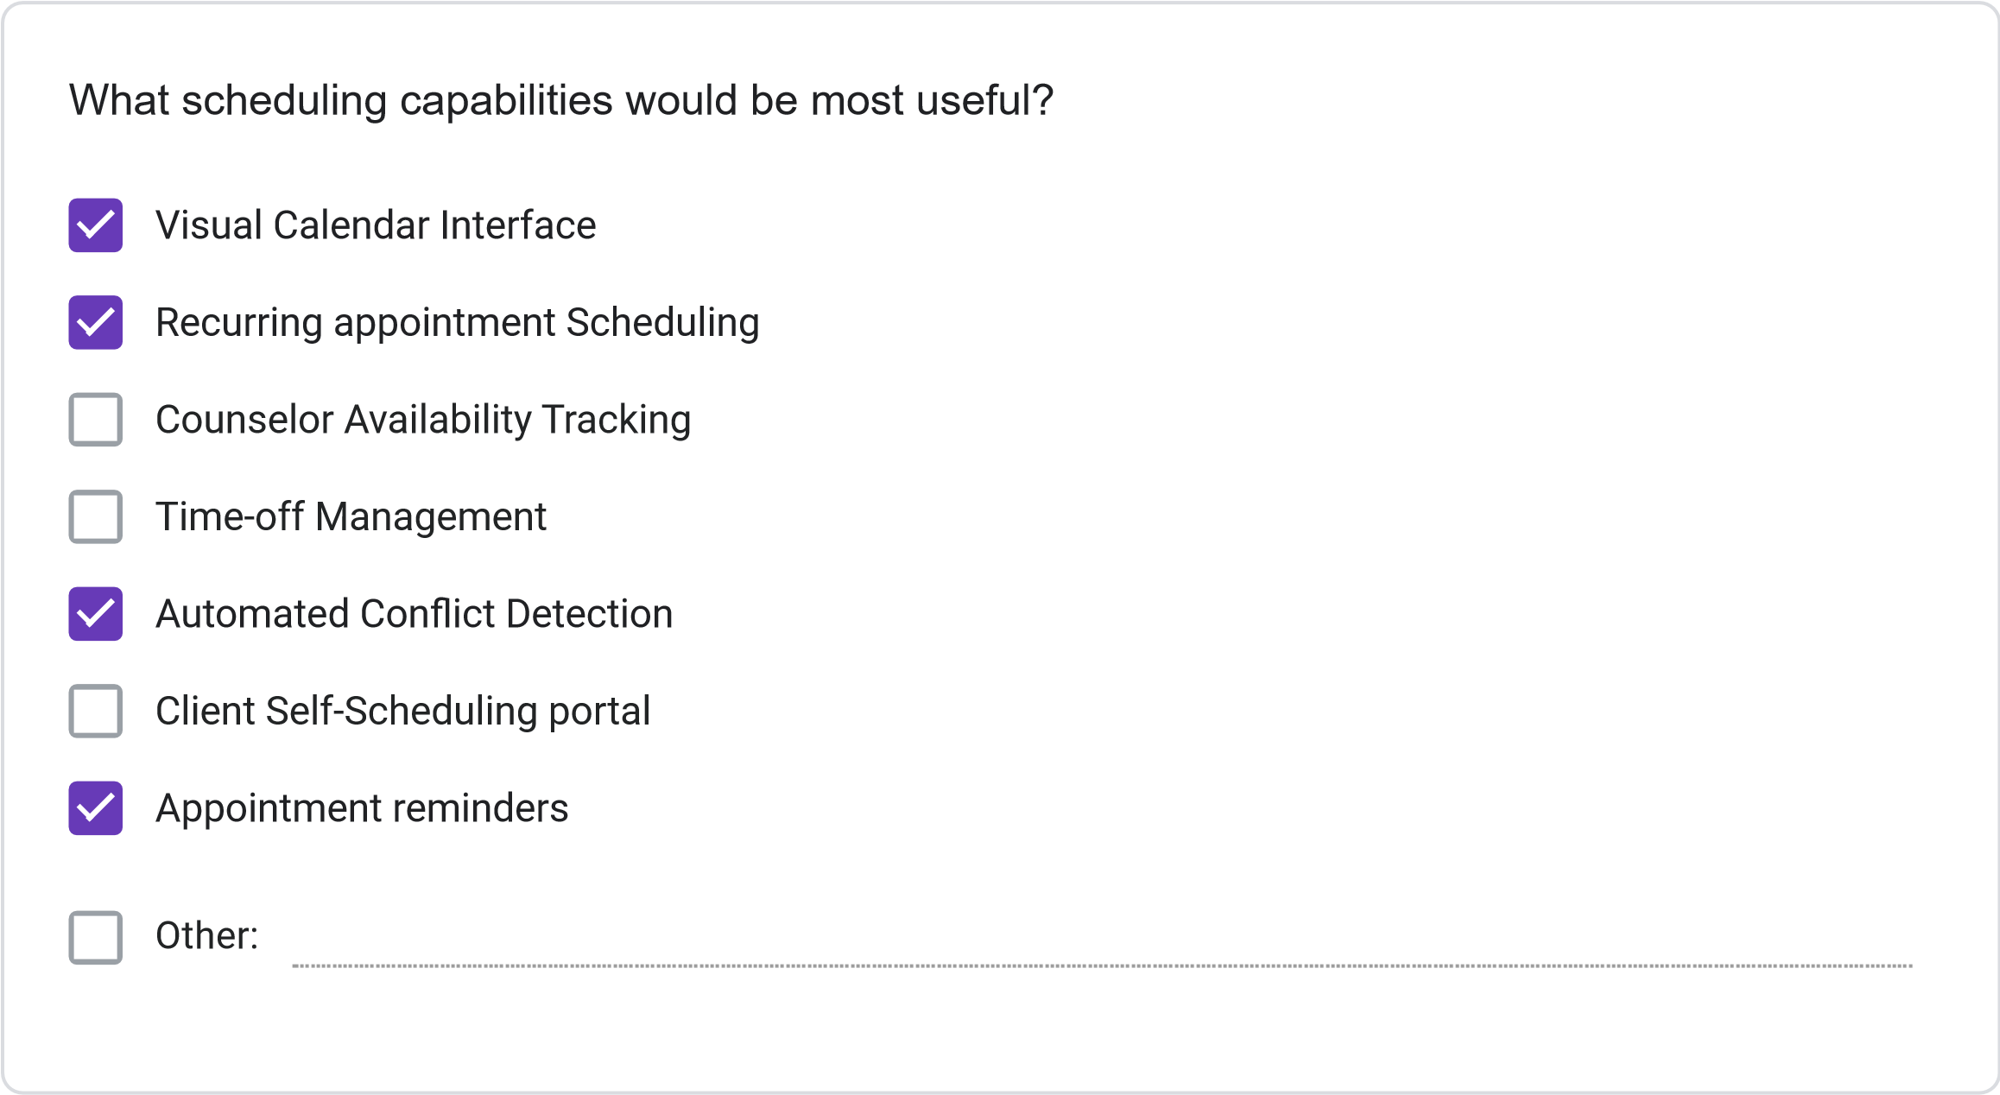
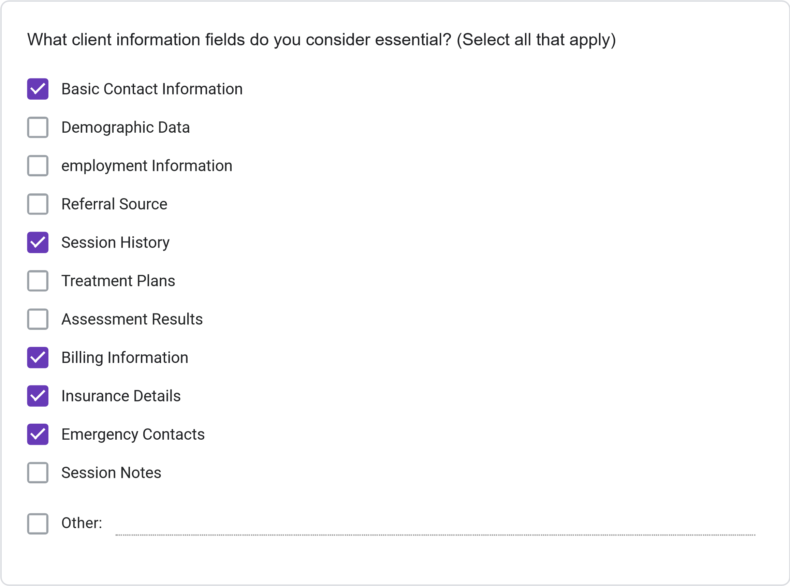
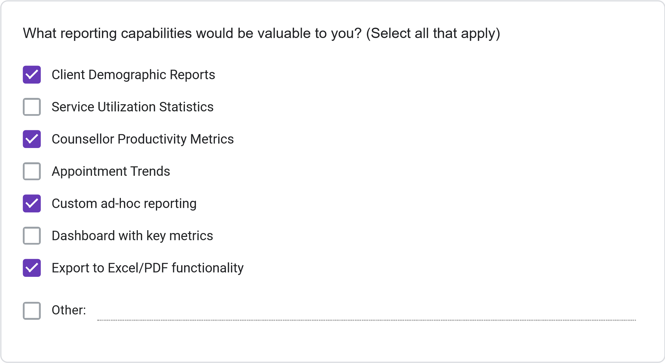
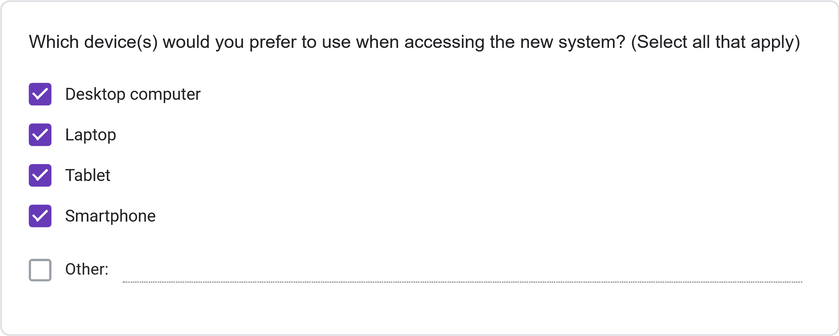
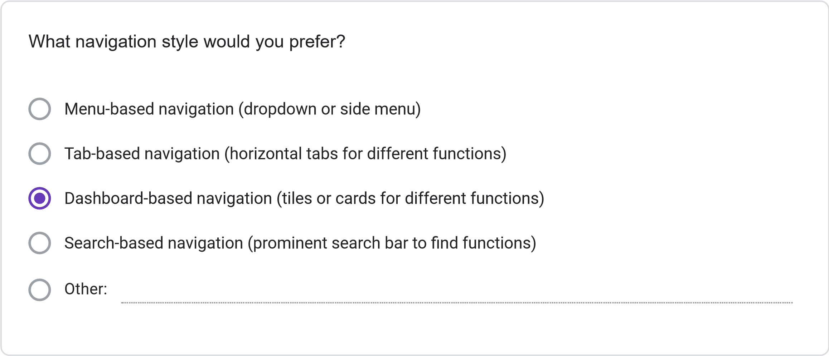
=
11
. Please rate your preference for the following user interface elements: (1 = Not Preferred, 2
Slightly Preferred, 3 = Neutral, 4 = Preferred, 5 = Strongly Preferred)
1
2
3
4
5
Dashboard with
summary
information
Visual calendar
display
Tabs for
different
functions
Search
functionality
Color-coding for
different
information
types
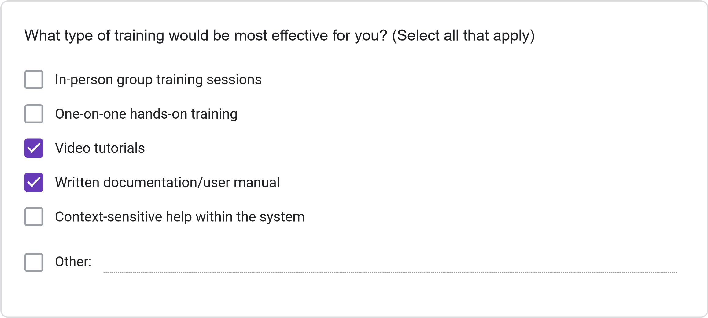
Less than 2 hours
2-4
hours
4-8
hours
More than 8 hours
How much time would you be willing to invest in training for the new system?
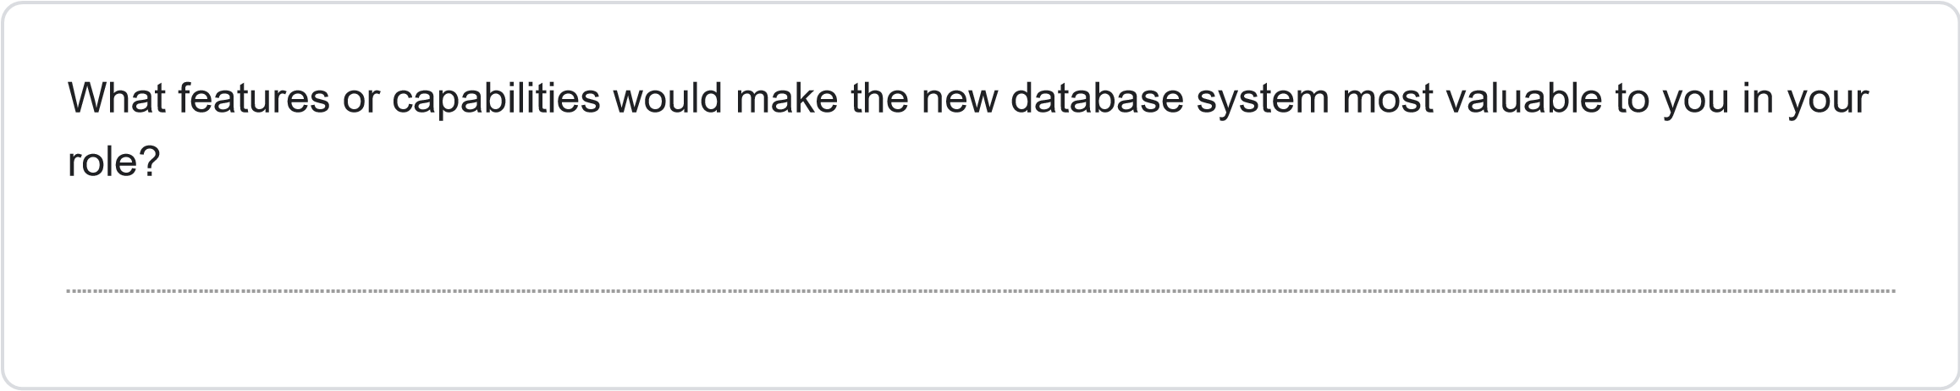
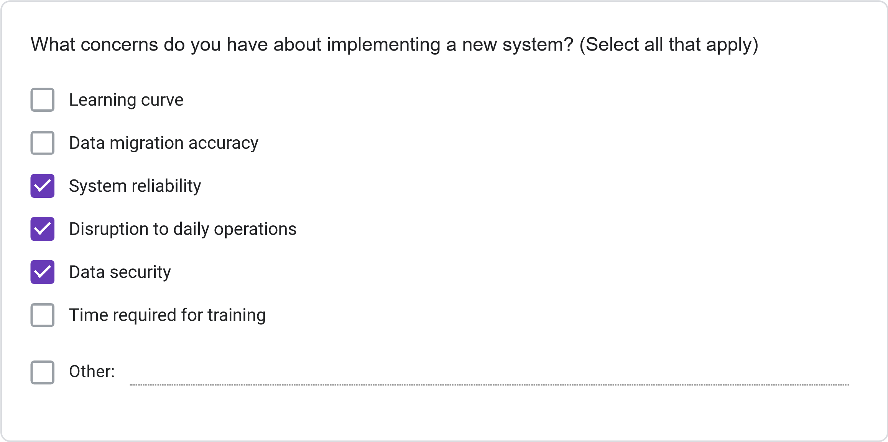
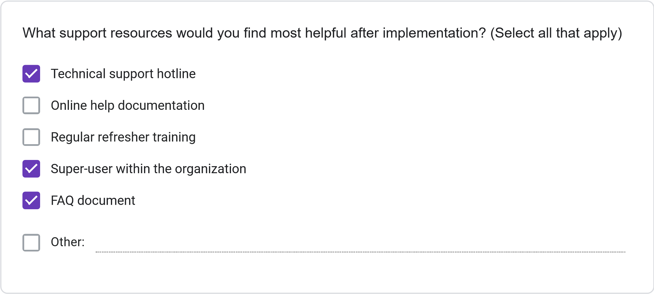
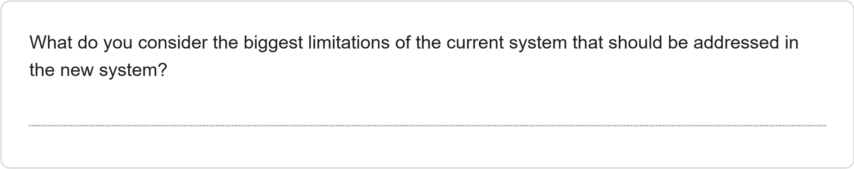
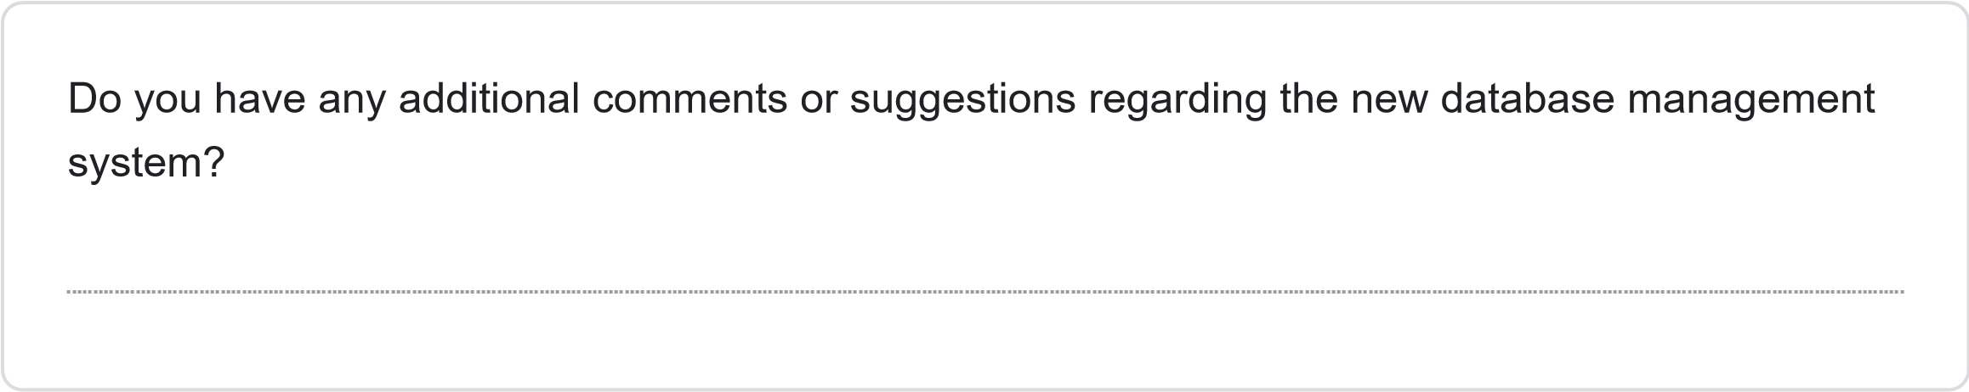
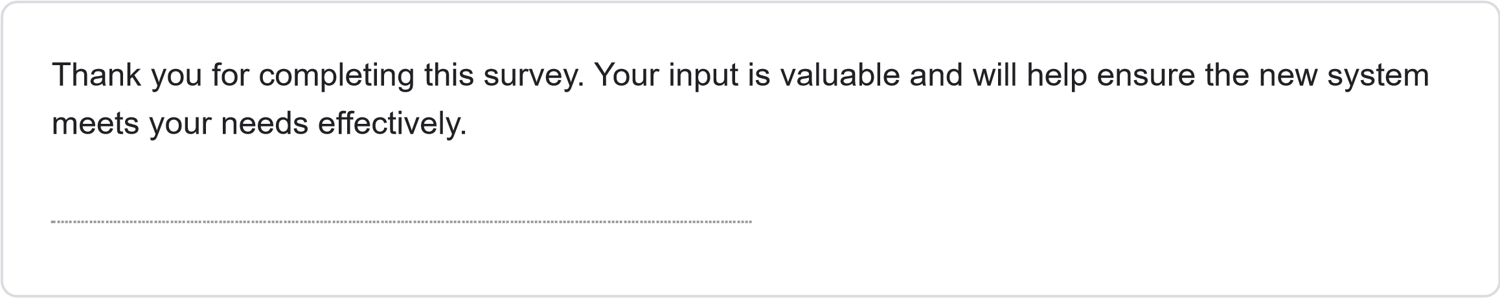
This content is neither created nor endorsed by Google.
Forms
JOSAL CONSULTING DATABASE MANAGEMENT SYSTEM PROJECT REQUIREMENTS SURVEY
Less than 1 Year
1-3
Years
4-6
years
More than 6 years
How long have you been working at Josal Consulting?
This survey aims to gather specific requirements for the new database management system for Josal Consulting. Your responses will help ensure the system meets user needs and improves operational efficiency. The survey should take approximately 15-20 minutes to complete.
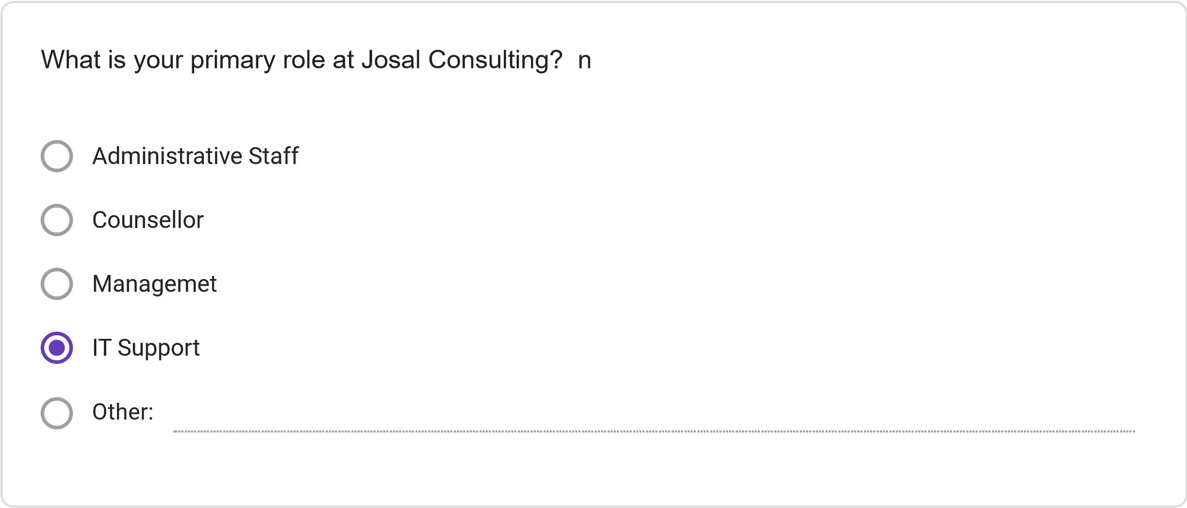
Multiple times daily
Daily
Several times per Week
Weekly or less Frequently
How frequently do you use the current information management system?
Please rate your satisfaction with the following: (1 = Not Preferred, 2 = Slightly Preferred, 3 =
Neutral, 4 = Preferred, 5 = Strongly Preferred)
1
2
3
4
5
Ease of finding
client information
Scheduling
capabilities
Accuracy of
information
Report generation
Data security
System
speed/performance
Less than 30 minutes
30
minutes to 1 hour
1-2
hours
More than 2 hours
On average, how much time do you spend per day on administrative tasks using the current
system?
How often do you encounter the following issues with the current system? (1 = Never, 2 = Rarely,
3
= Sometimes, 4 = Often, 5 = Very Often)
1
2
3
4
5
Schedulint
Conflics
Difficulty Finiding
Client
Information
System Errors or
Crashes
Duplicate or
Inconsistent
Data
Inability to
generate needed
reports
SECTION 3: NEW SYSTEM REQUIREMENTS
Please rate the importance of the following features for the new database system: (1 = Not
Important, 2 = Slightly Important, 3 = Moderately Important, 4 = Important, 5 = Very Important)
1
2
3
4
5
Integrated
calendar/scheduling
system
Client history tracking
Automated conflict
detection
Custom report
generation
Mobile access
capability
Document attachment
functionality
Automated
reminders/notifications
Role-based access
controls
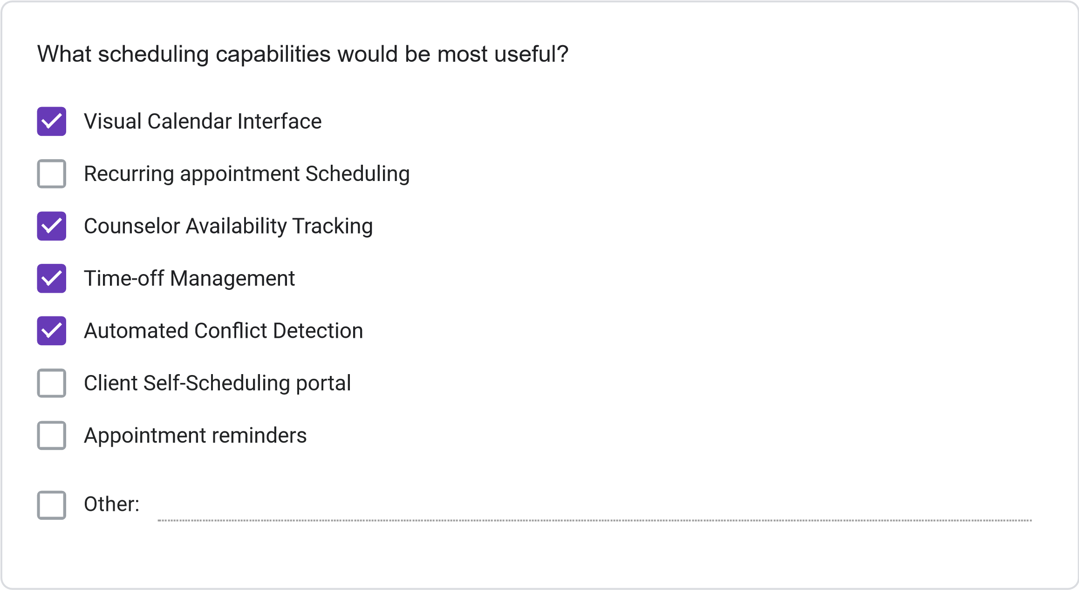
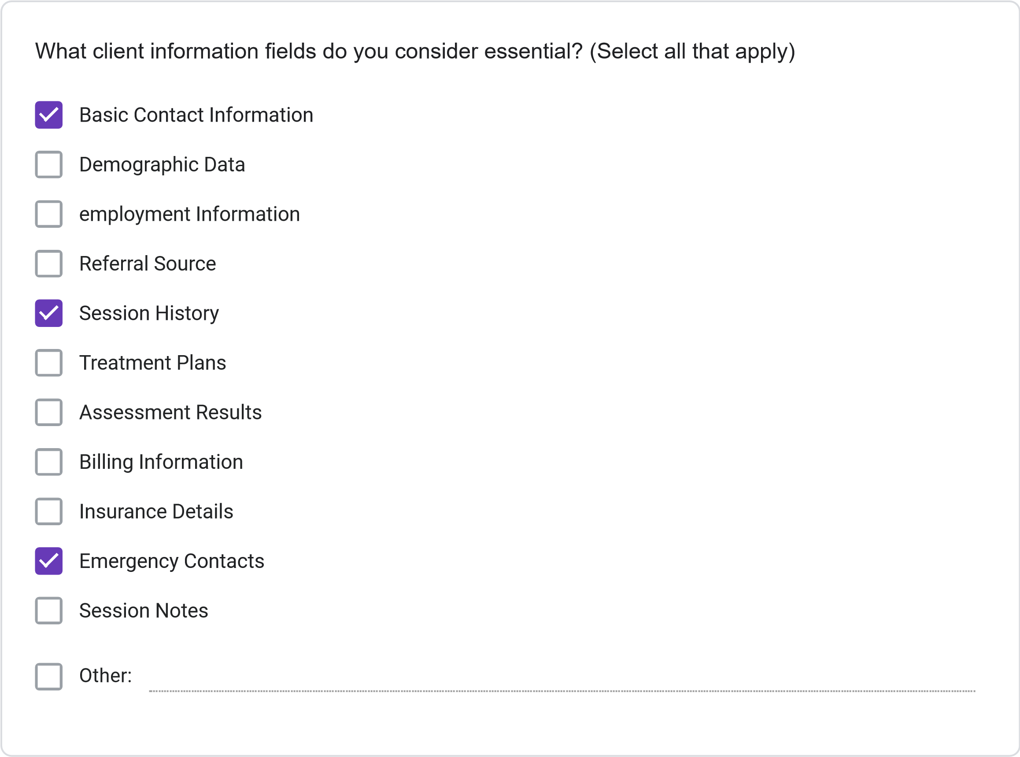
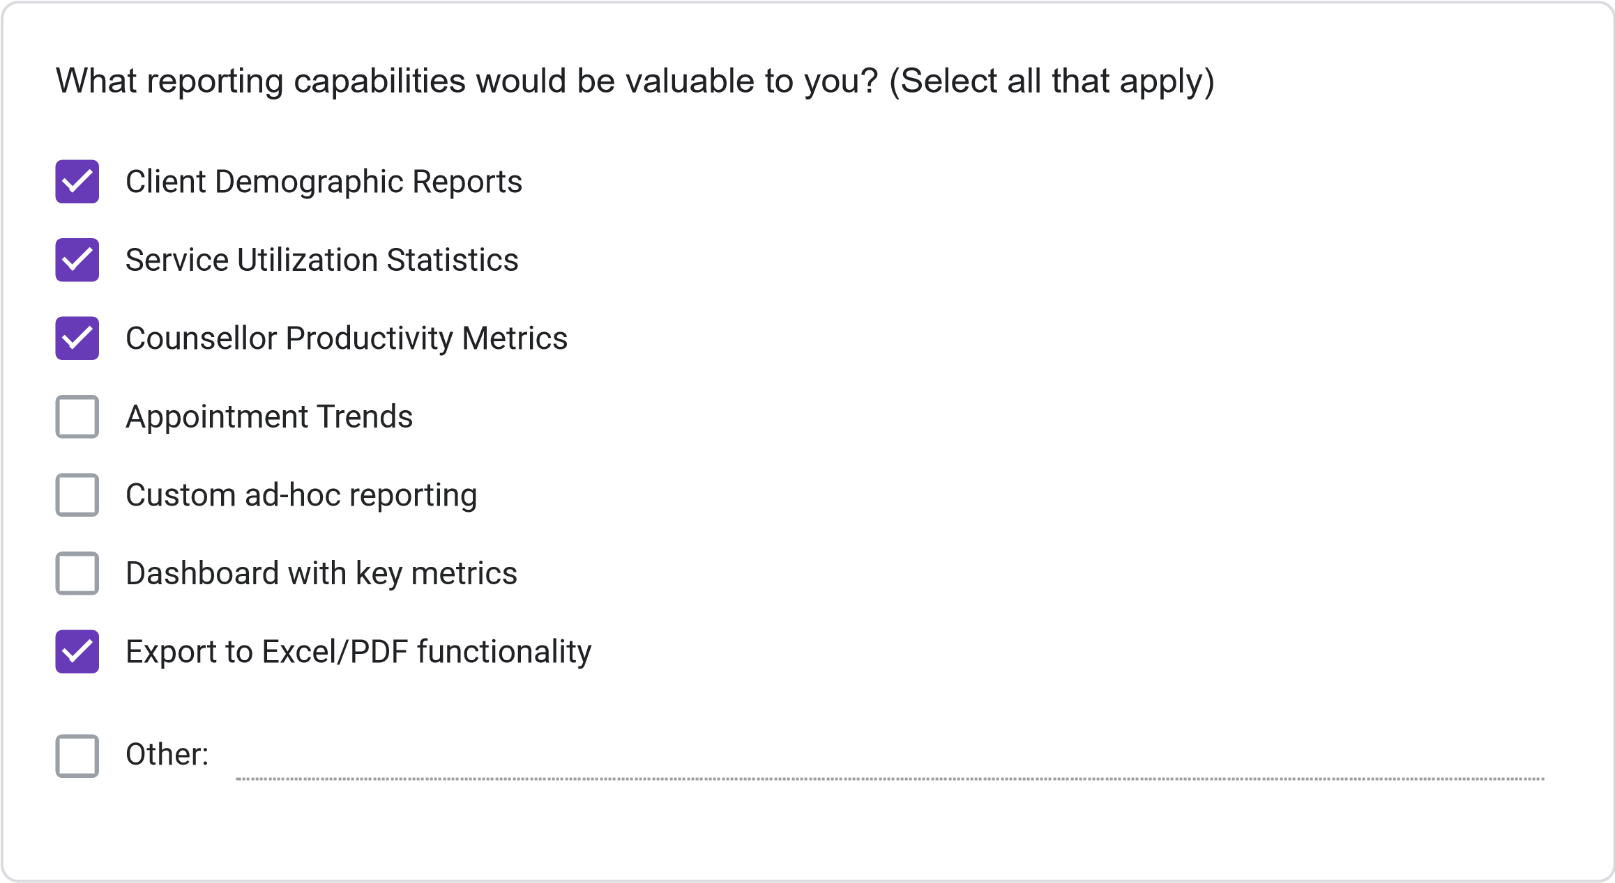
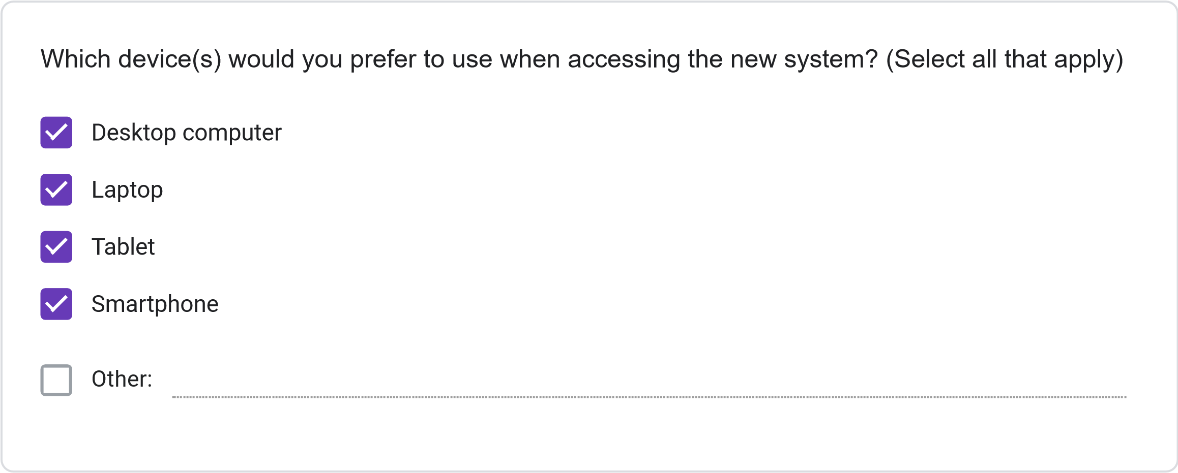
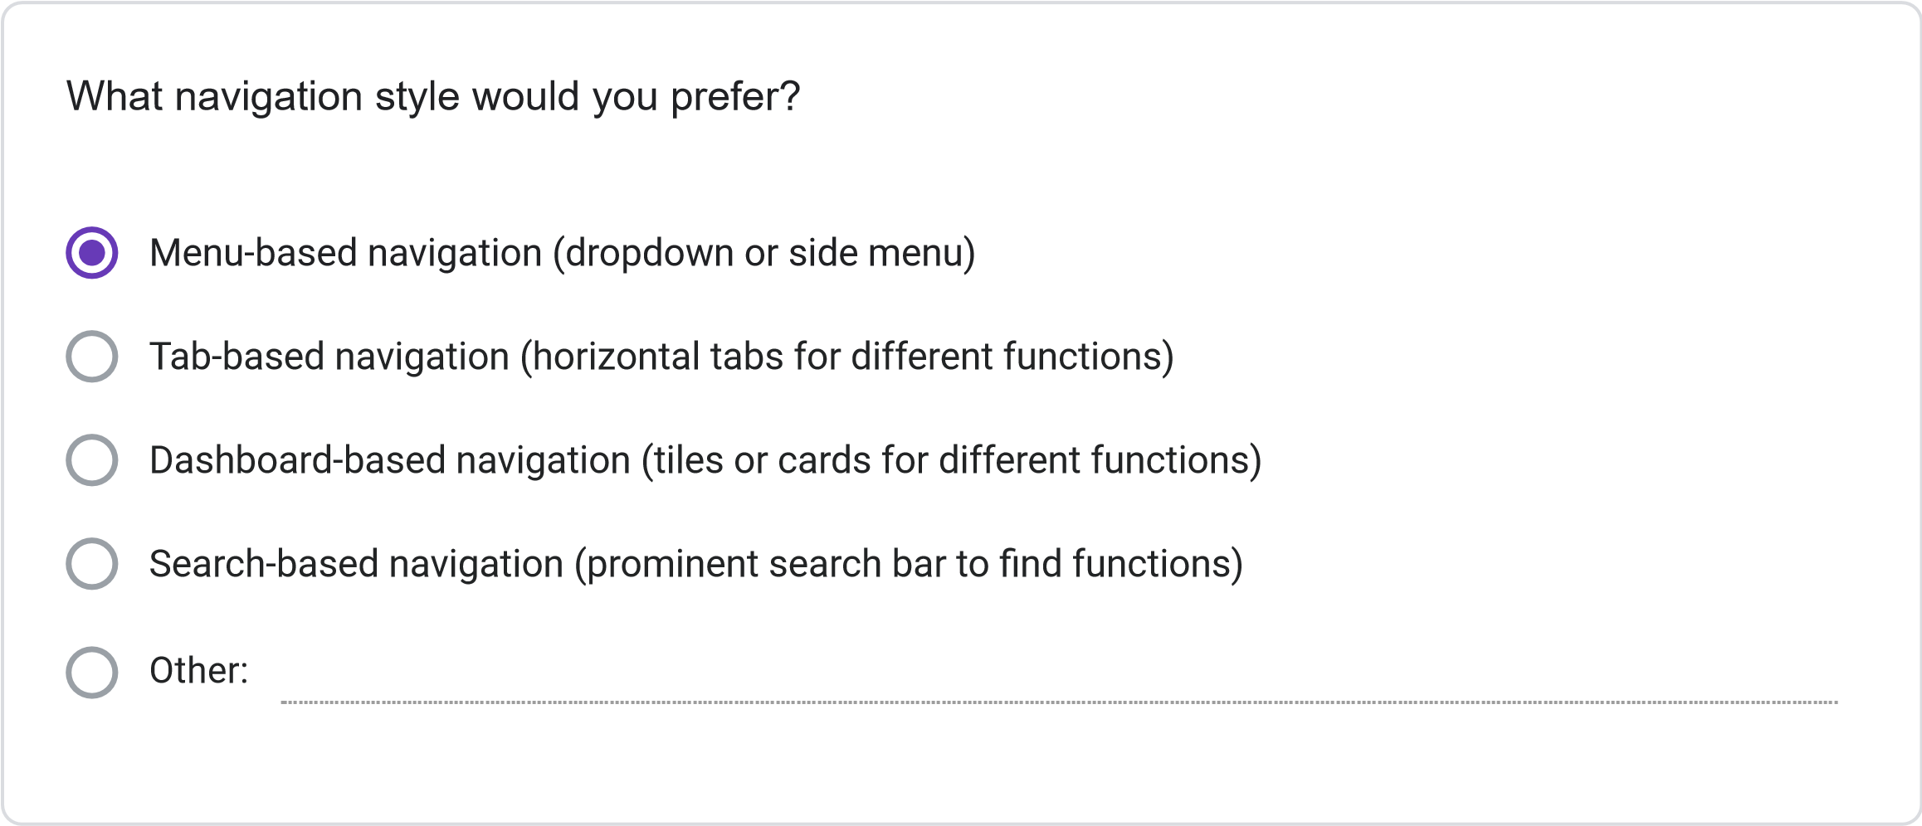
=
11
. Please rate your preference for the following user interface elements: (1 = Not Preferred, 2
Slightly Preferred, 3 = Neutral, 4 = Preferred, 5 = Strongly Preferred)
1
2
3
4
5
Dashboard with
summary
information
Visual calendar
display
Tabs for
different
functions
Search
functionality
Color-coding for
different
information
types
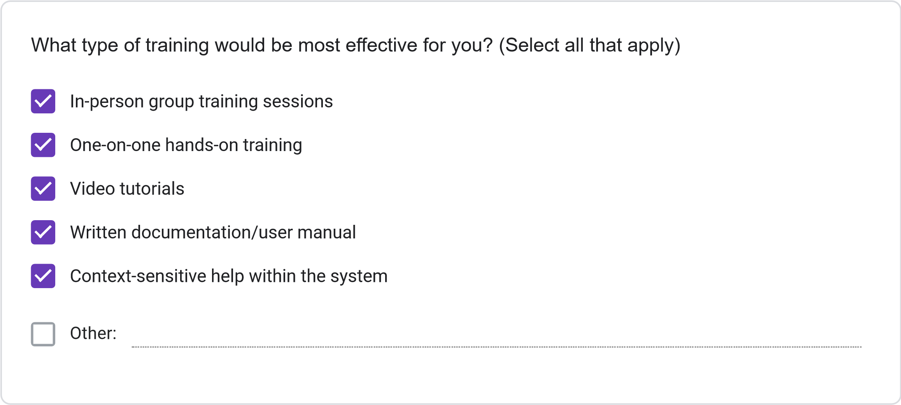
Less than 2 hours
2-4
hours
4-8
hours
More than 8 hours
How much time would you be willing to invest in training for the new system?
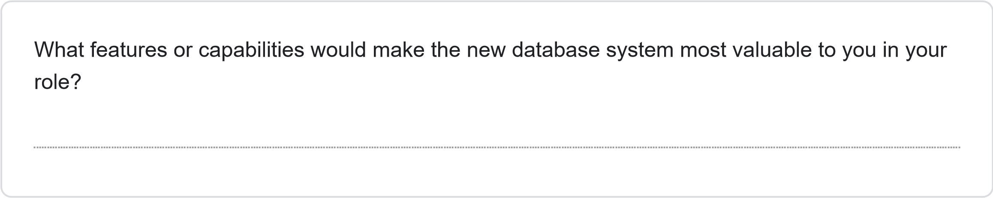
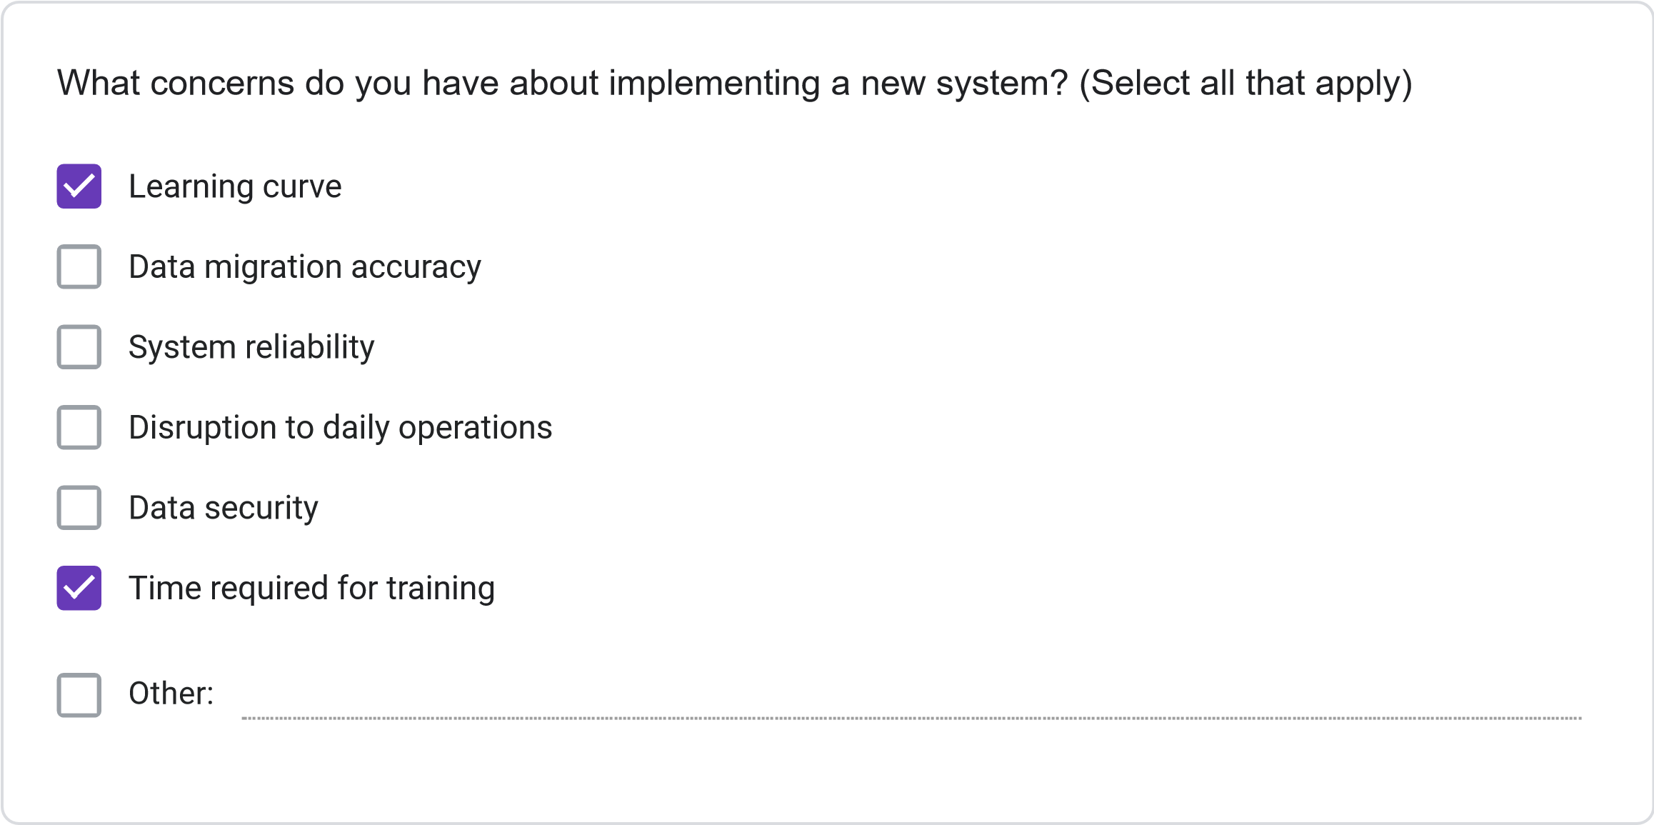
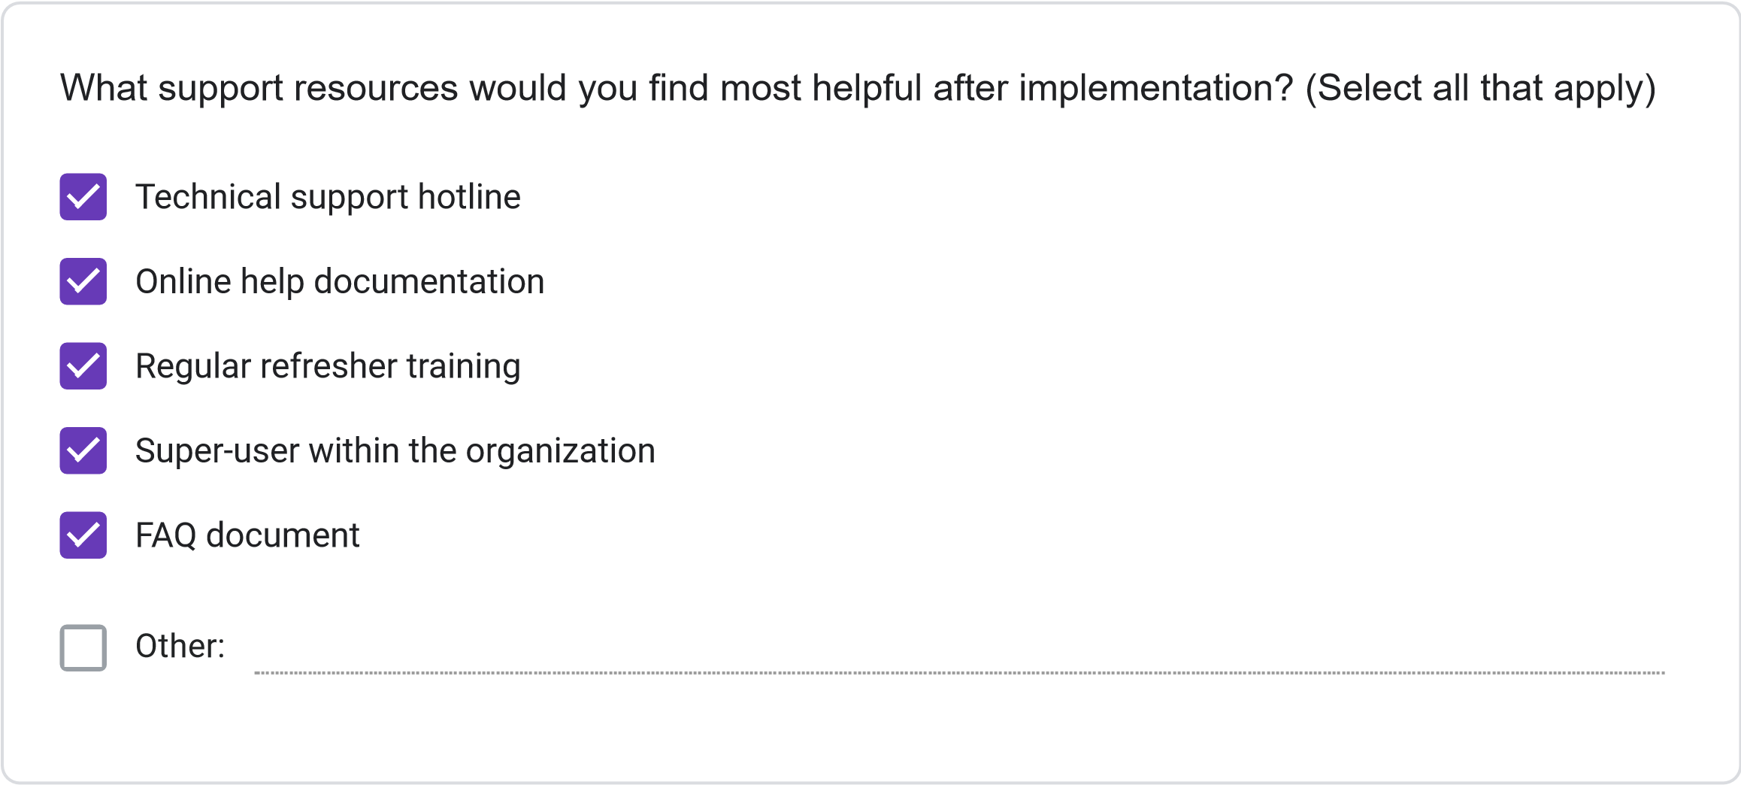

This content is neither created nor endorsed by Google.
Forms

